Kids 2 Kids 4 Jesus - "Mission trip"
by Shirley Davis
www.imofinc.org

Purpose To help children better understand life in other countries and why so many people need to hear about Jesus and be given hope. To show them ways they (the children) can actually get involved in missions.

Preparation Set up 4-5 stations to represent different countries (if possible, in a variety of continents and highlighting countries where the local church has made trips or has missionary contacts). Decorate each station with pictures and articles relating to that country and its principle religion, and have a "guide" (if possible dressed accordingly) who tells about the country and way of life for many of the people there.

Suggestions: map and country flag; sample of basic common food for the children to taste; pictures depicting the main religion; souvenirs or cultural artifacts if possible...

Have a simple craft or activity for the children to participate in that can be later sent to the missionary or church contact as a resource to help evangelism or to show that the children are praying and learning about the country.

Make a simple "passport" for each child, with their name and stamp it for each "country" they visit.

Program As children arrive, let them sit in a waiting area, considered to be an airport lounge. Explain to the children what is involved in traveling to another country (passports, customs inspection, long travel time, different language etc). Divide children into groups and assign a group leader, who distributes the passports, writing each child's name on his/her own. Set a timer to go off every 15 mins or so (according to time available) and each group leader leads his group to a "new country" every 15 mins, so that eventually all the countries are visited in the time available.

At each country, the guide points out the country on a world map and tells interesting facts about the life (especially of children) in that country and answers questions (5-8 mins). A sticker is put for that country in each passport. Children then participate in the craft/activity, giving them ideas on how they can start to help with mission work and evangelism in that country. At the end, everyone returns to the "airport lounge" for final remarks, prayer for the missionary contacts, and to answer questions. Ensure that the children take home a page of suggestions of such activities that they can continue to do. (see examples)

The following are examples of four countries we highlighted, along with some photos of how we decorated each area. Also included are pictures and suggestions for information to be shared about each country and some simple craft ideas. Obviously a little research done on whatever countries are chosen, and personal information about the church's missionary contacts, should be used to adapt the "mission trip" to each local church.

We also include a pattern to make "passports" (2 per page, printed front and back)

Examples:
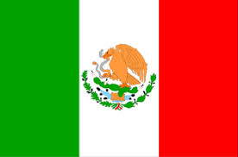Mexico (local church missionary working there)
Mexican snacks or candy, Mexican artifacts and pictures
Craft - take photo of each group of children, then get each child to write a short signed greeting on a large sheet or poster board, to which the printed photo will later be attached in the center. This will be sent to her as a nice reminder that the children and church have not forgotten her!
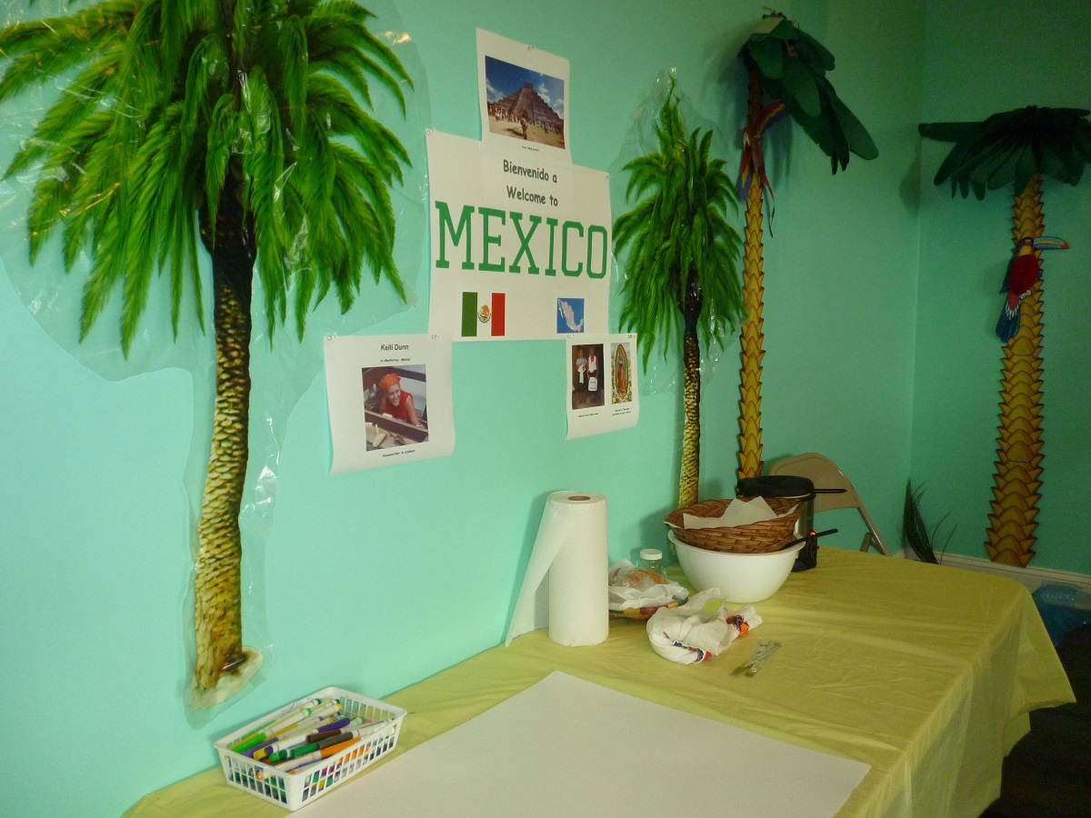Country info - Neighboring country to the south of USA but still considered in North America. Spanish is the main language but some 68 different languages are recognized among the many Indian groups, who mostly live in the mountainous areas and the South. Many ruins of the Aztec and Mayan cultures remain, and the influence of these cultures (with worship of the sun god etc) is still strong through superstitions, religious festivals, and witchcraft. Mexican food is well-known in the USA but this is very different from what most poor or rural Mexicans eat – mostly beans, corn tortillas, rice and fruit. Many types of candy are made from tamarind or other fruits often covered with hot chili pepper! In recent years Mexico has become particularly dangerous due to drug traffickers who recruit people (even children) from poor areas and other unstable Central American countries, promising to smuggle them into the USA for a better life.
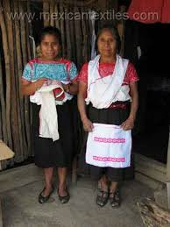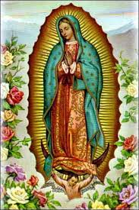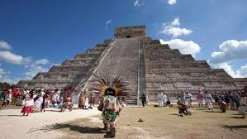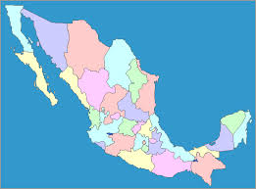

Map of Mexico Ancient Aztec pyramid Indian women Virgin Mary of Guadalupe

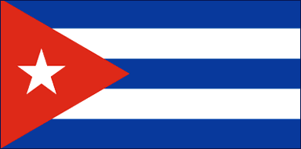Cuba (local church contacts there)
Plate containing week's food ration, pictures of buildings and old cars.
Craft - as Cuba is a communist country where Christian literature and freedoms are forbidden or severely restricted (often with harsh punishment) the children can make colored bead "salvation" bracelets (black, red, white, green, yellow) to be sent to Cuban children as a reminder of Jesus (local Cuban Christians can explain the meaning of the colors).
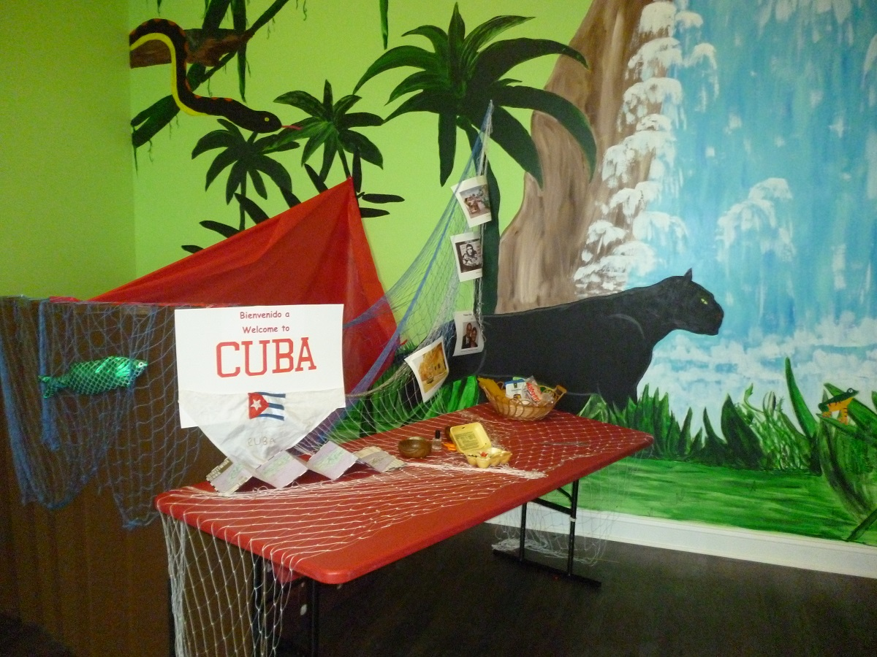Country info - A large tropical island <100 miles south of Florida. Communist country for over 50 years under Dictator Fidel Castro (now his brother Raúl); NO free enterprise (so no advertising or independent businesses) so all work is for the government and everyone gets paid about the same (less than $20 per month); children have to renounce Christ in school and embrace communism and often Christian children are not allowed to graduate or go to college; from middle school age all children sent to boarding schools in the countryside and only return home for holidays a few days each year; everyone must serve in the military for at least 2 years; until very recently NO new churches could be built and there are many hindrances for Christians who may only be given the poorest jobs or may have government permits held up for years; bibles and Christian literature are strictly controlled and smuggling them can lead to imprisonment; there is free medical treatment but the government does not maintain the roads or buildings, leading to sewage in the streets and crumbling buildings; because of a long ban on car imports, most cars are over 50 years old; most Cubans are very poor (unless they receive money from relatives abroad) and they eat barely enough food to survive (although food and other items are available in some stores the prices are way too high for most people). Show sample of monthly ration provided by government for each person at a cost of about $2:
5 eggs; 8oz cup of cooking oil; 5lb rice; 8oz dried beans; 4lb sugar; 1lb spaghetti; 8oz chicken (but all items not always available). In early 2015 the USA made changes to improve relations with Cuba so it is hoped that soon the situation there will start to improve and life for the people will get better.

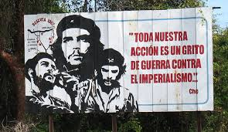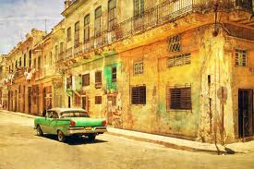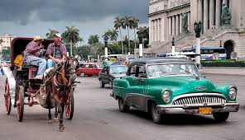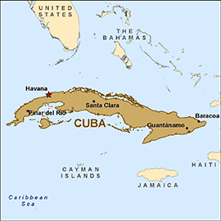

Map of Cuba Cuban transport Typical Cuban street Typical Cuban billboard
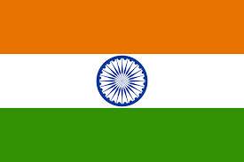India (IMOF contact there)
Lengths of brightly colored silky fabric, incense, pictures of Hindu gods, Indian bread to taste
Craft - each child can put together the photocopied pages of the Promise Book in Telugu and then get it stapled. They can be sent to our contact in India to distribute to Christian children.
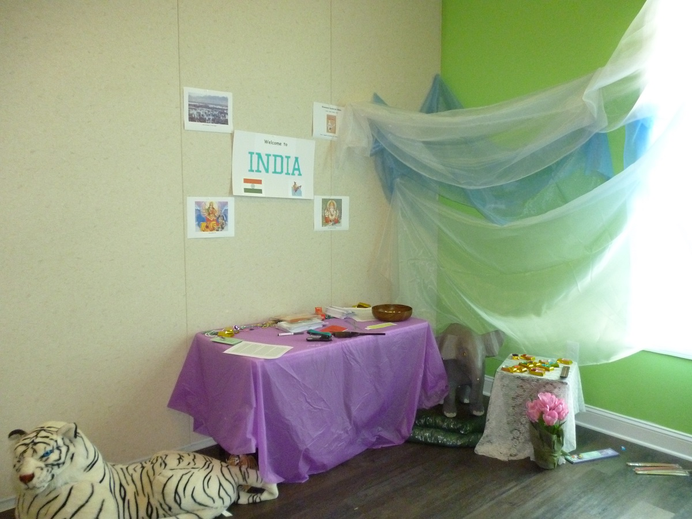
Country information - India is the large triangular-shaped country that dominates South Asia and the Indian Ocean. Its population is well over a billion, with world’s largest population density of 364 people per sq.km. Over 4,000 distinct people groups with different culture and caste, speaking 213 different languages, although Hindi is most widespread and English common in many parts. Over 900 million people live in poverty, with more than 400 million children under 18, (70 million as child laborers), 10 million are bonded servants (paying off their parents’ debts) and over 15 million children are homeless or on the streets. Hinduism (3rd largest world religion) is mostly found in India where 80% of the people are Hindu and worship millions of gods. Their beliefs are wide-ranging, but they believe in reincarnation after death – sometimes as animals or insects and not just as people. Hinduism is widely perceived as a religion of peace and tolerance, influencing around the world through Hare Krishna, yoga and New Age teachings, but Hindu fanatics often attack and kill Christians. The main gods are Brahman, Shiva and Vishnu, but many animals are thought sacred and so cannot be killed – such as cows, snakes and even rats! The River Ganges is considered divine water able to heal and wash away sins. Millions flock to its banks daily to bathe in it and even drink it – although it is terribly polluted, even with the bodies of dead animals!
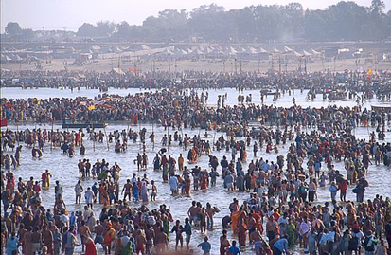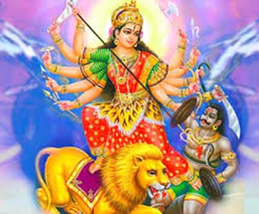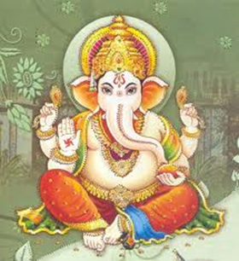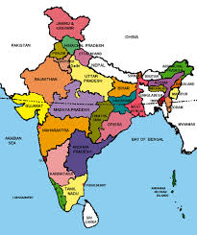

Map of India Hindu elephant god Ganeshu Hindu goddess Kali Hindu worshippers in River Ganges
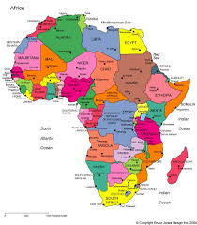
Africa (IMOF contacts with orphanage and children's ministries in Togo, Kenya and C.A.R.)
"Refugee hut" built of scraps of wood, plastic, fabric; pictures of African idols; plate of cooked maize (ugali) to taste
Craft - Demonstration of how to make a "little dress for Africa" from a pillowcase. Give each child a copy of the simple pattern and directions so they can make one at home if wanted.
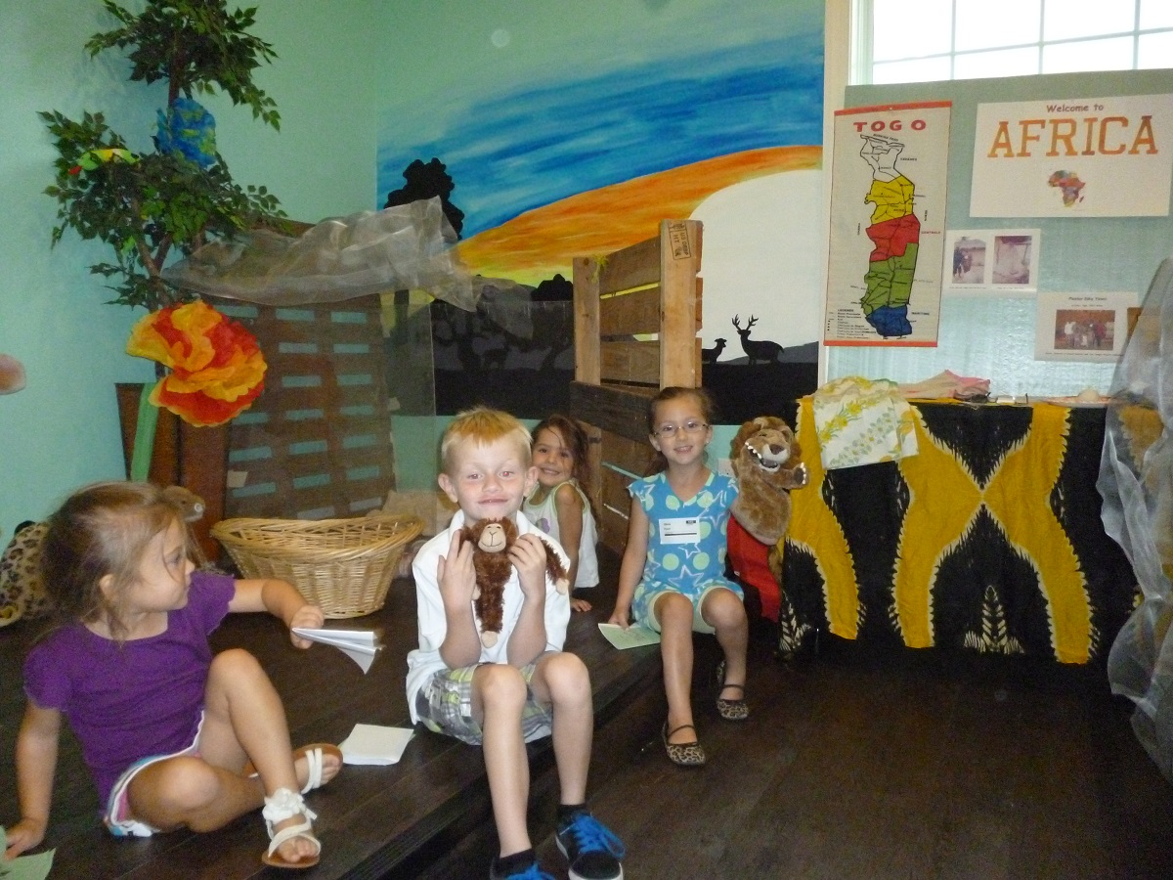

Country information - It is actually a continent with 54 countries and over a billion people, but is 20% larger than the whole of North America. There are over 3,000 different tribes, all with different languages, but many countries have English, French, Arabic or some other well-known language as their official language (depending on historic colonial ties). Much of Africa is desert (causing harsh living conditions and famine) and the Sahara Desert alone covers 3.5 million square miles and 12 countries. But with also huge areas of mountains and impenetrable jungle, much of the continent still cannot be reached by roads, electricity or civilization. North Africa is mostly Muslim, although Christianity is common in the rest of Africa due to centuries of missionary work - but often Christian beliefs are mixed with traditional animistic customs and many people believe in witchcraft and the power of local idols. Many governments are unstable and led by a dictator, and often wars or famine cause millions to flee their homes and live in makeshift refugee camps elsewhere. Poverty is commonplace in Africa, and children suffer especially from malnutrition and lack of schooling; diseases kill or orphan millions of children each year.
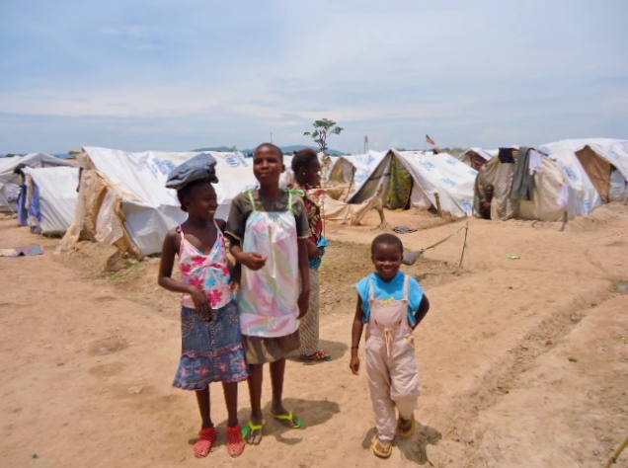Recipe for Ugali (also known by many other names: Bring 2 cups water and 1 teaspoon salt to a boil in a saucepan. Stir in 1 cup cornmeal slowly, letting it fall though the fingers of your hand. Reduce heat to medium-low and stir regularly, smashing lumps with a spoon, until the mush gets thick and forms a ball, about 10 minutes. Remove from heat and allow to cool. Wet your hands with water, form into a ball and serve (usually eaten with fingers from a common bowl).
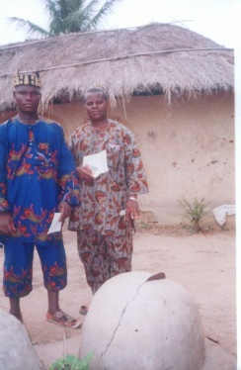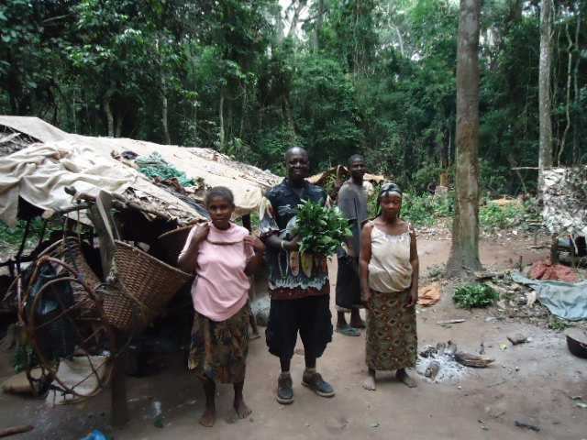
Little dresses With chief In a Pygmy
given to girls and village village in
in a refugee idol in Togo Central Africa
camp
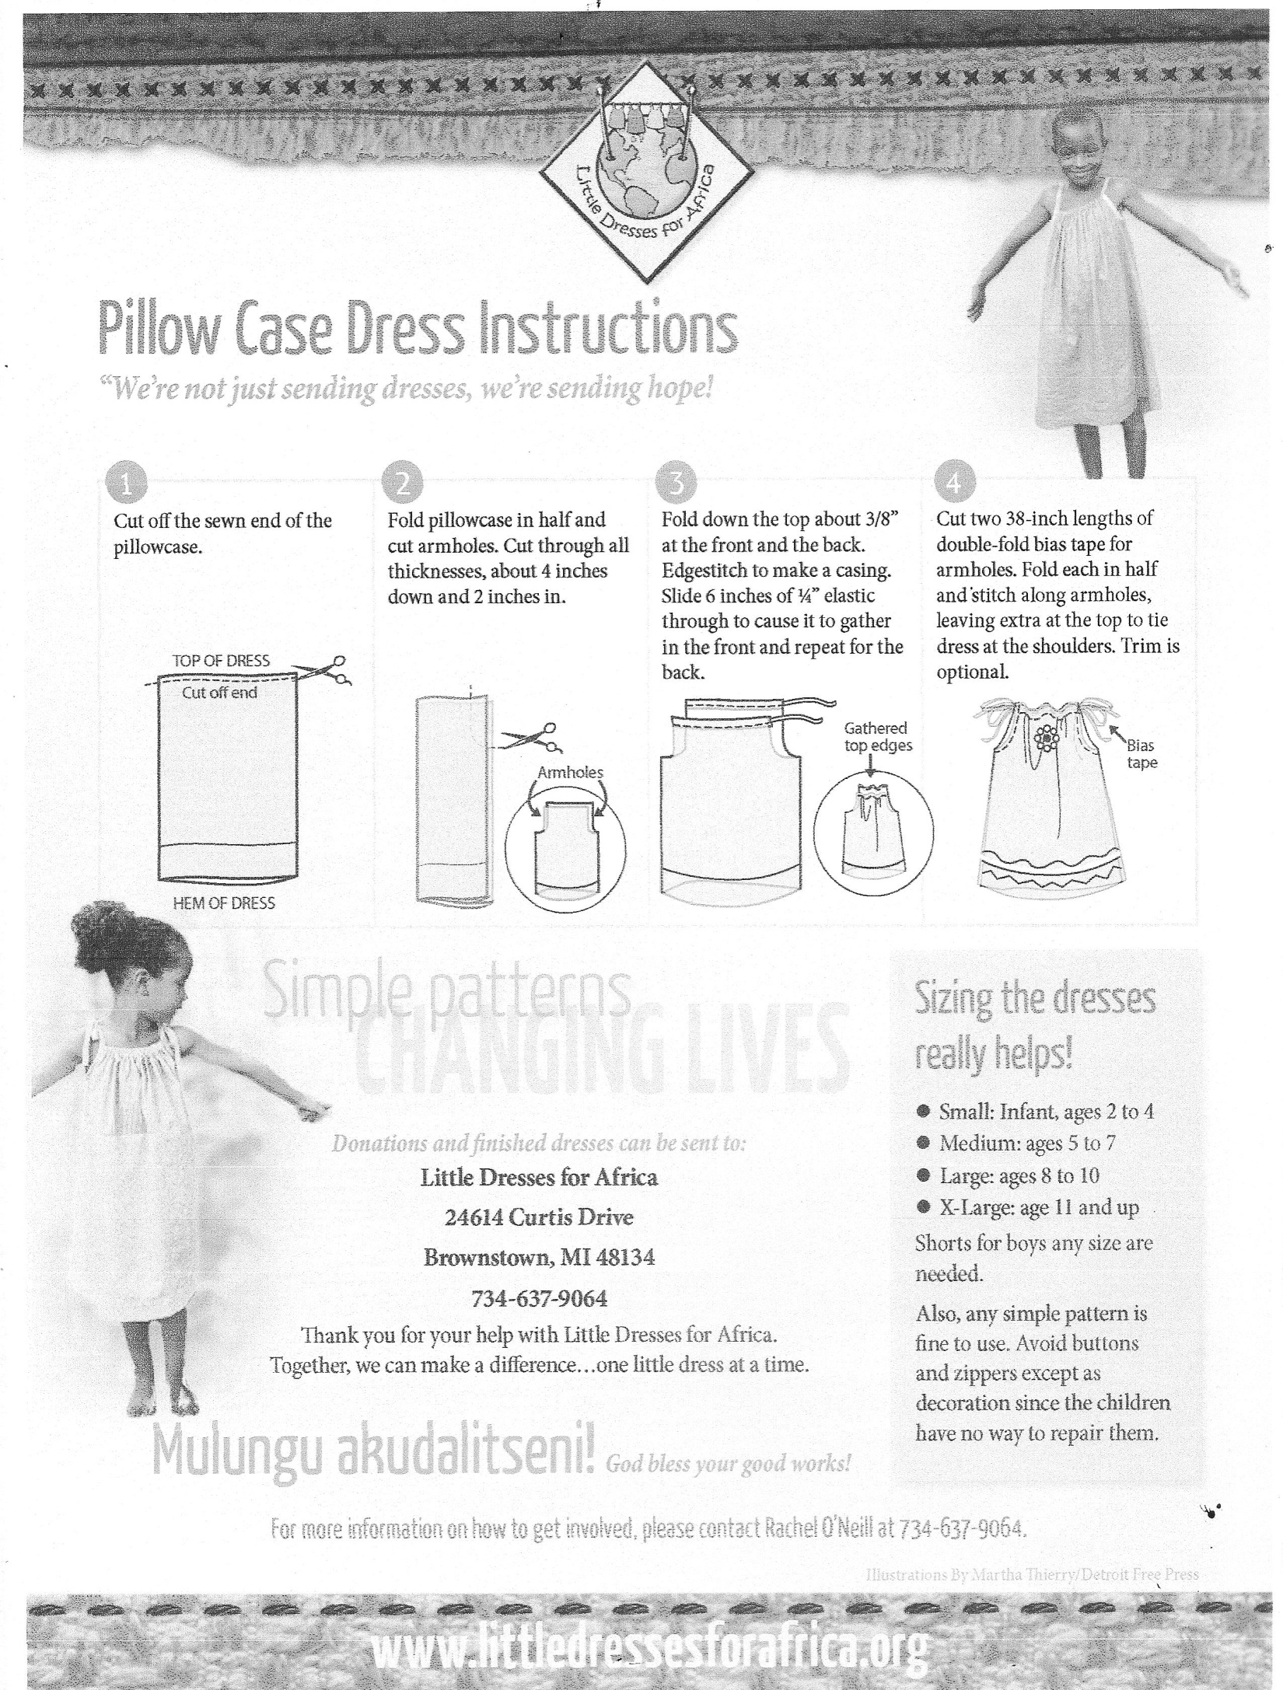
Africa
Mexico
This passport belongs to:

Valid:

9/6/2014 – 9/7/14

India
Cuba

Africa
Mexico
This passport belongs to:

Valid:

9/6/2014 – 9/7/14

India
Cuba

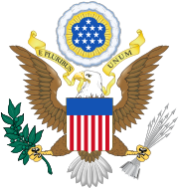
United States of America
Passport

Local church contact info

United States of America
Passport

Local church contact info

