Annual report from Michael Mwanikha New Year 2014
Praise the lord for bwana asifiwe
We are very much grateful to God for helping us the year 2013 and also we are thankful for all our supporters who came in with financial support and prayers and plus advice and even sending us teachings.
The year 2013 we did a lot together with God; I mean we managed to give out more than 400 bibles in school to teenagers both boys and girls and it really encouraged them very much we began with full bible and ended up with new testament bibles praise be to God for all that supported this project mainly Karen and Merrill.
We have school ministry in the past years as we have been giving you monthly report and we have seen hundreds of teens giving their life to Jesus and even when schools are in holidays have been getting phones calls from students are doing well and are happy in the lord.
Again children’s ministry along side school has been very good though last year we did very little of children ministers training, but towards the end of the year we managed to do several trainings here and even during our big annual children’s camp 2013.
In general we have done ministry to more than 15 high school and about 7 primary school and made long trips to Uganda and southern nyansa Kenya , we thank God for all this. Without also getting your attention to crippled children ministry which we have been always being involved for more than 10 years ( we visits open clinic where this children are brought to meet the doctors and we share the word of Hope to them and encourage their parents and we have seen a number parents giving their life to Jesus through this ministry; we would like to say a word of thank you for saints who have been sending stickers- it may look small gift but it makes this children we minister to smile and be happy”
The year 2013 and God willing this year 2014 we would like to keep on doing jiggers campaign in our community (you can google the word jiggers) we only need 150 Dollars to help more than 1400 children in a school and also the community and this opens door for the ministry of the love and the word of God please do pray with us.
This should now get us into prayer points
Pray that the year 2014 we shall expand even the more into more schools and churches and villages with the word of God.
Pray for jiggers campaign this one is a great door to families and homes for Jesus
Pray for my family we are adding another Irene’s sister whom she feels she go back to school Kenyan way (she is a Ugandan) to help her in future to attain training that will brighten her future
Pray for the peace of Kenya - recently we have had lot of attacks on our nation
Pray that we would be able to give more bible to teens (for when they have the word with them it’s easy for them to study the word at their own)
We would like to say a big thank you to director Shirley she has really directed us well, Mama Merrill I call her voice of Kenya mama, mama Karen, Kathy a lady of faith with golden heart, Anna Williams family and my wife and kids and the local church I go to sometimes I spent months without being there, and schools heads and chaplains for allowing me to share the word of God to students
Am here also to say a word of thank for Friends here whom we have been ministering together this are Anthony Francis and Pastor Mercy praise be to God for this great team, together with them we have been able to do great things .
God bless you friends and you can check on the below ink to see what we are doing and if you would like to receive monthly updates also register here www.imofinc.org then click Kenya

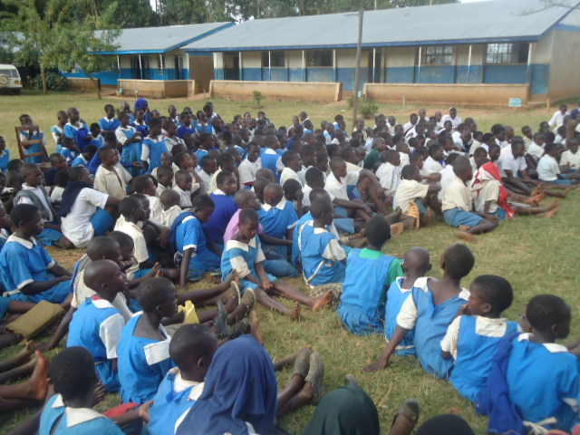Michael Mwanikha wishing you blessed new year.
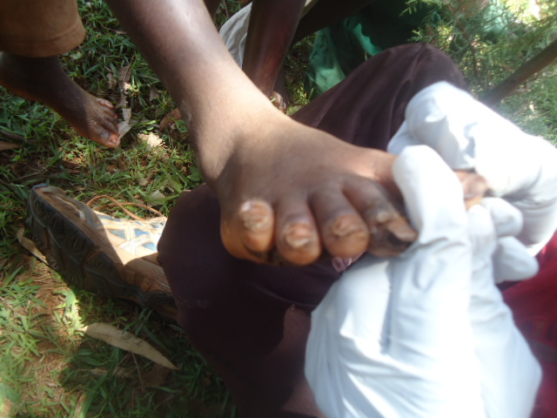

Jiggers removal - we also hope to do this in 2014 Ministry to primary schools. We are ready to sit and listen
to the word of God
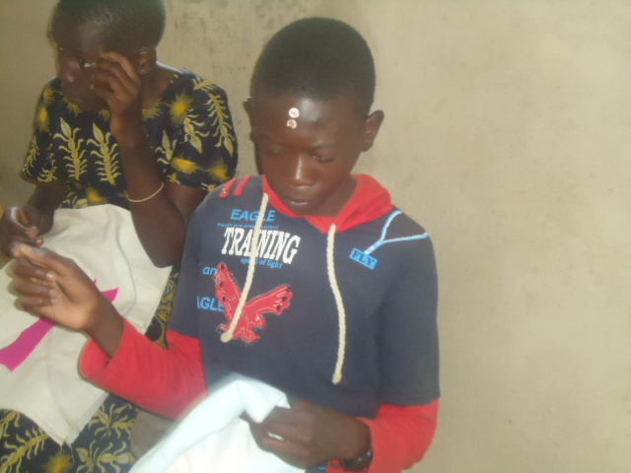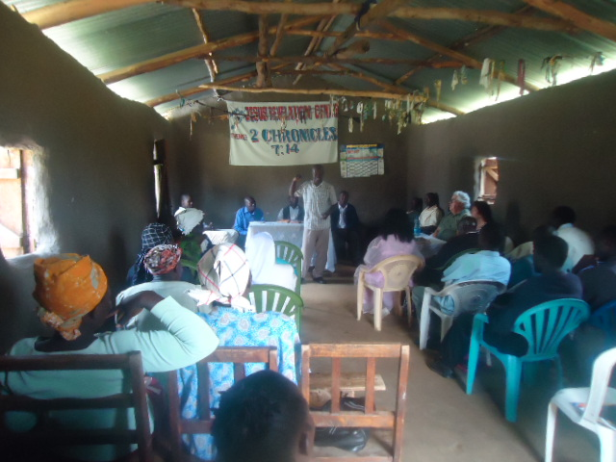

Ministry to church leaders about the importance of Children doing hand work at church - children ministry in the local church at Naitiri amazing its never done, but your support helped us do this
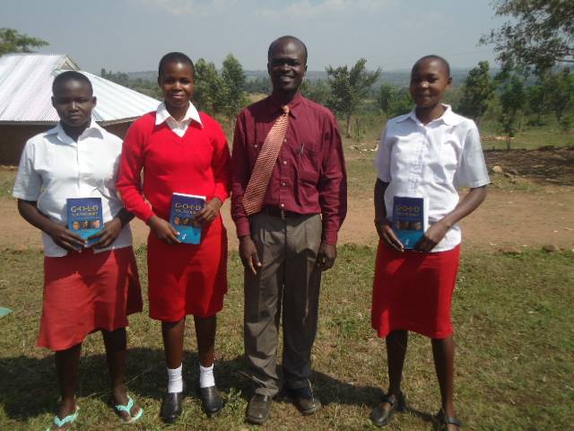
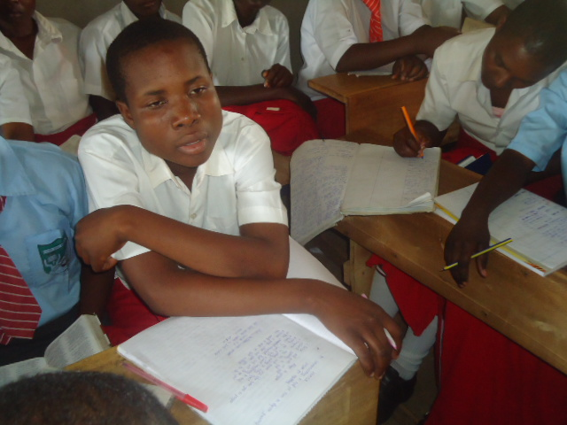

Ministry to high schools, we reached about Bibles given to students selectively for they were few,
12 high schools, this year we can reach more pray that we get more bibles for our boys and girls in school. For they are the future of Kenya, say with me “ the tomorrows Kenya with bibles in their hands”

