1. JOSEPH - RIGHTEOUSNESS AND PATIENCE

1. Key Bible Verses

Genesis 37:1-8 Joseph wants to do right - God prophesies to him - his brothers are jealous

Genesis 37:18,22,28 His brothers want to kill him but instead sell him into slavery

Genesis 39:1-4 As a slave, he works hard, is blessed by God and given responsibility

Genesis 39:6b-10 Joseph overcomes temptation and recognizes the sin would be against God

Genesis 39:17-23 He is thrown in prison because of a lie but God blesses and gives him favor

Genesis 41:1-4,14,28-30,39,40 Joseph interprets Pharaoh’s dream and is given charge of Egypt
Genesis 41:46 Joseph respects his position and doesn’t try to run away home

Genesis 42:3,6-8 His brothers come to Egypt to buy food

Genesis 43:29,30 Joseph weeps when he sees his younger brother

Genesis 45:1-5 Joseph forgives his brothers and understands that God had a plan all along

2. Discussion

Joseph had many opportunities to complain and become bitter and unforgiving. Life was very unfair to him - in what ways? Was it fair that his brothers treated him so badly for being obedient? Has anyone here been treated badly for being good? How?
How many years passed between Joseph’s arrival in Egypt as a slave and his being made leader of the country? (13) Why do you think he didn’t leave Egypt and return home when he had the opportunity? (He believed God had a plan and respected authority)
When do you think he forgave his brothers? (Soon, because bitterness and an unforgiving heart through the years cause many problems)
This story shows us the importance of trusting in God and being obedient, in spite of our problems and the unfairness of life.

3. Game

On blackboard or large paper, everyone tries to make up a crossword using as many words as possible from the story such as: FORGIVE
O GOD
PRISON Y
D POTIPHAR
T
2. JOSHUA - OBEDIENCE AND FAITH

1. Key Bible Verses

Exodus 17:9 Joshua is chosen to lead the Israelites when they fight in the wilderness

Exodus 24:12,13; 33:11 He helps Moses during important spiritual events

Numbers 13:16 He is sent as one of the 12 spies to go into the Promise Land

Numbers 14:6-9 With Caleb he believes in the help and protection of God to take Canaan

Numbers 14:26-30 Because of their faith Joshua and Caleb are allowed to enter the Promise Land although they have to wait 40 years

Deuteronomy 31:7 Joshua is made leader of the Israelites to succeed Moses

Joshua 1:1-9 God’s commandment and promise to Joshua

Joshua 3:7,8,15,16 God performs a miracle to confirm the leadership of Joshua

Joshua 6:2-5 An unbelievable plan of warfare - without weapons or understanding

Joshua 6:20 Obedience brings victory

Joshua 11:23 Joshua fulfills God’s plan to conquer the land and is victorious over 31 kings (Joshua 12:24), finally accomplishing peace

2. Discussion

What type of man was Joshua? (faithful servant, courageous soldier, wise leader, trusted and obeyed God completely - a true hero and excellent role-model)
How did he become like this? (he learned from Moses; when he didn’t know what to do he asked God; he talked with God, meditated on the Word and obeyed God and because of this he received God‘s blessing - Joshua 1:6-9)

3. Game

Write each word of the following scripture on a separate piece of paper. Do this three times and mix up the parts of each scripture. Divide the group into three teams. They have to rearrange the words in the correct order to form the scripture.
“Joshua 1:9b - Be strong and courageous. Do not be terrified; do not be discouraged, for the Lord your God will be with you wherever you go.”

3. GIDEON - HUMILITY AND COURAGE

1. Key Bible Verses

Judges 6:11 Gideon is threshing wheat in hiding for fear of the enemy

Judges 6:12,14,15 God calls him “mighty warrior” and has chosen him to lead Israel into victory against the enemy, although he’s the least likely

Judges 6:17, 20,21 Gideon cannot believe it and asks for a sign - sees a miracle

Judges 6:25-27 He still has fear, but obeys the Lord and destroys the altar to Baal

Judges 6:34,35 The Holy Spirit comes on Gideon giving him boldness and favor

Judges 6:36-40 Again Gideon has doubts about his ability and asks another sign - the fleece. God answers by another miracle

Judges 7:2-7 God reduces the men from 32,000 to 300 - Gideon courageously obeys although the enemy totals about 135,000 (Judges 8:10)

Judges 7:9-11,13-15 God knows Gideon is still afraid and encourages him

Judges 7:16-18 The plan - appears ridiculous without weapons, trusting only in God

Judges 7:20-22a The terrified enemy all panic and kill one another!

Judges 8:22,23 Gideon refuses to be king saying that God is the only king

2. Discussion

Gideon is a perfect example of humility - why? (His amazement at being chosen as a leader, awe at the responsibility of leadership, obedience and total trust in God in spite of fear and lack of understanding, open recognition that God gives victory).
How can we apply what we’ve learned from this story to our own lives? Often we see needs or are aware of a bad situation but no-one does anything about it - we may want to but have fears and doubts about our own ability. What should we do? Discuss examples such as being in a group that is making fun of another student or teacher; seeing an elderly person in need but everyone else is embarrassed to help; standing up for what we believe is right when we are alone.
Each person can be challenged to do something special in the following week - e.g. hand out tracts and talk about Jesus to 3 or 4 friends; visit an elderly neighbor to encourage them and share the love of Jesus. Pray for boldness and empowerment from the Holy Spirit to overcome fears and doubts.

3. Puzzle (see over)
HOW MANY WORDS FROM THE STORY OF GIDEON CAN YOU FIND?

X X X X X A X X X X X X X X X
X H X X F L E E C E X X X X X
X U X X X T X X X X I X A X X
X M I D I A N I T E S X N X X
X I X X X R X X R X R X G O D
X L X X X X C O U R A G E X R
G I D E O N X X M X E X L X E
X T X X X I X X P X L X X X A
X Y X X X G X D E W X X W X M
X X X X X H X X T O R C H X X
X X X X X T X X X N X X E X X
X X X X X X X X X X X J A R X
X X X X X X X X X X X X T X X

(answer - 17)

4. SAMUEL - PURITY AND RIGHTEOUSNESS

1. Key Bible Verses

I Samuel 1:20,24-28 Hannah keeps her vow to God and takes Samuel (age 3 or 4) to live in the temple with the priests and serve God

I Samuel 2:11,18-21 Samuel is raised by the priest Eli and is visited each year by his family

I Samuel 2:12,17,22-25 Samuel’s only companions, the sons of Eli, were wicked and sinned greatly, disobeying both their father and God

I Samuel 2:26 But Samuel was not led astray into sin but continued to grow in the Lord

I Samuel 3:1-10 God speaks to Samuel by night although he is so young and doesn’t yet know the Lord

I Samuel 3:11-18 God begins to use Samuel as a prophet

I Samuel 3:19-21 Samuel is recognized by all Israel as a prophet of the Lord

I Samuel 10:1; 16:13 Samuel is directed by God to anoint first Saul and then David as king

2. Discussion

Do you believe that it’s possible to grow up among wicked people, or in a bad family, yet still be faithful and follow Jesus? Samuel did it - he saw many sinful things, he knew the truth about Eli’s sons and probably was invited by them many times to participate in wickedness, maybe mocked because he didn’t. He is a good role-model for us today, to encourage us not to be led astray by others around us. Many people today want to use their background as an excuse - what do you think?
God called Samuel when he was very young and still didn’t know God. What does that show us? God wants to use children and young people and doesn’t wait until they are adult or until they know a lot about the Bible.
Share experiences about recognizing God moving in our lives, or speaking to us.

3. Game

Divide into 2 or 3 teams each with pencil and paper. Write the word RIGHTEOUSNESS at the top. Each team has to write words of more than 3 letters made from the letters in the key word e.g. tree, snore, house, session etc. The team with the most words wins.

5. DAVID - COURAGE, HONOR AND REPENTANCE

1. Key Bible Verses

I Samuel 16:10-13 As a boy tending sheep, he is chosen by God and anointed to be king

I Samuel 17:34-37,45,47,50 David has courage to fight Goliath because he has learnt to trust in God’s protection and knows Goliath defies God’s people

I Samuel 18:5,14 David is faithful to serve King Saul

I Samuel 18:8-12 Saul is jealous of David and wants to kill him

I Samuel 18:30 David continues to be victorious and grows in fame

I Samuel 24:2-7 David has opportunity to kill Saul but doesn’t do so out of respect

I Samuel 26:9-11 Again David refuses to kill Saul, believing it is God’s responsibility only

2 Samuel 5:4 Finally David becomes king at the age of 30

2 Samuel 8:13-15 David wins more victories and is a good king

2 Samuel 11:1-5 David stays home from war and sins with Bathsheba, later having her husband killed

2 Samuel 12;13,14 The prophet Nathan confronts him with his sin, and David immediately repents and accepts God’s punishment

Psalm 51:10-12 David’s desire is to be restored to God

2. Discussion

Why was David a hero? (He was strong and courageous, killed thousands in battle, was loved by the people - someone like Arnold Schwartzeneggar). But also he was a good leader and showed respect - he refused to kill the king.
Was he perfect? No, when he had accomplished everything, he relaxed and fell into temptation - the danger of sitting back at ease. It’s important to always be alert to the enemy - Satan never rests from tempting us or taking advantage of opportunities to lead us astray. How can this apply to the lives of young people today? (e.g. being innocent but being in the “wrong place at the wrong time”; trying to save sinners when we ourselves are not yet strong Christians)
Why is David remembered as being a friend of God and the greatest king of Israel? He recognized the importance of repentance and maintaining a perfect relationship with God.

3. Puzzle (see over)

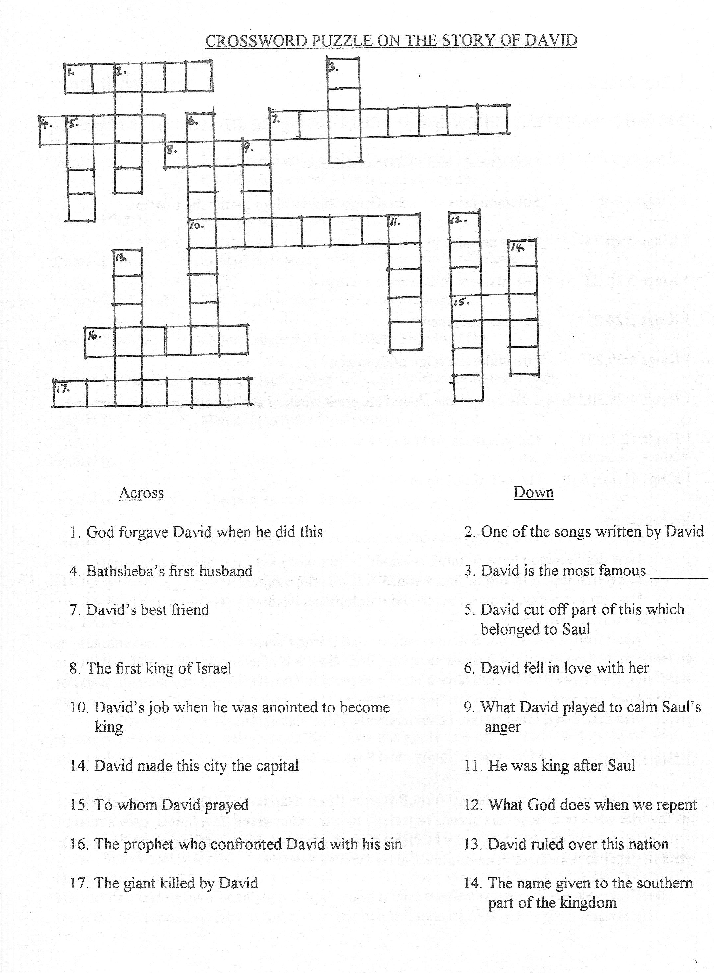
6. SOLOMON - WISDOM AND KNOWLEDGE

1. Key Bible Texts

2 Samuel 7:12,13; 12:24,25 He is chosen by God to be king after David and to build the temple

I Kings 3:5 God appears to Solomon in a dream

I Kings 3:7-9 Solomon asks for discernment and wisdom to rule the people

I Kings 3:10-14 God’s promise to Solomon

I Kings 3:16-22 The first test of Solomon’s wisdom

I Kings 3:24-28 His wise judgment

I Kings 4:20,25 Life under the reign of Solomon

I Kings 4:29,30,32-34 He taught and shared his great wisdom and knowledge with everyone

I Kings 10:23-25 The greatness and fame of Solomon

I Kings 11:1-3,7-10 The fall of Solomon

2. Discussion

How did Solomon have so much wisdom? (He asked God for it to help him reign)
In his first test, how did he know which was the true mother?
How do we, today, know so much about Solomon’s wisdom? (He wrote the book of Proverbs - full of wise advice)
Apart from his wisdom, Solomon studied and learned much about nature and animals - he understood the importance of not just receiving from God, but of using his own natural ability to study and learn more - we should have a hunger to grow in knowledge and understanding and be willing to do our part, and then be willing to share that with others. However, God’s wisdom is greater then man’s and often cannot be understand by the “natural man”.

3. Bible Search

Assign each student a chapter from Proverbs (from chapters 10-31) to read and choose his favorite verse or a verse that speaks especially to him. After about 15 minutes, each student reads his verse and comments on why he chose it. Everyone can write out their verse on a blank sheet of paper to remember them or pin them on the wall.

7. DANIEL - COMMITMENT AND COURAGE

1. Key Bibles Verses

Daniel 1:3-6 Daniel is chosen to be prepared to serve King Nebuchadnezzar in Babylon

Daniel 1:8 He requests only simple food because he is Jewish and wants to continue to obey the laws of Moses concerning food

Daniel 1:12-16 The test and the results

Daniel 1:17,20 God blesses them with wisdom and intelligence

Daniel 2:1-5,11-13 The king’s dream - impossible to interpret

Daniel 2:16-18 Daniel trusts in God and asks Him for help

Daniel 2:19,27,28 Daniel explains that God has the answer to the dream

Daniel 2:47,48 Daniel is given a high position in the land

Daniel 6:3-5 His faithfulness earns him grace with the next king and others are jealous

Daniel 6:7-9 The plot against Daniel

Daniel 6:10,11 Daniel’s courage - he continues to pray openly in spite of the danger

Daniel 6:16-24 God saves Daniel and it brings glory to God

2. Discussion

In what ways did Daniel live in accordance with the will of God? How did God support and help him? When we trust and obey God, we often find ourselves in a situation that tests our faith - but God is faithful if we do not give up. Share testimonies of this.
Why did the other leaders become angry with Daniel? (They were jealous of the blessings he received for being good) How does this apply to our lives today? How do we feel when others cause us problems because we have been good? How should we handle this?

3. Game

Daniel 6:22 “My God sent his angel.....because I was found innocent”
Divide the text into 12 parts and number each from 1-12. Using a prepared cloth or chalk on the floor, mark 12 squares (3 x 4) numbered 1-12. Each student in turn must stand behind a marked line and throw a beanbag trying to make it land inside a square. When accomplished, write the corresponding part of the text on the board. Students must guess the complete text.

8. RUTH - LOYALTY AND OBEDIENCE

1. Key Bible Verses

Ruth 1:3-6 Ruth is a gentile (Moabite) but her mother-in-law is Jewish

Ruth 1:8-10 Naomi encourages her daughters-in-law to return to their families

Ruth 1:16-18,22 Ruth’s promise - she wants to follow Naomi and God

Ruth 2:1-3 Ruth works to find food and “by chance” ends up on Boaz‘ land

Ruth 2:5-12 She finds favor with Boaz because of her unselfishness and loyalty

Ruth 2:14-18 Ruth is blessed and takes food to Naomi

Ruth 3:1-6 Her obedience to Naomi’s suggestion

Ruth 3:10,11 Boaz is touched by Ruth’s good character

Ruth 4:9,10 Boaz fulfills the law and marries Ruth

Ruth 4:13-17 Ruth gives birth to Obed who will become the grandfather of David

2. Discussion

Was Ruth a Jew at the beginning? No, but God chose her to be very important as the great-grandmother of King David, and an ancestor of Jesus. He chose her because of her loyalty to Naomi and her acceptance and obedience to the laws of God in spite of her own desires. If she had not submitted to God, how might the story have been different? (Stayed in Moab, been unwilling to help Naomi, looked for a younger, more handsome man to marry...) Our family and position in life are not important if we are faithful to God, and He will use us and bless us.

3. Puzzle

The students must change the vowels in the following paragraph to be able to read a passage from the story (without using bibles):

“DEN’T ARGO MO TA LOOVA YEA UR TI TORN BUCK FRIM YAI. WHARI YOE GU O WALL GA, END WHIRO YUI STOY O WELL STUY. YAIR POUPLI WULL BA MY PIAPLO OND YEIR GID MY GAD. WHARO YEA DOU A WALL DUE, END THORA O WELL BO BAROOD. MUY THO LARD DOIL WATH MA, BO AT OVIR SU SUVAROLY, OF UNYTHANG BAT DOITH SOPIRUTAS YEA UND MO.” (RATH 1:16,17)

9. HANNAH - COMMITMENT AND FAITHFULNESS

1. Key Bible Verses

I Samuel 1:2,6,7 Hannah is very sad and is mocked because she cannot have children

I Samuel 1:10,11 She prays and asks God for a son and makes an oath to God

I Samuel 1:12-16 The priest doesn’t realize Hannah is praying and thinks she is drunk

I Samuel 1:17,18 He speaks a blessing over her and she believes God has heard her prayer

I Samuel 1:20 God answers her prayer by a miracle and Samuel is born

I Samuel 1:24-28 Hannah fulfills her promise to God with joy

I Samuel 2:19 She faithfully visits Samuel each year and makes him clothes

I Samuel 2:20,21 God blesses Hannah with more children because of her faithfulness

2. Discussion

Who has promised to be good or do something special if they could get want they wanted so much? Then who has forgotten to follow through with their promise later, or had lots of excuses why they couldn’t keep their promise?
Many times we are willing to help or promise something, but when the circumstances change or there is an opportunity to do something better, we change our minds. This is a test of our integrity, our commitment ,our word. How do you think Hannah felt when she finally held her own baby, but remembered her promise to God? What would you have done?
How can we overcome this temptation to not keep our word? (Think more before we speak, decide if we will still be willing to keep our word if the situation changes) How do you feel when someone promises to help or do something with you, then doesn’t keep his word? As Christians our integrity, keeping our word, is our most important witness.

3. Game

Write each letter of the word INTEGRITY on a separate piece of paper and place them in a sack. The students sit in a circle and the sack is passed around to music. Each time the music stops, the student with the sack removes a piece of paper. At the end, they must rearrange the letters to form the word correctly.

10. ESTHER - COURAGE AND FAITH

1. Key Bible Verses

Esther 2:5,7-10 Esther is Jewish and because of her beauty is taken to the palace for a beauty contest, where the king is going to choose a new wife

Esther 2:17 She is chosen to be the new queen

Esther 3:2-6 Haman decides to kill all the Jews in the land

Esther 3:8-11,13 The plan

Esther 4:1-4 Mordecai is mortified because it is his fault

Esther 4:10-14 Esther explains to him the law and Mordecai answers that Esther has a chance to save the people

Esther 4:15-17 Esther agrees to help in spite of the danger - she asks for prayer and fasting

Esther 5:6-8 Esther finds favor with the king and invites him to a banquet with Haman

Esther 5:11-14 Haman plans to hang Mordecai

Esther 7:1-6 Esther pleads for the lives of her people

Esther 7:9,10 Haman is hanged for his wickedness

Esther 8:2,8,11,15,16 The Jews are saved and Mordecai is given a high position in the land

2. Discussion

Why was it dangerous for Esther to talk with her husband? What do we know about the king’s character? (had problems with rage, judged quickly instead of finding out all the facts)
Do you believe the prayers and fasting of the people affected the situation?
When we pray for a situation which later turns out well, we never know how it may have turned out without the prayer - some people say the prayer made no difference, but there are many testimonies of situations changing dramatically when prayer is involved. (Share testimonies) Also Jesus taught of the importance of prayer and fasting.

3. Puzzle (see over)



