TOGO ACTIVITIES REPORT OF FIRST QUARTER 2016

Dearly Beloved in Christ, sister Shirley and prayer partners

Greetings!
Hereby receive my sincere greetings in Jesus Christ. I would like to seize this opportunity to break the moment of silence and to inform you about all the activities which have been carried out in Togo. As usual, none of our activities have been brought to a successful end without your prayers and financial support. God has enabled us to create, in the course of this year, two new churches in two villages which are hostile to the Gospel.

First New Church or the Year in a Village Called Fiokondji

Fiokondji is located in the South Eastern Togo, about 50 km from Lome which is the capital. It is a village dominated by paganism. Every house or so is equipped with idols and the village is renowned for the worshiping of these idols. So many children in this area are denied access to education as they are thought to be taking over their parents in idol worshiping in the future. Churches and schools are therefore seen as threats to perpetuating the traditions of idol worshiping.
Our visit to this area was possible thanks to the director of a school who invited us to share the gospel with the people, given the dark future awaiting the whole village. However, the villagers could not grant us a good welcome. We were not received and were chased away two times. Our third visit was with SHOEBOXES and by the grace of God, we were warmly welcomed. Following the preaching , 15 people gave their lives to Jesus Christ in addition to 42 students.
See here below, some of the pictures of his preaching and of the decision taking time of the newly converted souls.

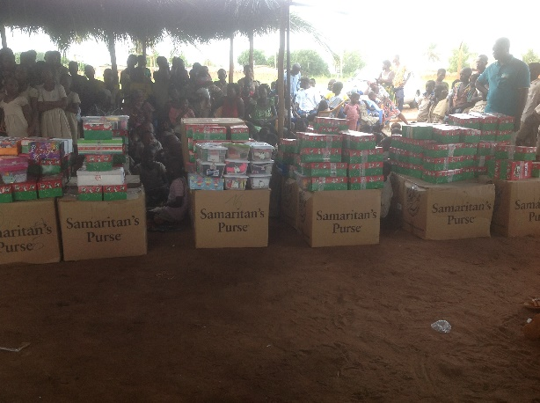
Shoeboxes opened us the door to reach these people…

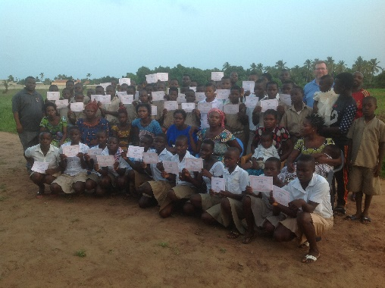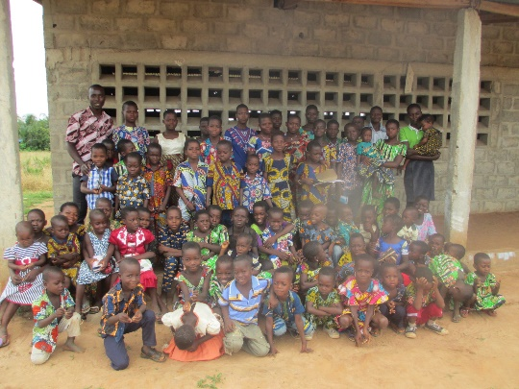
60 people confessed Christ …. The church is growing up with 75 saved
After our third visit to this village, we express our gratefulness to the Lord for providing a brother who undertakes a two-time weekly visit for the follow up of the saved souls. Today, the Lord has blessed the new church with 80 people, all of them attending the Sunday morning service. The school of the village serves as the worship place of the new church and we use one of the classrooms for this purpose. Unfortunately, we are constantly threatened by some of the village authorities to stop any church activity in the school. So now, we really need your prayers for the purchase of a plot of land which will serve as the place for building of our new church. This is hence a pressing need to save the people of this village who really need salvation.

- Heart Cry of a Village in Need of Salvation
Here, things all worked like a miracle. My visit to the village of Kovie was in response to the SOS alert of a school director who pleaded with me to come and preach in his school. This school belongs to the government and I was really surprised to be invited to preach the Gospel to the students there. Kovie is a village which is more hostile to the Gospel than the first one. I started teaching and ministering to the kids through our Bible Courses. Today I am ministering to about 400 students. About 80 of them have confessed Jesus Christ. There is a pressing need to send a laborer to the field and to find financial support for him. For the meantime, the director of the school has provided us with some classrooms where to worship every Sunday.
The pictures below show the activities undertaken in this village.

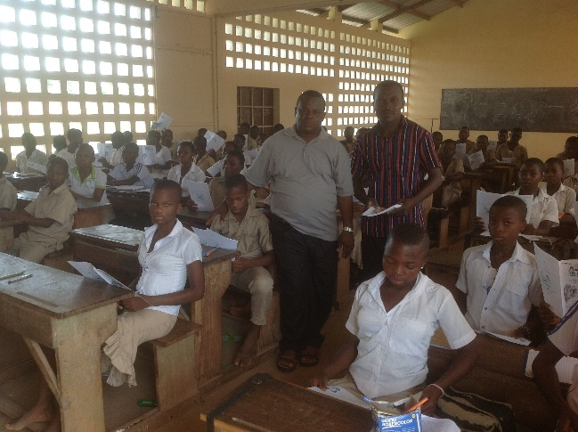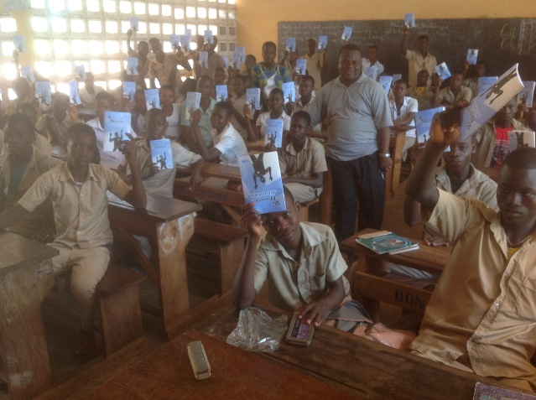
Bible lessons study inside the class…. Almost 400 souls come to the Lord
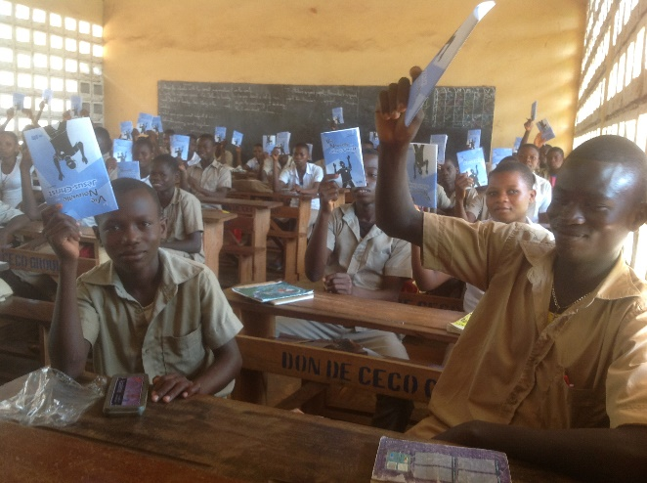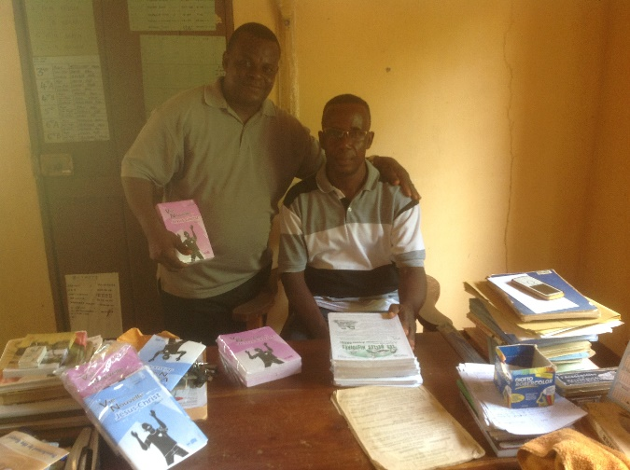
Bible lessons students School Director office with Pastor SIKA

`
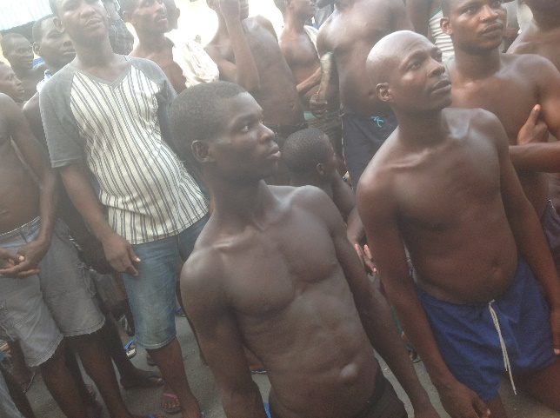
Visit of Prisons in Togo: the prison of Aneho city inside the country

….. A good testimony received recently by Kofi one of prisoners……

Pastor SIKA your bible lessons have forced me to confess my sins and receive Jesus as my Lord and Savior because I had read and filled almost 3 of your bible course without spiritual consideration but the biblical course speaking about ‘’ New life in Christ ‘’ touched my hard heart when I read about the works , destiny and personality of the devil because I was a strong animist and witchcraft and I often killed people physically and spiritually. And it is for this reason that I am now in prison.
I know that I'll spend all my years here in jail but I have joy because I have an eternal guarantee even if Togolese justice not lay me today . And I am sure and believe that my name is written in the book of life. .
I have Jesus Christ in my life and I am ready to die and go see my Lord. Many thanks for your biblical lessons.
From the Prison of Aného , your brother Gilbert / TOGO.

PS . Please let pray for this brother .

- Activities of the Operation Christmas Child

- Shoe Boxes Distribution in a Muslim Dominated School. The distribution of the boxes provide the opportunity to share the Gospel with those students.

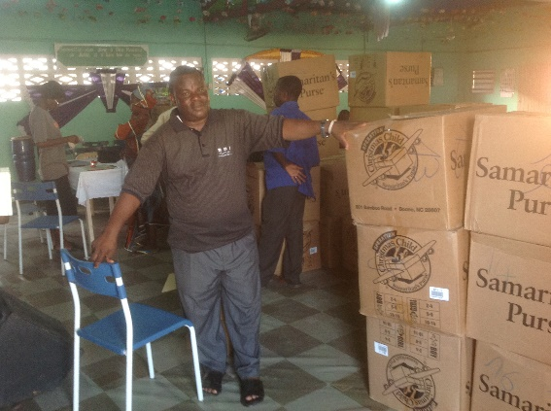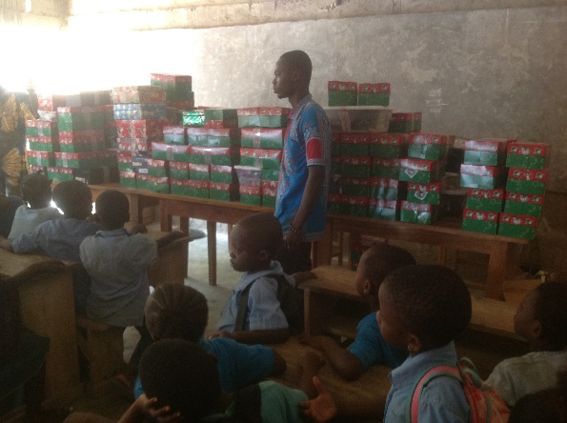
God is using these shoeboxes to enter among the hostile people to the gospel

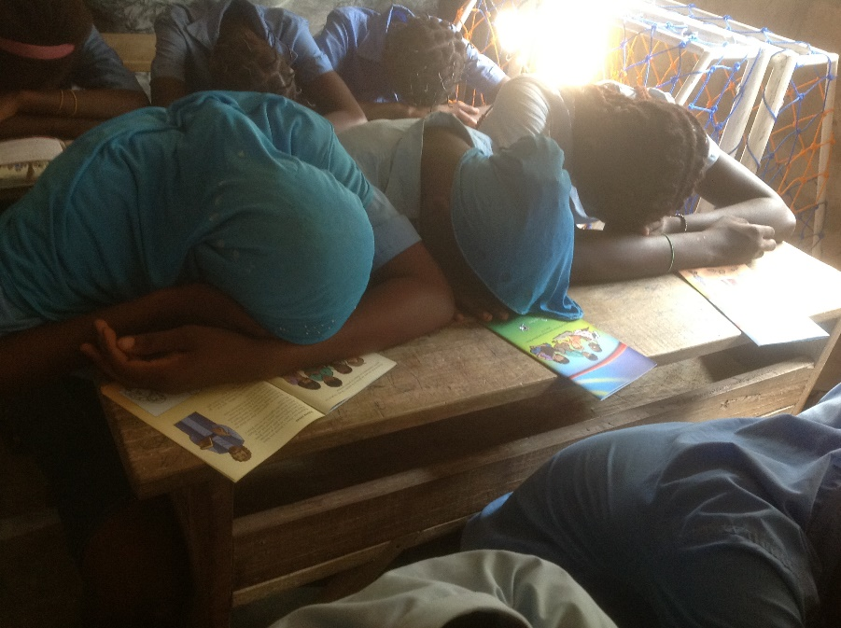
Prayer time before the distribution
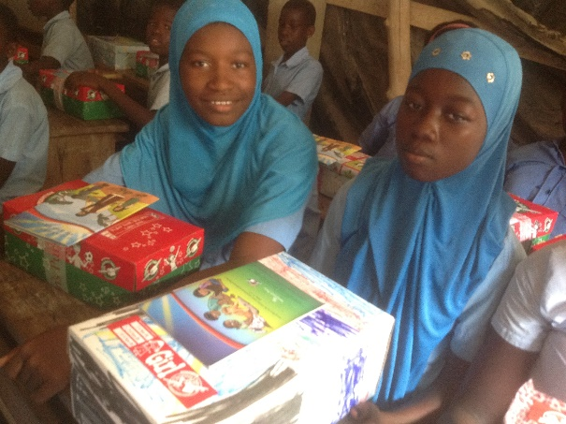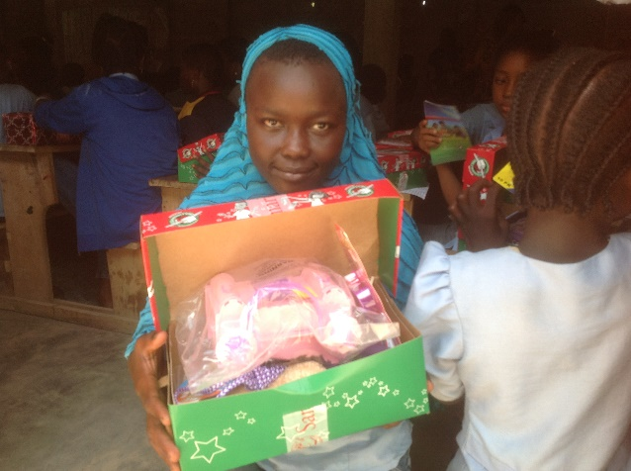
Shoeboxes inside the muslim school and they enjoyed .
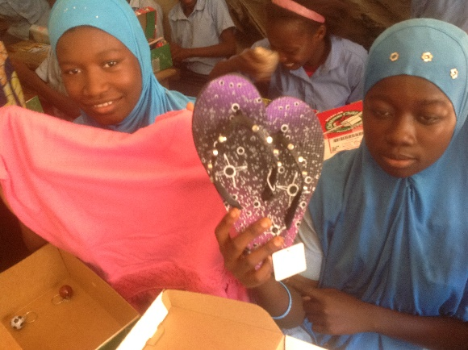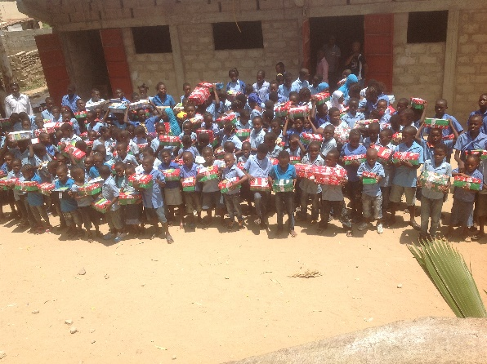
These girls enjoyed the shoeboxes gift and promised to talk to their parents how Jesus Christ is lovely God .
6- Orphans at Lome
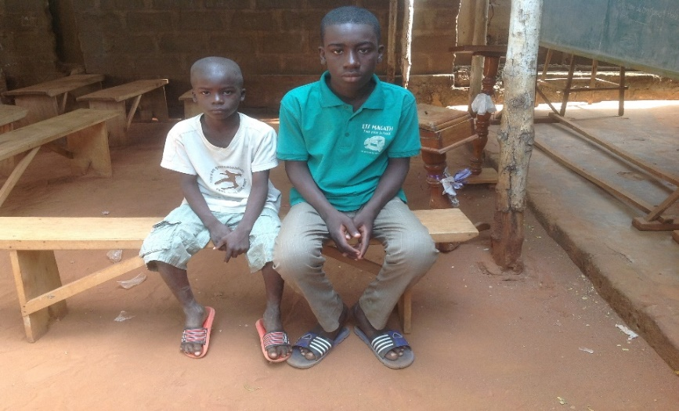
Please pray for these two orphans that lost 2 years ago their MOM and dad. Pray for their daily bread , clothing and their schooling. With $ 100 per month these children can be saved from natural disaster... They are very suffering. Their names are : In white clothing smaller Timothy and Dieudonne .

7-Evangelism campaigns Organized in Villages
We are grateful to the Lord for touching the hearts of many souls for salvation in the various areas of our activities.
Dearly partners please join me to support spiritually all those who support spiritually and financially the Ministry of salvation of souls throughout the world and especially our Ministry and my family in Togo.
This is to inform you once again that since January 2016 until today Lord JESUS could touch beyond 389 hearts of lost souls and some of them begin by attending church ..PTL! We want to reassure you that the Lord is doing big thing in Togo. We do not sleep here .

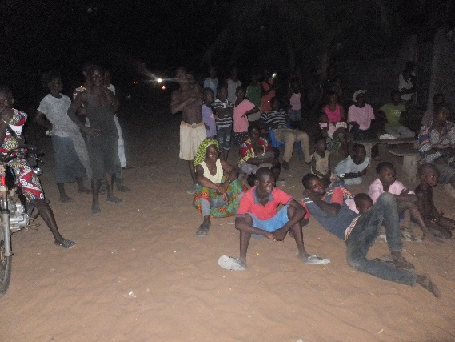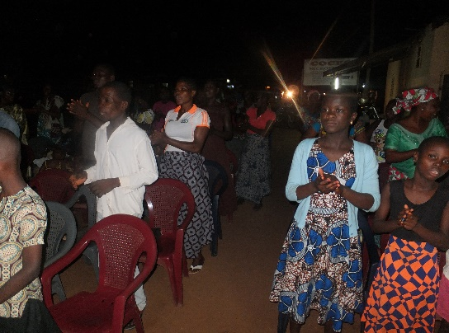

THROUGH THE VILLAGES

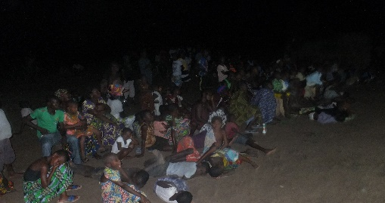

As Jesus said in :
MATTHEW 6 VERSE 33 ‘’ But seek first the kingdom of God and His righteousness, and all these things will be added unto you.’’
My daily concerns to see many lost souls come to the Lord become increasingly large . I need more of your prayers.
Ps. And especially on behalf of our donors who support us spiritually and financially, I would once again like to tell you that without you we can do nothing at all and for this reason I say thank you and that God father of Jesus Christ fill you with all His blessings.
I could also say as Paul in 1 Corinthians 3 verses 5 to 9 :
‘’ Who then is Paul, and who is Apollos, but ministers by whom ye believed, even as the Lord gave to every man? I have planted, Apollos watered; but God gave the increase. So then neither is he that planteth any thing, neither he that watereth; but God that giveth the increase. Now he that planteth and he that watereth are one: and every man shall receive his own reward according to his own labour.
For we are labourers together with God: ye are God's husbandry, ye are God's building. ‘’

8-Our Prayer Requests

- Please, pray for the pressing need of the purchase of a plot of land in the village of Fiokondji to help save the situation . Pressing need ………
- Please, keep on praying for the salvation of so many lost souls in the various areas of our activities
- Please, pray for the Lord to provide laborers for the field activities. We have the strong desire to plant many churches
- Please pray for the spiritual and financial safety of Joseph Project orphans and also pray for my family .

Thank you again for all your prayers and support of God’s work here in Togo through us .

Be blessed

Pastor Sika Yawo

