Highlights of Two-Day Visit to J.P Orphanage June 2016
Evangelism Campaign
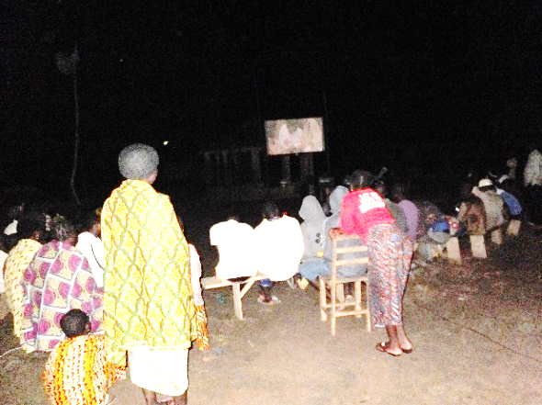
Hereby receive my greetings in our Lord Jesus Christ. I would like to express my gratitude for your prayers without which nothing could be driven to a successful end in the scope of my ministry. I reached the village of Sika-Kondji at a time of very bad weather. It rained heavily all day long. However, the evangelism campaign could eventually start around 6.00 Pm at the stop of the rain. I was very surprised by unexpected event at the very beginning of the activities. All the P.A. Systems got seriously damaged in a twinkling of an eye. Any other P.A. Systems used to save the situation also went out of use, what proved weird for me. I felt really down but I am grateful that the Lord enabled us to show a movie about Jesus Life. The Lord touched the heart of 5 people who confessed Jesus as their Savior despite all the mishaps. All these 5 people who got saved were left to the care of the Bethania Baptist Church, the site of which is in the premises of the J.P. Orphanage. The evangelism campaign lasted all night and the activities could be stopped only at dawn.

News about the Orphans
The next morning, activities started within the orphanage. I carried out discussions with the leaders of the orphanage, what enabled me to be informed about how the orphanage is run and to be in contact with the latest news. Next, I took upon me the responsibility of meeting and discussing with the orphans about what is going on in the orphanage.
Throughout this process, the following remarks were made:

Despite all the efforts of Pastor Tomety, some kids stayed disobedient. Those kids, in their disobedience, were caught in tempting to have sexual contact with the girls of the orphanage. Many of the orphans are not willing to attend the church of the orphanage. They would prefer to attend other churches. They, unfortunately, fail to be grateful for the help granted to them about 4 years now. They, rather, think that they deserve more and better support than what we provide. They believe that we receive huge amounts of money and just leave a tiny portion to their care. They are lazy; in the sense that they refuse to clean and care for the premises of the orphanage and I often feel obliged to pay other people to do these manual activities. They even refuse to go working on the orphanage farm. They compare their lot to the one of the children of a Christian organization called Compassion International. The kids who benefit by the program of Compassion International are well supported financially. So, this situation triggers rebellion in the children of the J.P Orphanage who think that they are being cheated.

The work of the woman called Sodossime, who cares for the orphans, proves inefficient in the sense that she does not encourage the culture of self-dependency amid the children. Given all these mishaps which undermine the normal development of the J.P Orphanage, the following decisions are taken:

The number of orphans are reduced from 13 to 11. 10 have been dismissed and we have admitted 8 new orphans who were on our waiting list. All 11 orphans are now attending the church of the J.P orphanage.
1) Due to the inefficiency of Sodossime, the latter is dismissed and replaced by two other women who are currently in charge of the children. The first one is called Akossiwa and the second one is the wife of Pastor Tomety. Her name is Kayi. Both women are now members of the Bethania Baptist Church of the J.P Orphanage.
2) Kossi Biam is appointed the spokesman of the orphans, given his hard work in the farming activities and in caring for the premises of the J.P Orphanage.
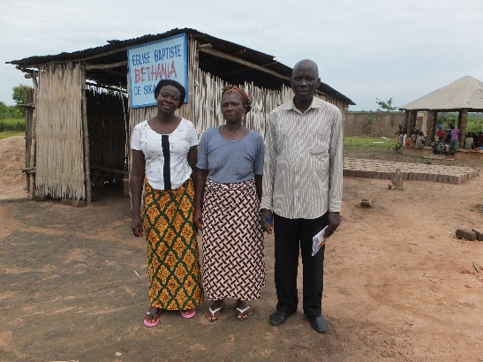
3) A new supervisor has been admitted within the administration of the orphanage. His name is Sika Seenam and is a carpenter visiting regularly the orphanage. We now have two supervisors. I need your constant prayers for this change within the orphanage to be fruitful.
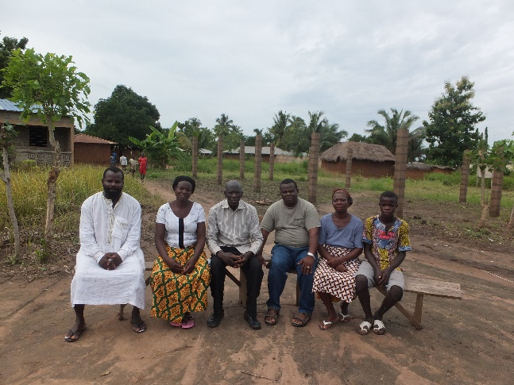
The new administration at the JP (left) and the new worker Akossiwa, between Pastor Tomety and his wife.

About the New Building
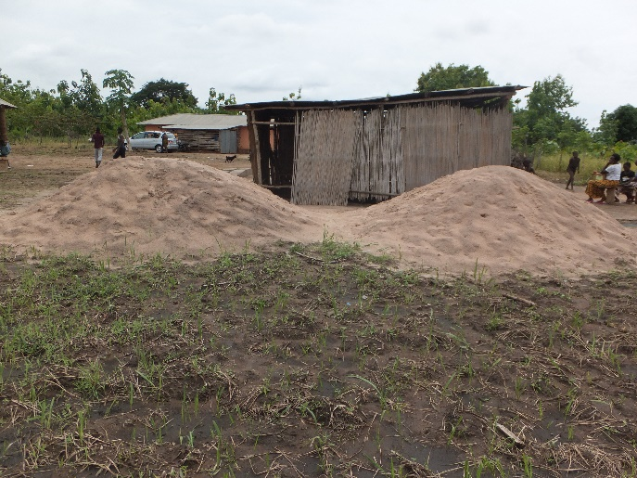
I desired to see the laborers of the new building at work but unfortunately, this could not be the case, given the heavy rain of the day. However, the bricks were ready; two piles of sand were made available for the continuing of the work. I could pay them a part of their wage. By this very time I am writing you, I am quite sure they are at work. Please, pray for the Lord to provide more financial means in order to complete the activities of the building.
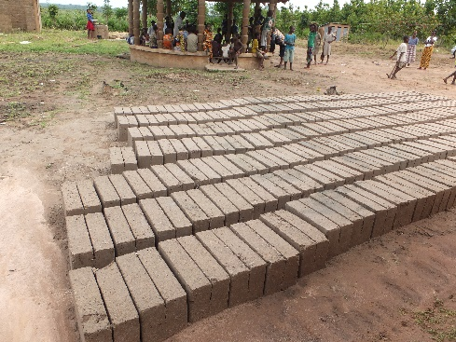
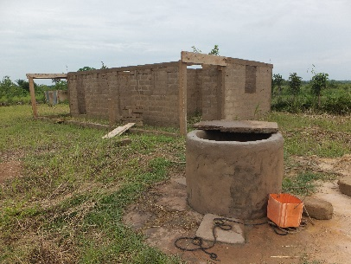
About the Orphanage Farm
We are grateful to the Lord for making rain fall and this rain fall has favored the growing of the crops (corn and cassava.) We are also grateful to the Lord for the life of Kossi Biam, the spokesman of the orphans who devotes due attention and care to farm despite his school programs. Until the end of July, we hope to harvest. Of the 20 palm trees planted, we have only six left. The rest are stolen by the village people. The thorns have not been sufficient enough to cover the limits of the orphanage and serve as fence. We are thinking of planting some more.
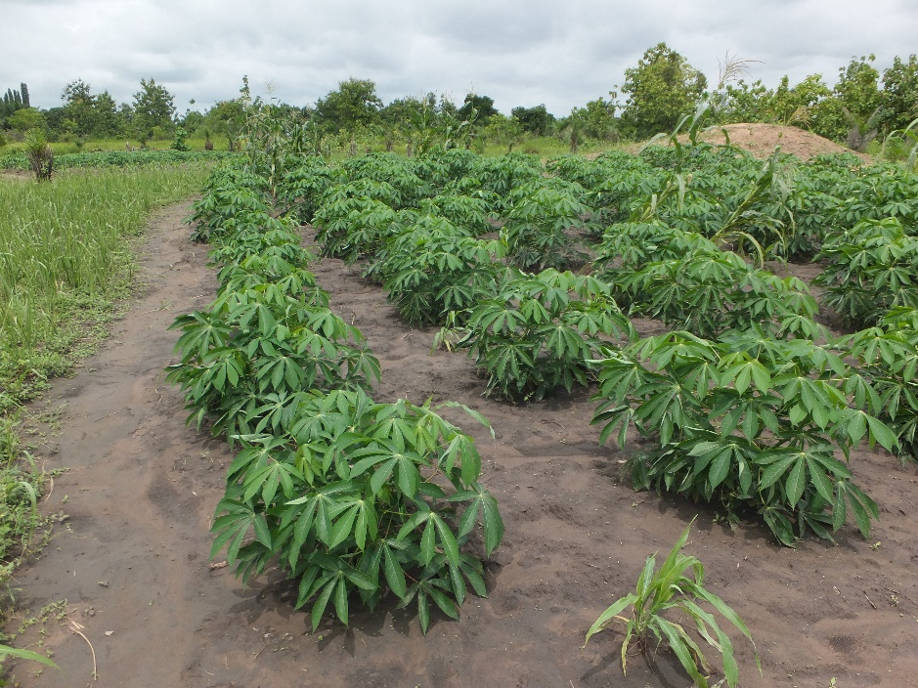
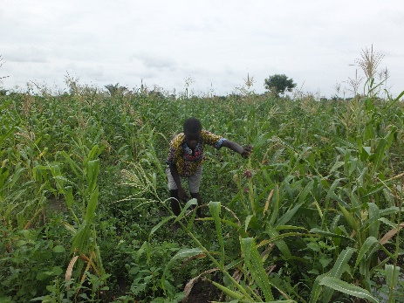
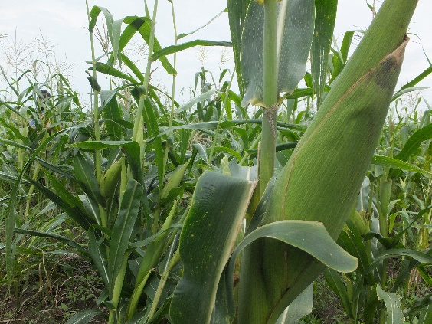

About the Church
The church of the J.P. orphanage consists mainly of needy kids and orphans. Today, we can number more than 40 people and among them 28 children (see below left). The church could plant another church in a neighboring area. More than 30 people attend this church and among them we have some of the notables of the village. We pray the Lord to provide the means in order to help them with a building for the church meetings. We thank the Lord for Samaritan Purse who, through the Operation Christmas Child, has funded the beginning the church building within the J.P orphanage (below right). This is an occasional action undertaken by Samaritan Purse. Please, do pray the Lord to touch the heart of other people who could fund the completion of the building.

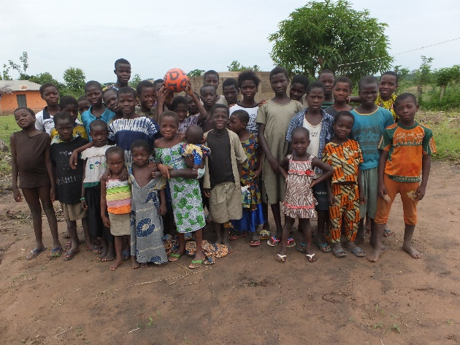
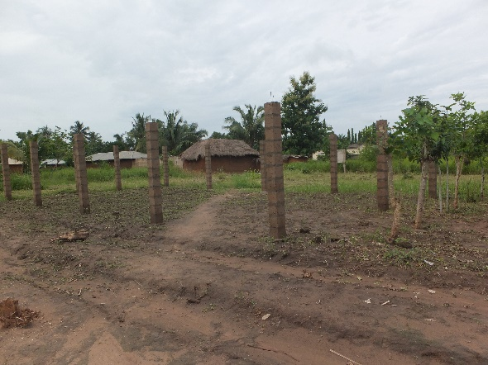

About my Departure from the Village
I am thankful to the Lord for his two-day guidance. I could share wonderful moments with the kids and the leaders of the orphanage. I enjoyed their fellowship and offered them pocket money. Unfortunately, I could not attend the funerals of the mother of the village chief. My departure from the village back to Lome occurred around 2 P.m. On my way back, I had a 40-minute pause in the house of a colleague Pastor of Christmas Child Operation with whom I shared lunch. I left him at 3 P.m. After ten-minute drive, I got involved in a terrible misfortune which could have put an end to my earthly life. The car, suddenly, went beyond my control, deviated from its normal direction, crossed the road independently from my will and headed to a farm of palm trees. The reasons of this deviation remain to this day unknown to me. I was heading for serious danger which would surely be fatal to me, but I can’t reckon how the car went about all those dangers. The only thing I can remember is how the car slides passed the palm trees, heading for the bush alongside the road, went bumping in the holes and eventually stopping in a muddy pool of water. A crowd of people who quickly assembled to see what happened was astonished to see me alive. The only thing they could do is to cry: “Your God has saved you.” And I replied: “My God is with me in the car.” I was surprised that I was safe. No car was coming by, if not I would crash automatically into it. Second, there was nobody by the side of the road, if not I would be convicted of murder. Moreover, I did not bump into any tree, otherwise I would die. In addition, the car did not get into the gutters that were being dug alongside the road, otherwise, I would suffer severe injury or even die. Once again, I cannot understand what God did, but I praise him for saving my life. Out of all these events, I am resolved to go back to the village for another evangelism campaign. My arrival at Lome was effective around 7 P.m because I was not going too fast. However, I was really down and afraid because I remembered my road accident in 2005 when a witch challenged me that I would die after 3 days. Anyway, I am grateful to the Lord for protecting my life and I am thankful to all of you for praying for me, for my family and my ministry.

