September 2016 Newsletter from Pastor Sika
Acknowledgement
Hereby receive my sincere thanks for the financial, moral and spiritual support which you grant my ministry and family in Togo. Please, do receive our gratefulness as nothing can be compared to your good-heartedness toward us but we do believe that only God can grant you, in return, all spiritual, physical and financial blessings more than anything else.

Heart Cry for the Spiritual Status of Togo
Seeing all the endeavors of the multiple radio stations, televisions throughout the country as well as the efforts of religious institutions to bring poor souls to salvation through the organization of evangelism campaigns, we are terribly sorry to notice that according to the latest religious statistical report, we are mistaken about our belief that the Gospel in our country is touching the lives of so many people. Therefore, according to the report, 50% of the people are still pagans, 13% are Muslims, 26% are Catholics, only 9% have espoused the Protestant religion (Baptists, Assembly of God, Deeper Life and Pentecost Churches, Methodists, Lutherans, in addition to other Christian ministries) and 2% are caught up in the net of sects. All in all, we still have a lot to do for the advancement of the Christian ministry in Togo and we need your prayers.

Our Ministry in Togo

The Prison Ministry
We are always grateful to the Lord for the whole lot of blessings he grants us in the scope of our ministry in prisons and especially for the salvation of the souls of poor prisoners. Our Bible courses remain crucially important in driving them to true repentance. Following the spiritual support granted to these prisoners, comes also the attendance to their physical needs. Therefore, this season, together with the Togo Bible Society (our principal supplier in Bibles and food), we were able to provide them with food and Bibles. Today, we can count, amid the pastoral and evangelical ministry, saved prisoners who are released and engaged for the Lord’s ministry.
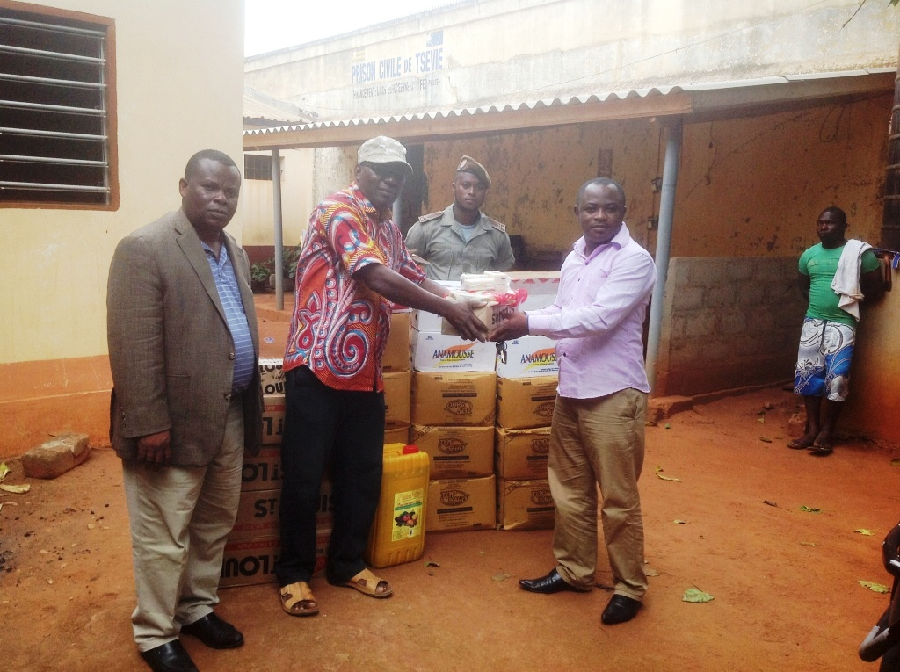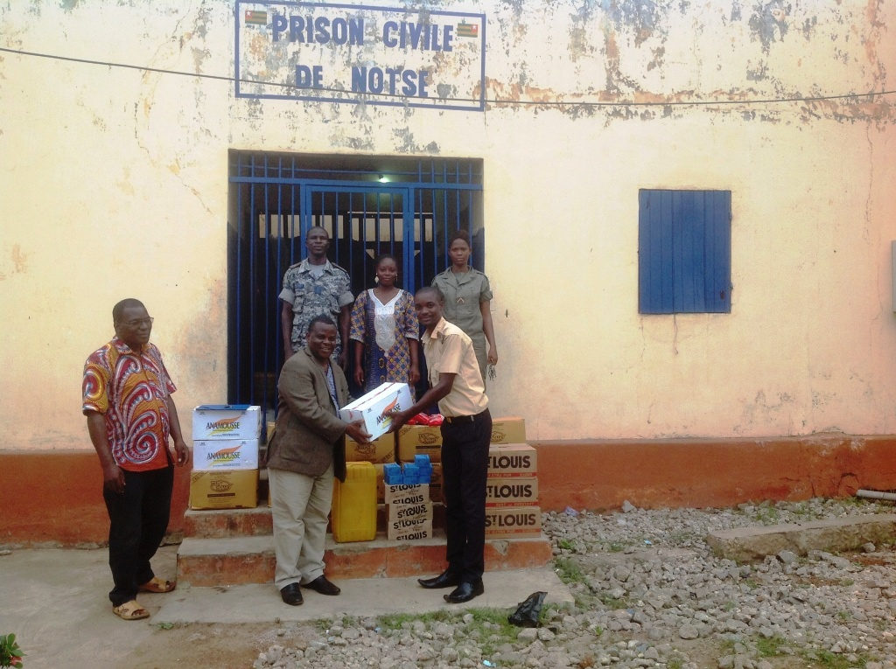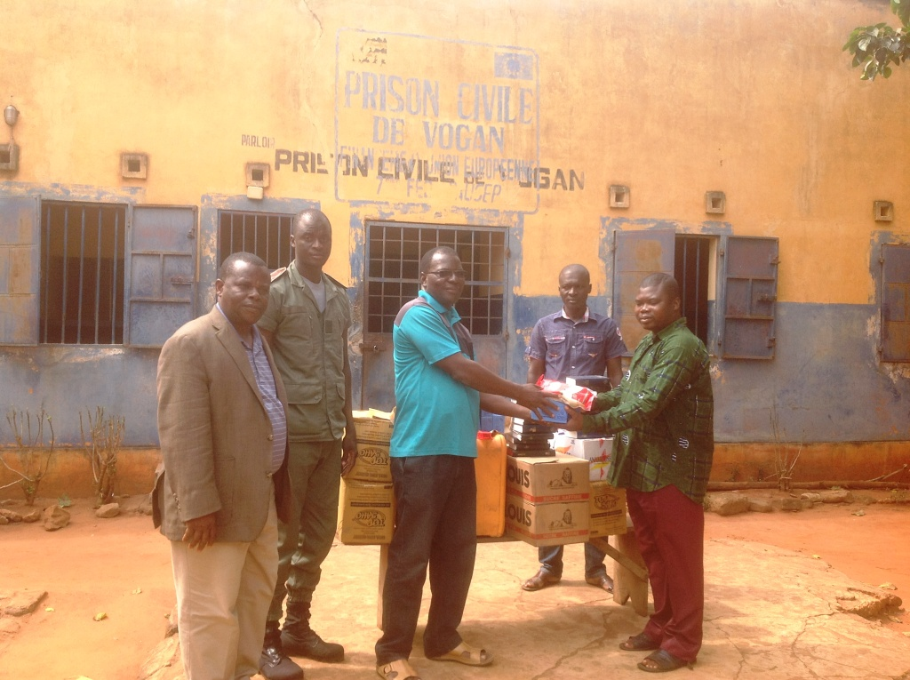
The Training Ministry
For the reinforcement of churches in evangelism, we were able to get more than 200 pastors together to train them in the judicial and efficient use of our Bible lessons in schools, military camps and prisons, and even in their own churches. The seminar earned their positive reception and was followed by their request of repeating it three to four times a month, but this very request seems too difficult to me due to the lack of finances and of human resources.
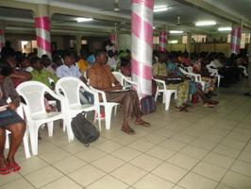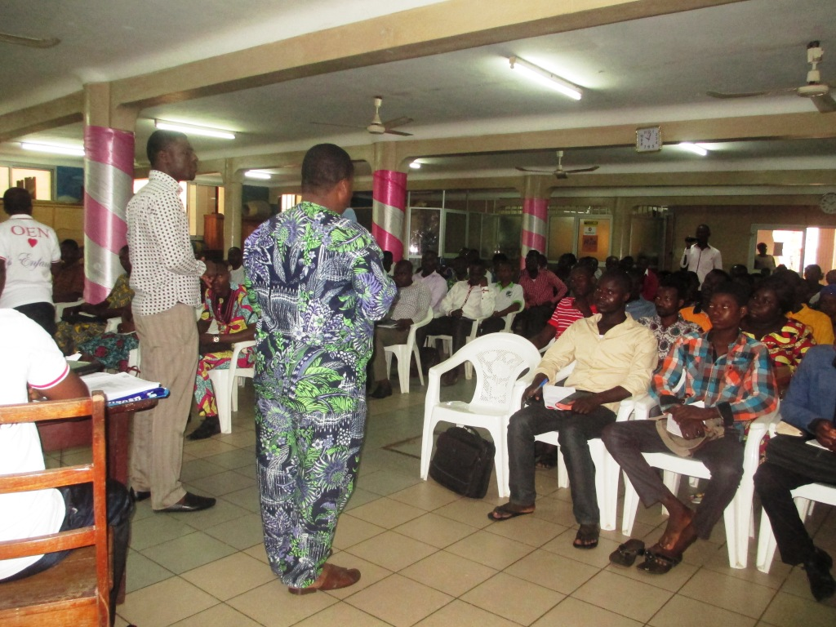

Our Ministry in Schools
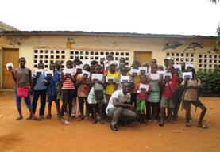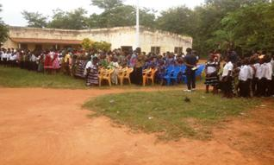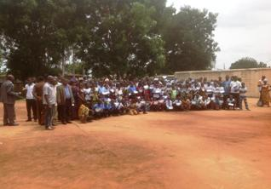The school ministry is very much fruitful since it enables so many lost souls to come to Jesus. Students always have our Bible courses at hand and display a keen interest in studying them. Today, there are so many schools which request our help in introducing their students to our Bible lessons.

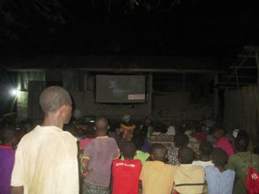Evangelism Campaigns
God offers us his everlasting support in the organization of evangelism campaigns, mostly with the powerful materials of Final Frontiers. This enables us to perform activities in rural areas with no electricity supply thanks to the powerful batteries. This season, we were able to cover over six villages where about 70 people effectively confessed Christ after our call. Now, we humbly request from you to pray for the true salvation of these people and their growth in the Lord. Nevertheless, we come across so many hardships during our mission trips. We have formed four teams and we fall short of means of transport such as 2 motorcycles and obviously, financial means for fuel purchase.

Joseph Project Orphanage
Last week, although I was suffering severe pains from my left leg, I was able to travel to the village which hosts the Joseph Project. The children are doing pretty good and were peacefully enjoying their vacations. Sister Shirley, this is the right occasion for me to express, on behalf of all orphans, my grateful thanks to you and all those contributing financially and spiritually to the advancement of this project. I would particularly like to express sincere thanks to you for sending me the 2 medicines that efficiently concur to ease the pains in my leg. I got these medicines last week.
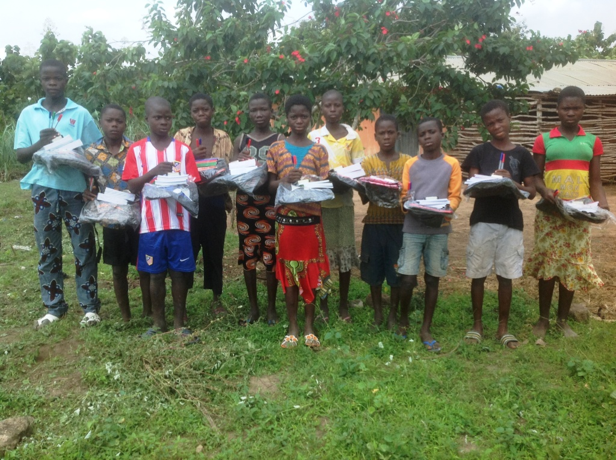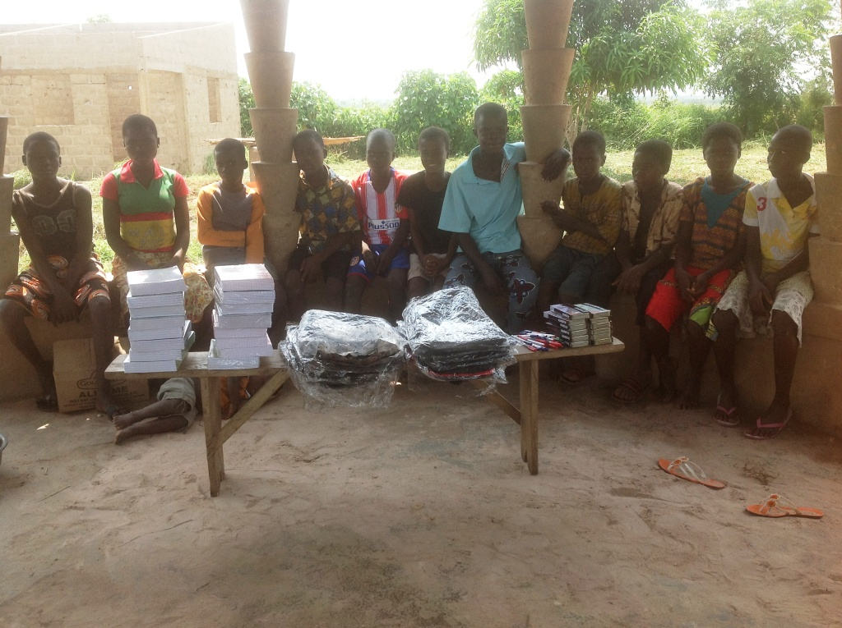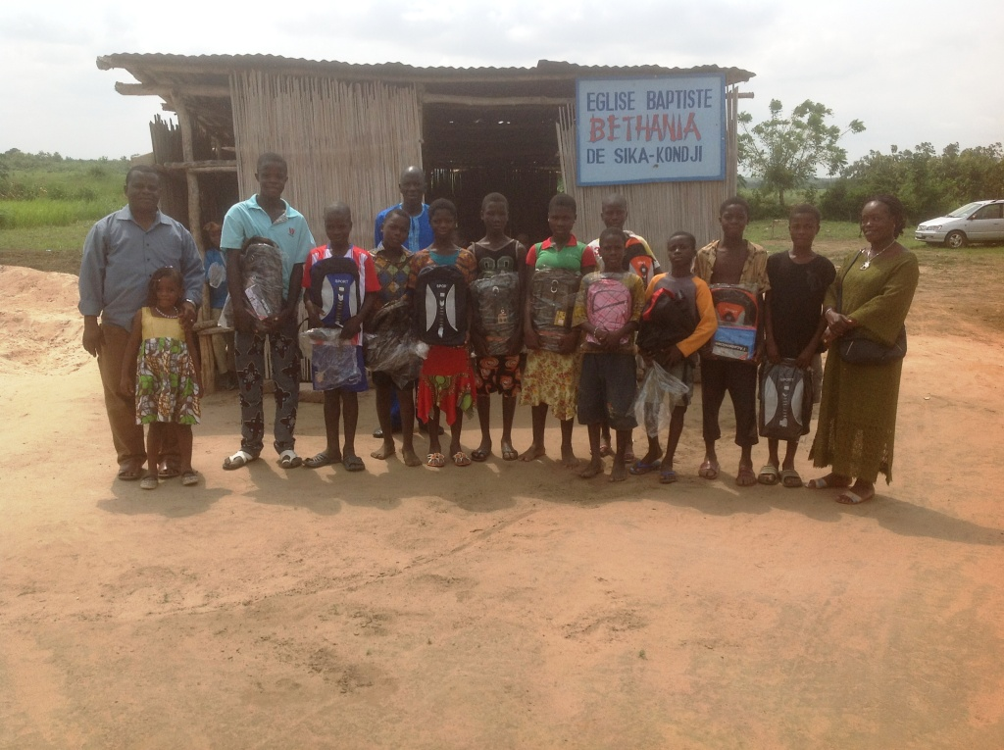
The school materials
The orphans in front of the church
Distribution of the school materials

In the village, with the help of the supervisors, I was able to give the school materials to the kids; we could safely keep their school fees and purchase some other materials for the building of the orphanage. We were also able to help the supervisors financially and Pastor Tomety. The harvest was good enough and they could even offer me some corn which I brought back home. What remains a crucial challenge is the completion of the new building. We need to provide materials for masons and carpenters to finish their work. Soon, the government will supply the village with electricity; therefore, we need to get ready financially to provide the orphanage with electricity.
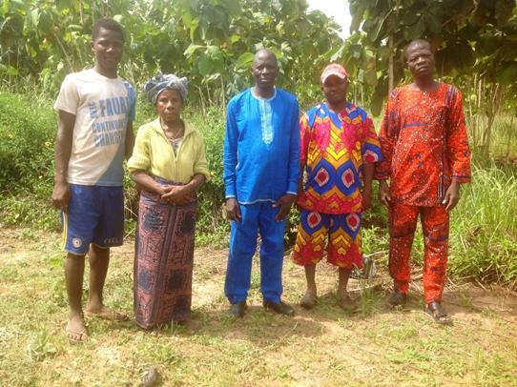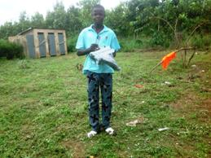

The supervisors and other helpers
The student captain of the orphanage
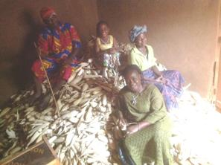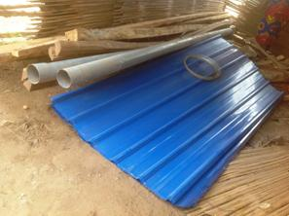

The corn harvest
Part of the purchased building materials

Operation Christmas Child
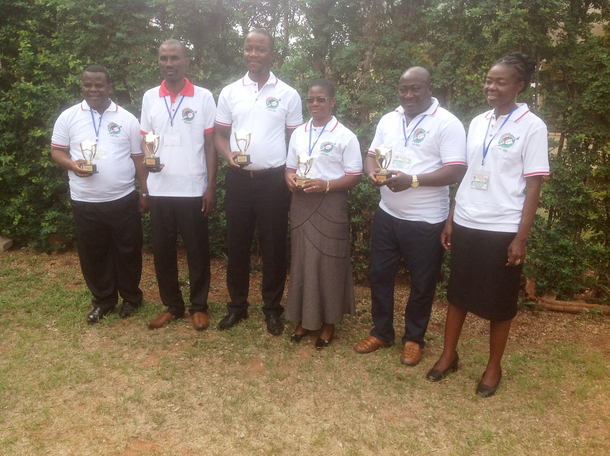I was able to undertake a week-trip to Accra in the scope of a training which aims at reinforcing my capacities in coaching the teams in charge of the field activities of Operation Christmas Child in my region. I also partook in a national conference and witnessed a ceremony of certificate award to kids, which was organized by the teams of my regions.
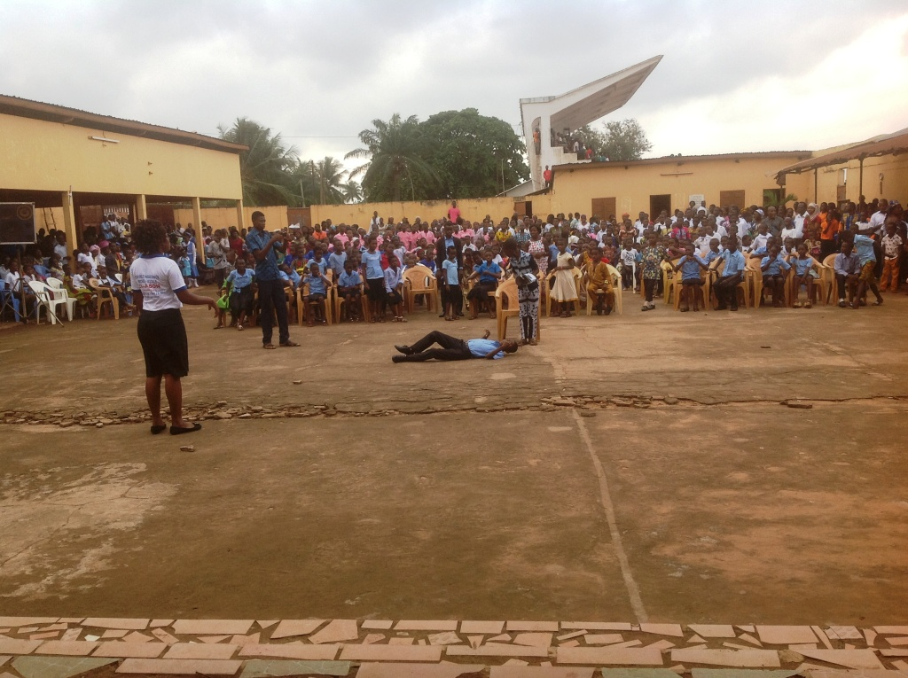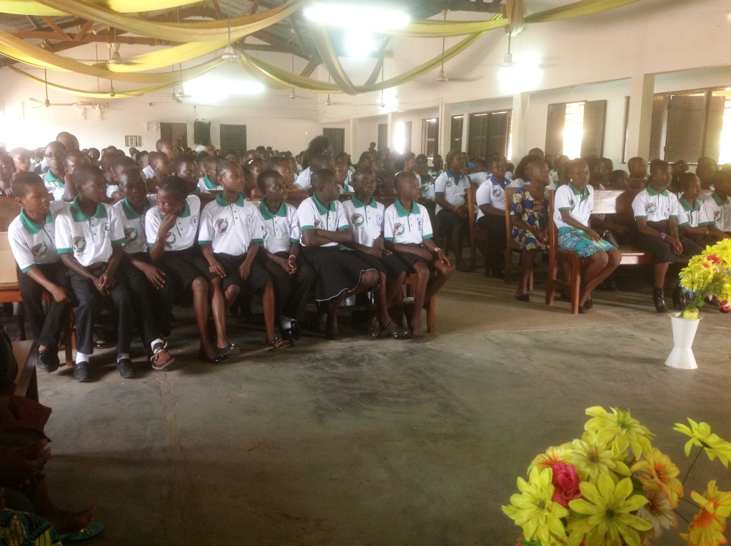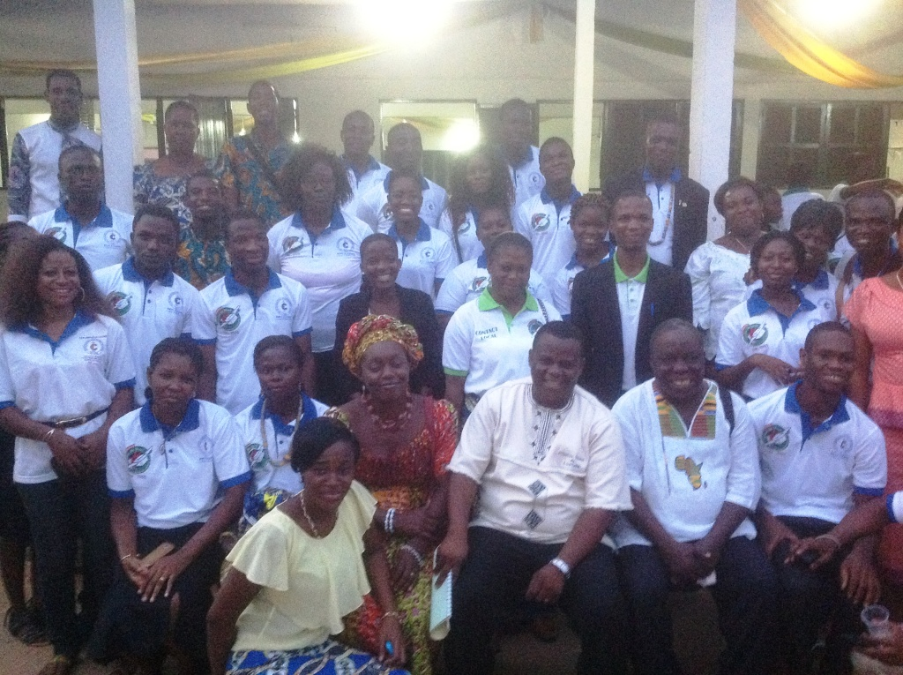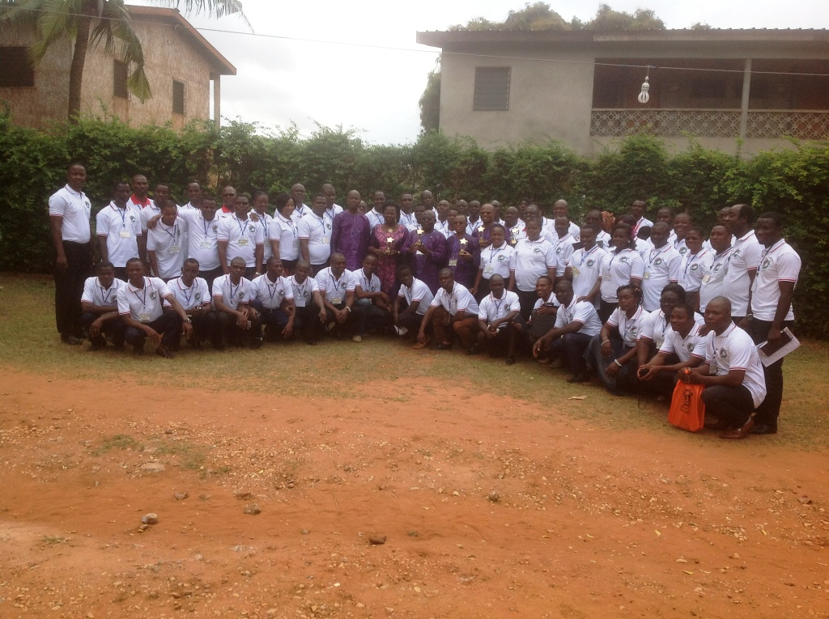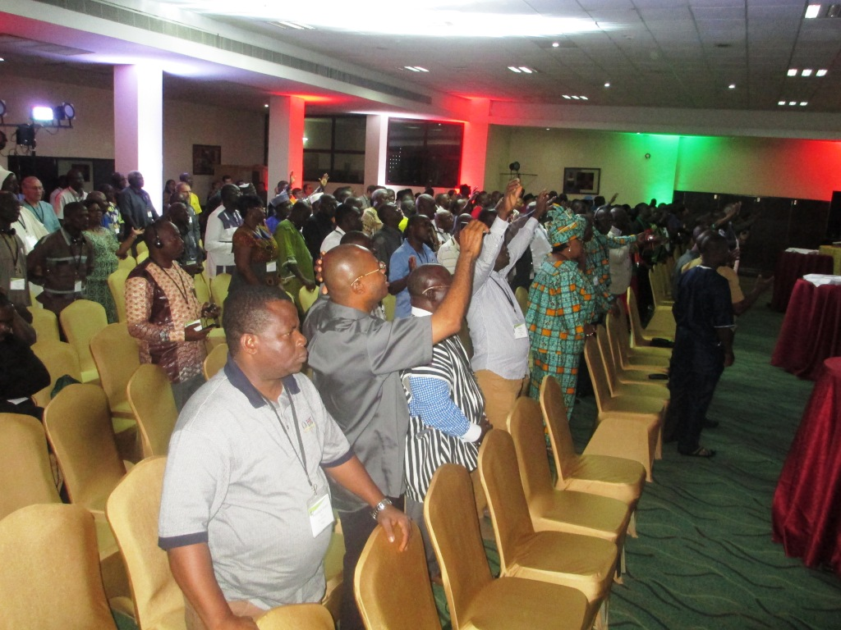
The Accra conference (Ghana)
The Lome conference (Togo)
The team of supervisors under my leadership
Teachers of the regional teams
Graduation
Students performing skits

Helping Young Seamstresses
We would like to sincerely express our gratefulness to you for your financial contributions that have achieved great things and have profoundly impacted the lives of the two young seamstresses (Rose and Benedict) whom we started to help a year ago. I would hereby like to point out the courage you instill into them. They have been greatly strengthened through your encouragement in that they are faithful in their church attendance and service. They are even more motivated to complete their trainings. Now, they have taken their end of year examinations and are awaiting the results. It is an official examination which is taken care of by the government. We invite you to join us in prayer for the Lord to provide financial means in order to help open a workshop for them so that they could achieve self-sufficiency.
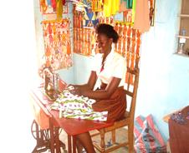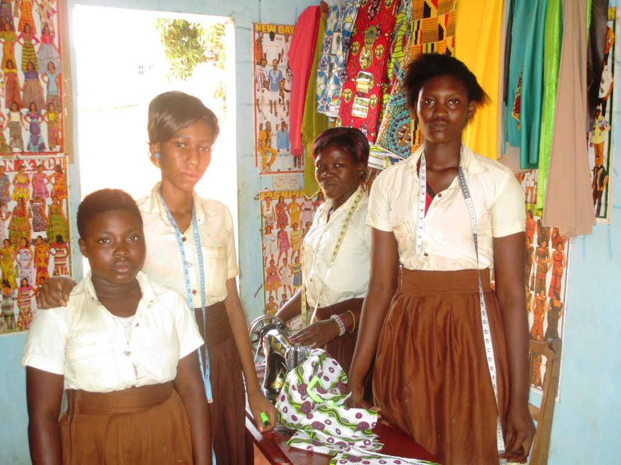

Sister Rose with her instructor

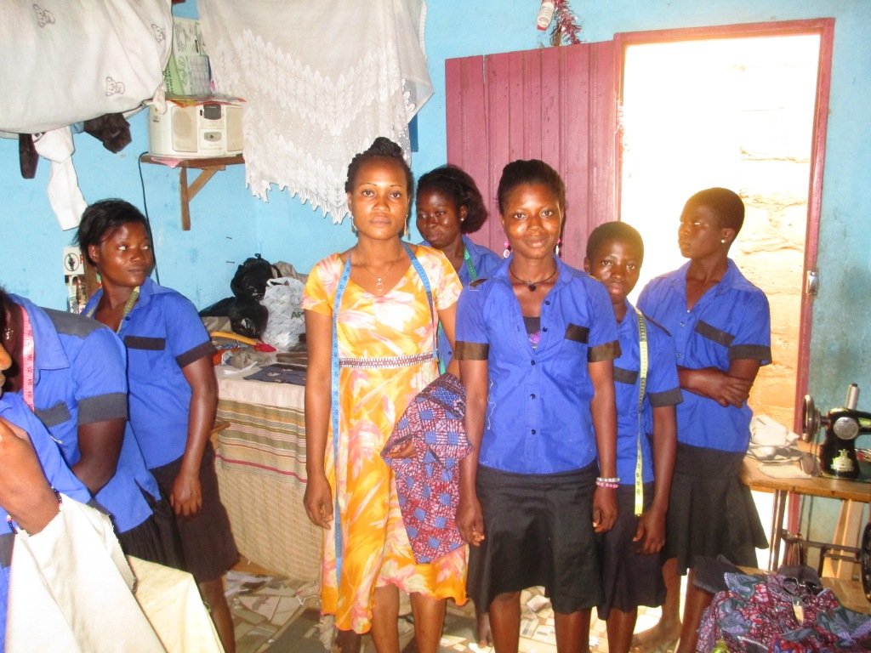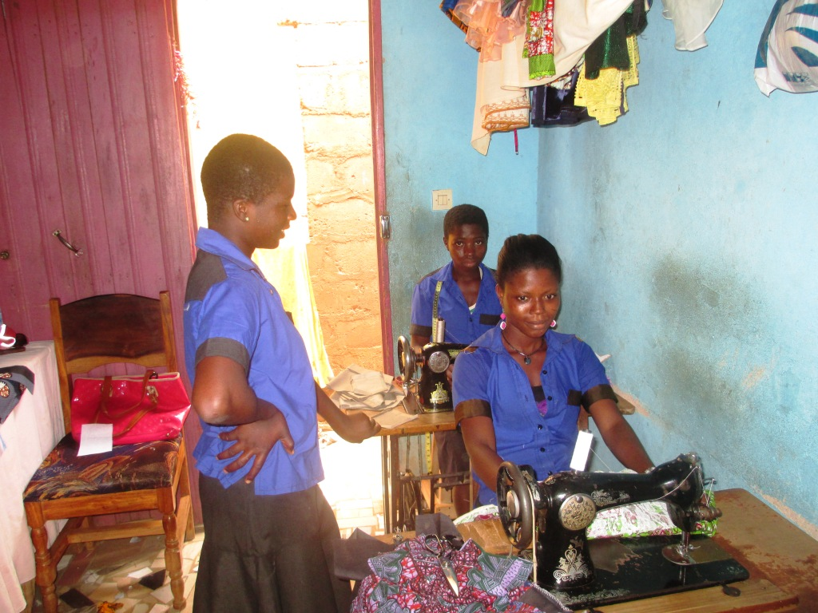

Sister Benedict and her instructor

Prayer Requests
Please pray for my spiritual safety and that of my family.
Pray for the financial means for my family because we are going through hard times. At this very moment when the school resumption is drawing near, I crucially lack financial means to even purchase school materials for my own children.
We urgently need two motorcycles, mostly to better enable efficient and well-done ministry work in the villages.
We need to pilot a national project to sustain the ministry.
May God Almighty abundantly bless you as you efficiently take part in the achievement of my mission work and ministry in Togo.
Thank you, Pastor Sika Azankpé Yawo.

