Details of the staff and children at the Joseph Project Orphanage Christmas 2016

Staff at J.P. Orphanage:
Pastor Tomety and wife Kayi Supervisors - Sika Beaugard + Sika Seenam Housemother - Soeur Akossiwa

Children:
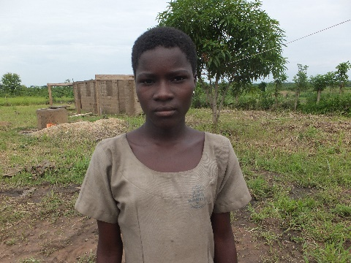
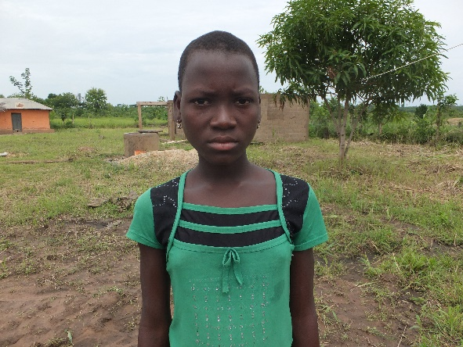
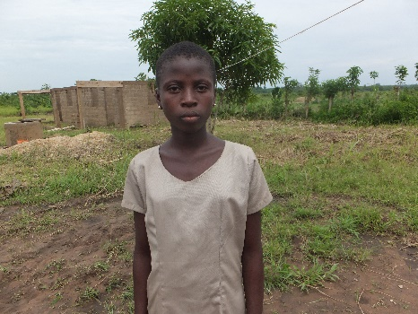
1. Chantale Senou (girl, 15) 2. Mawussime Anato (girl, 14) 3. Dogbeda Hounou (girl,14)
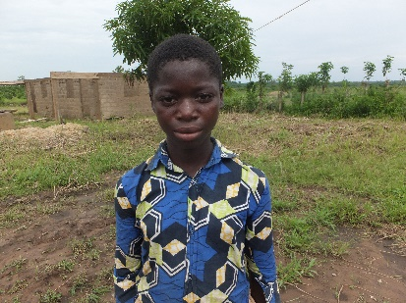
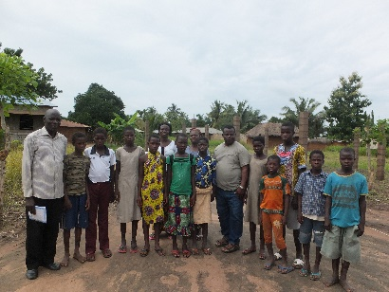
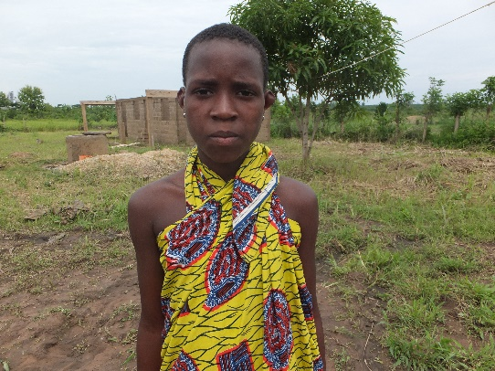
4. Chantale Agbofan (girl, 14) 5) Dalolo Anato (girl, 11) The orphans with the new administration
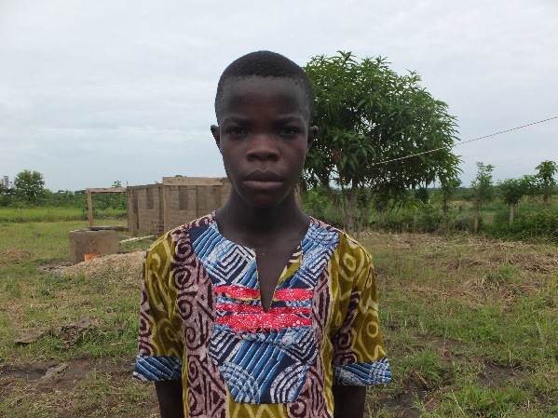
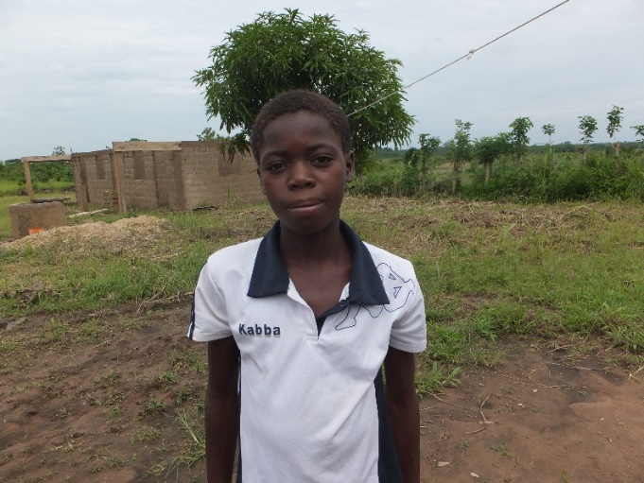
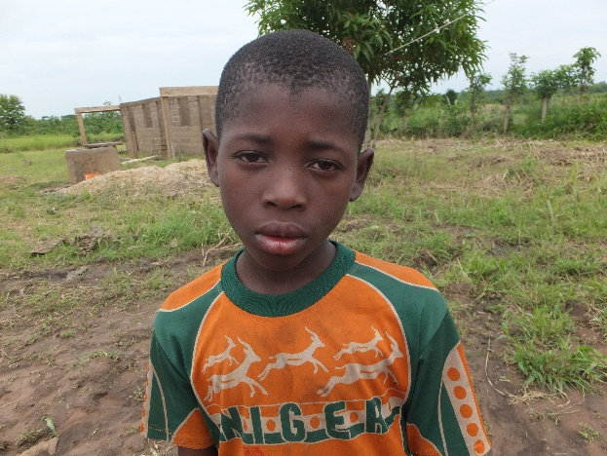
6) Kossi Agbemadon (boy, 13) 7) Kossi Biam (boy, 15) 8) Komi Agbofan (boy, 14)
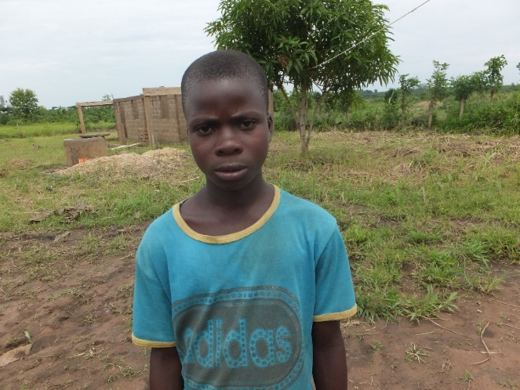
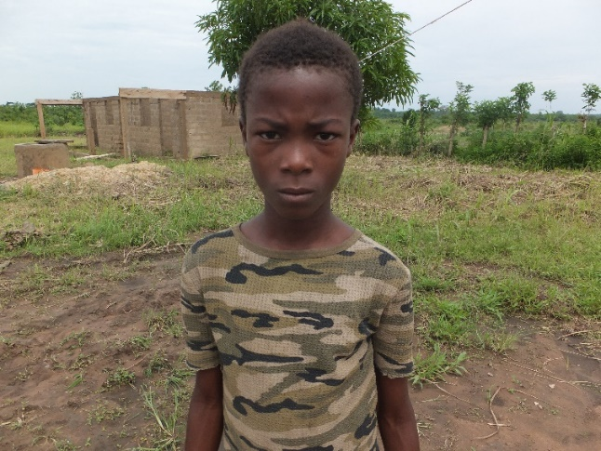
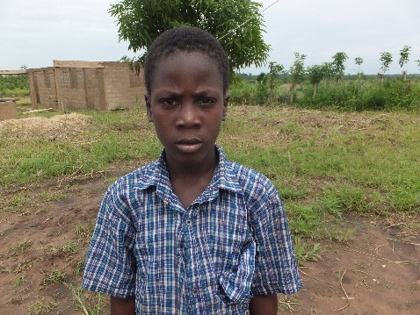

9) Matthieu N'Zi (boy, 13) 10) Seraphin Assiledome (boy, 12) 11) Mawugnon Hounou (boy, 10)

