Togo Activities Newsletter December 2016
Our sincere greetings go to you in the precious name of our Lord Jesus Christ. We find this the right opportunity to renew our plain gratefulness to you for all your endeavors on our behalf. We are thankful for everything the Lord does in the development of the ministry in Togo. This ministry finds its right development due to your personal involvement in the Lord’s harvest since you are the fuel which serves to energize the ministry. I would once again like to share my family photo with you even though my wife Lucie and my son Frazee do not enjoy a good health at all.
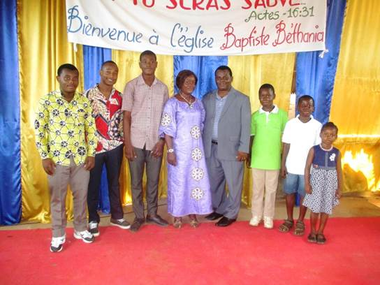

Please, pray for the Lord to provide financial means to pay the school fees for my children.
We would like to share the different activities the Lord enabled us to undertake this season with you

Bible Courses-based Training Activities in Schools
As usual, we works in schools through OCC bible courses . At the end of these Bible courses in the schools, participants receive certificates which serve to encourage them and offer them much joy. We henceforth need your prayers for the involvement of so many students and why not all the schools in our program.
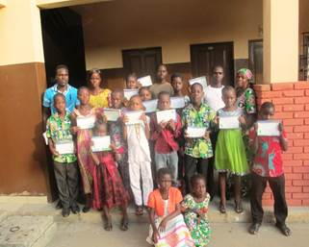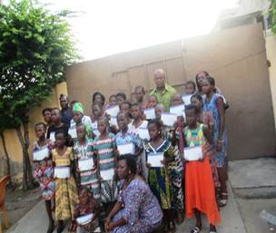

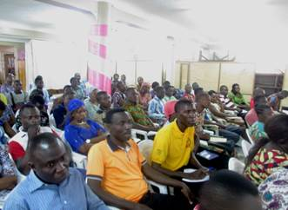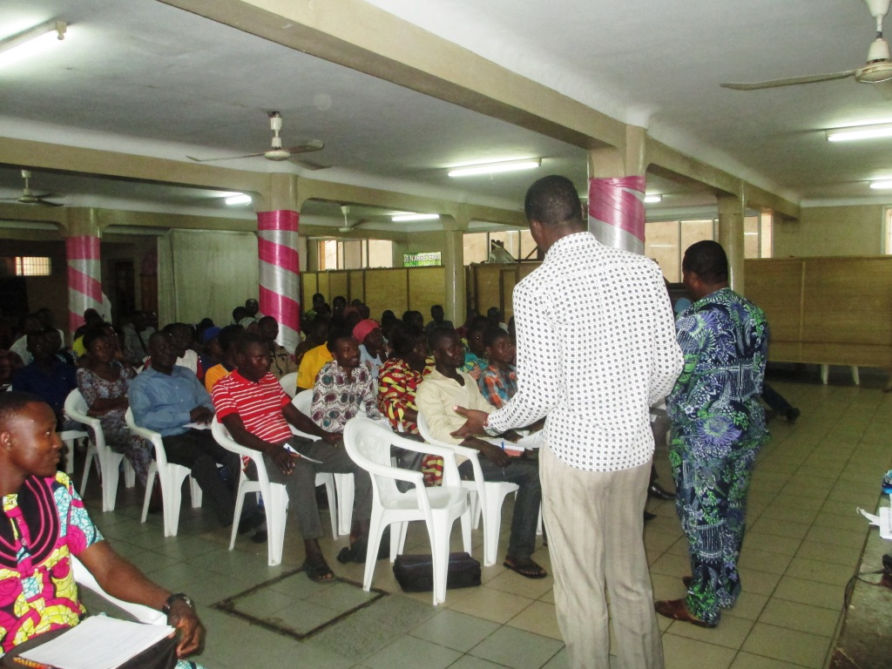Sensitizing Pastors and Sunday School Teachers on The Bible Courses
During this season, we have had the opportunity to sensitize pastors and Sunday School teachers on the benefits of getting a whole church involved in the study of our Bible lessons. We hereby express our thanks to God for the interest these pastors showed in working with us.

One-Week Visit of Trainer Missionaries in Togo
With the aim of reinforcing pastors and Sunday School teachers in the task which God has assigned to them, Dr. Bruce Snavely and his wife Grace came to boost pastors and their wives in their different roles in the Lord’s ministry by enabling them to bridge the gaps existing in their ministries for the advancement and the betterment of their missions. This training resulted in all participants’ bearing of good testimonies. Let me share some pictures with you; mostly a photo of their visit to my church and a family photo.
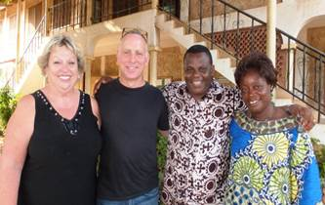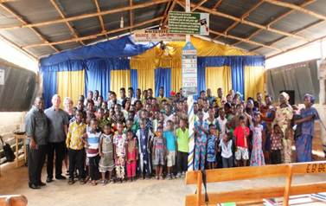

SOS Prayer for the New Church and the People of the Village of Fiokondji
The particular attention we devote to this village to the point of requesting a special prayer on its behalf is due to the fact that they also need salvation in order to escape hell. The village is effectively devoted to idol worshipping and the direct result of this situation is that they display true hostility to the gospel. The same situation applies to all surrounding villages which also follows the same belief pattern.

The new church which has just been planted in the village experiences serious hard times. The village people are evicting our newly-saved from the school and the poor souls do not have any place to worship. Consequently, the number of saved has considerably decreased to twelve. We sincerely request your prayers so that the Lord could help us purchase a land on which we could have a building for the new church. For you to get motivated in prayer on our behalf, let us now share with you the image of the god these village people worship and which prevents them to come to the salvation offered by our Lord Jesus Christ.
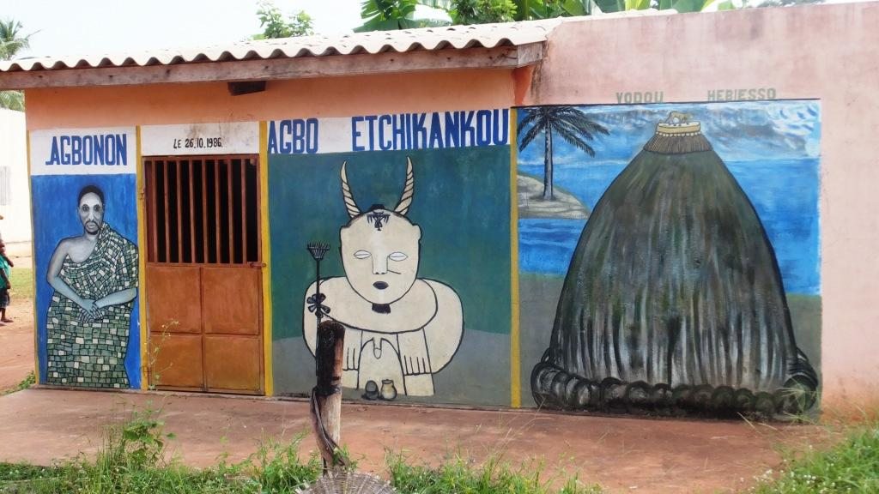
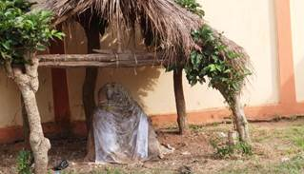

We pray that the Lord helps us find a local native missionary who could work efficiently and on a regular basis in this village and its vicinity. For the ministry in this area to be effective and for the salvation of souls, we think that the missionary should totally settle in the village. This constitutes one of our most important needs of the time.

Baptism of some New Members of our Church
God has enabled us to baptize some brothers and sisters last Saturday, which is a proof that the church in Togo grows. We, therefore, request your prayers for the members of the church to understand the importance of evangelizing the souls and bringing them on to the path of salvation.
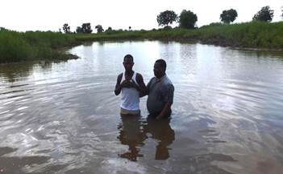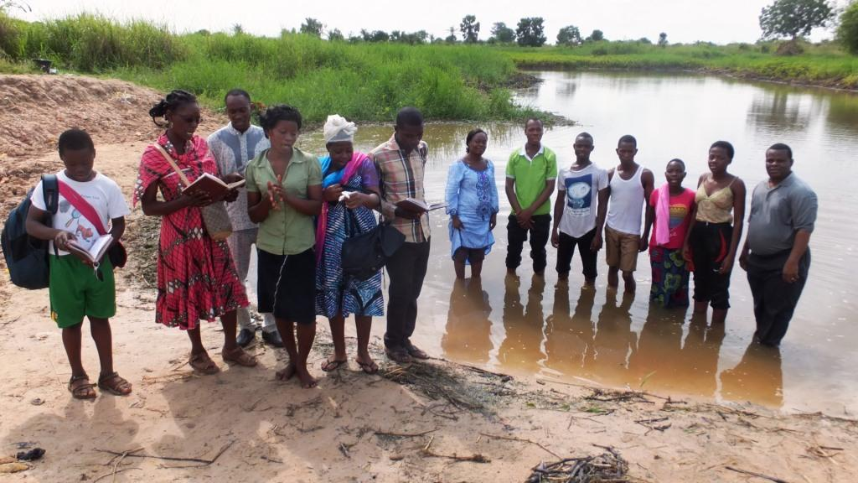

Joseph Project Orphanage
We are planning to celebrate the feast of Christmas and the New Year with the children of our orphanage, and to provide these children with toys, clothes, skirts and shoes, and also us to purchase medicines for their health issues. We are planning to offer them a Christmas and a New Year dinner. We request your prayers for their schooling and their physical and spiritual health. We are grateful to the Lord for helping us provide our new building with a roof. You will see the pictures in our next newsletter. It remains the doors, the windows, the painting, and the ceiling. See here below the picture of all the children of our orphanage. My visit in Nov.
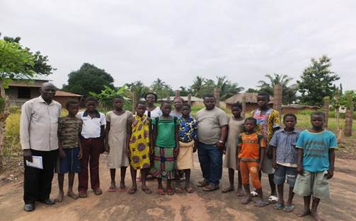

Attending Government Seminar on the Effective Management of Churches
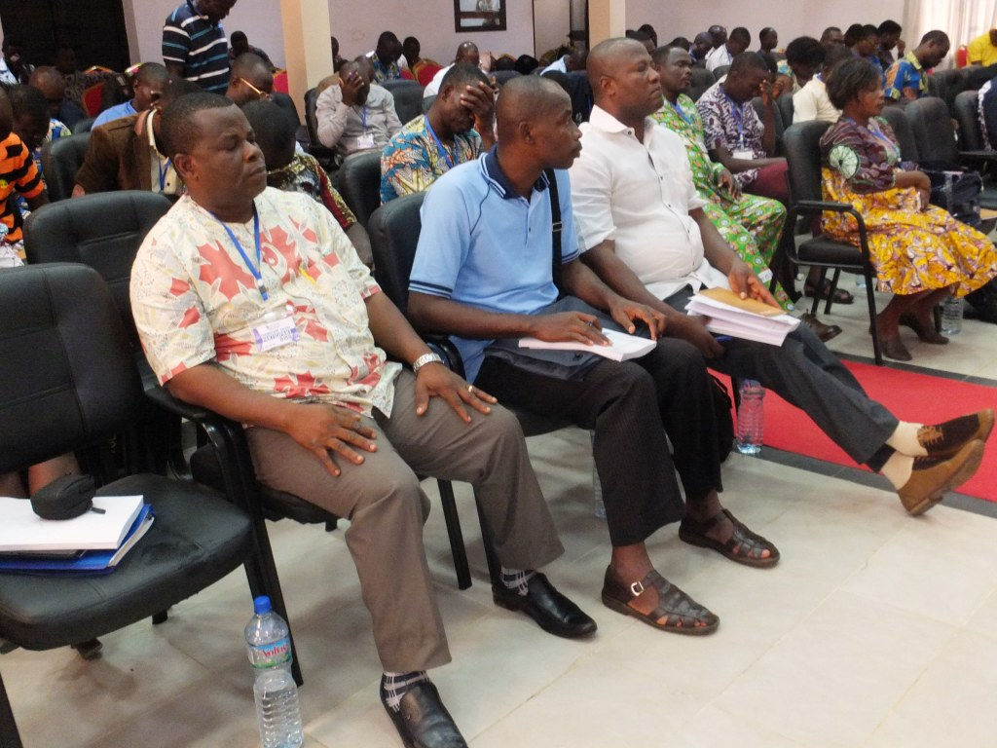Last week, I had the opportunity to attend a seminar organized by the government following the mess caused by many pastors and church leaders who misunderstand the Bible. Among the topics discussed is the non-respect of individual liberties in the night by some churches which disturb people in neighboring houses with their noise. See picture.

Prayer for our Christmas and New Year agenda in Togo
We would like through this agenda to reach the lost souls. The program starts from December 23 to December 31, 2016.
Dec. 23- 24. From morning to evening: Organization of different sorts of games in order to attract people’s attention to the preaching of the Gospel. There is film projection during the nights of these two days.
Dec. 25. Invitation of all the newly-born again to a feast and we will give them our Bible lessons
Dec. 29-30. Same program.
For the accomplishment of this program, we have been able to set up a budget of $1000 for the purchase of food and game materials. We still need your prayers and since you are determined to go with us through hills and valleys, we need your valuable contributions for the success of this program.

About the Seamstress Project - I would like to inform you about how well the two apprentices are performing in their workplaces. I still need your constant prayers for the funding of the project in favor of these two apprentices regarding their own shop. My family and I are reassuring you of how we make mention of you in our daily prayers and sincerely praise the Lord for your life. May you and your family be covered by the grace of the Lord.
Pastor Sika and his Family

