Togo Newsletter March-April 2017
Beloved Sister Shirley,
All my greetings and sincere acknowledgement for everything you continue doing on our behalf as our donors. We express our gratefulness for your prayers and your support for us and our ministry. May God grant you and your respective families a good health and provide you with so much blessing of peace of mind and spiritual as well as material prosperity as you faithfully help with the advancement of the Lord’s ministry. It is quite obvious that the advancement of our ministry in Togo is exclusively due to your devotion to the Lord and willingness to keep faithful to His Word. Without the Enabling Power of God acting in you, so many achievements could not be fulfilled in the scope of our ministry. Despite the convalescing period of our whole family following the stormy winds that blew against it, the Lord has enabled us to carry out the following activities only thanks to your devotion to prayers on our behalf.

Visit to Orphanage
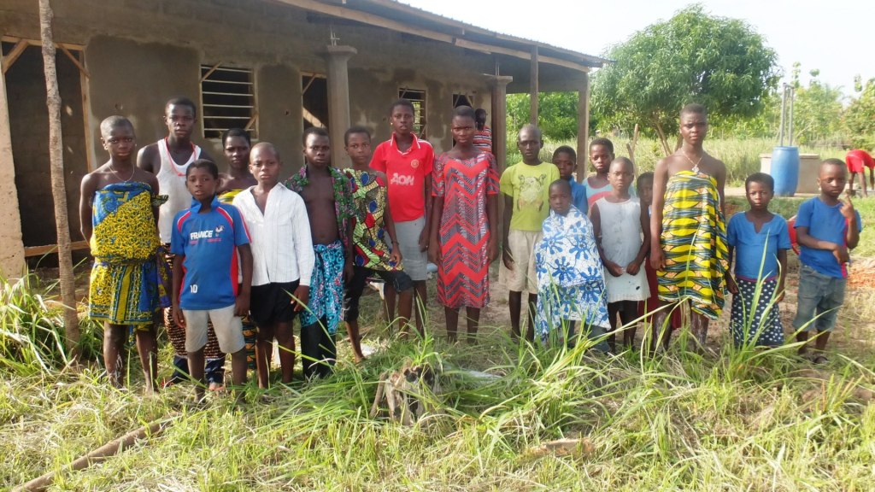
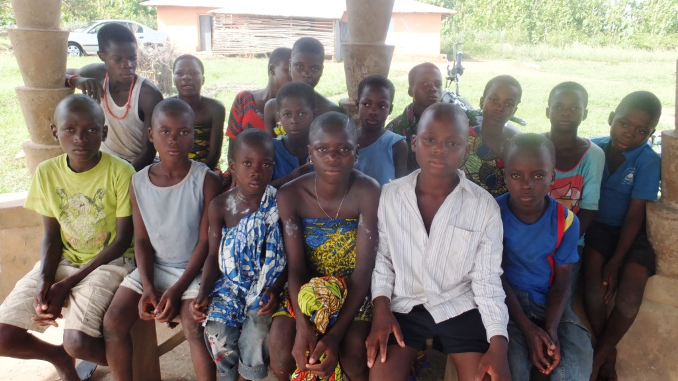
Our last visit to the orphanage enabled us to commune with the orphans and share some food together with them. We were also able to supervise the completion of the orphanage building activities and visit the orphanage farm in order to make sure the crops are growing right.
Visiting with the orphans
Orphans with their friends
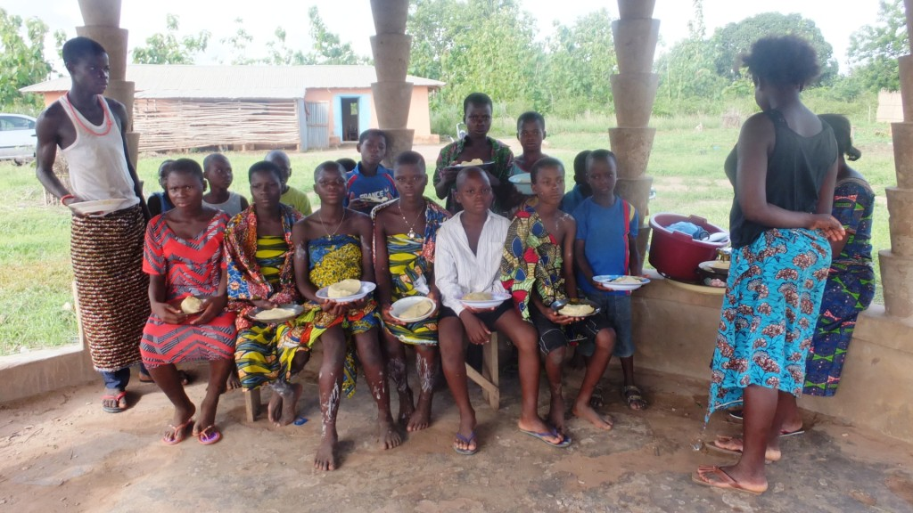
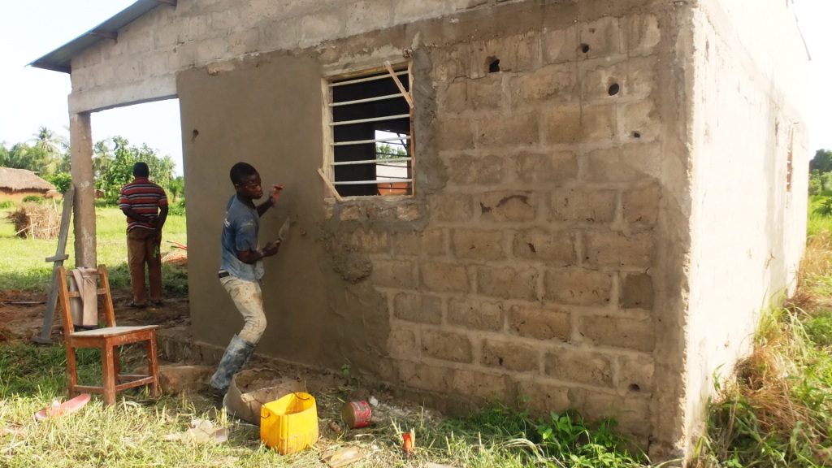
Sharing a meal
Plastering the walls of the new building

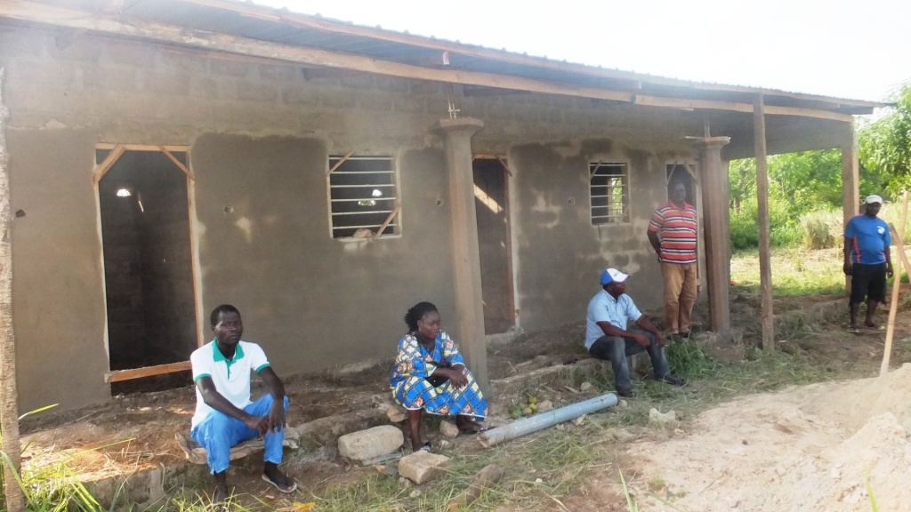

The new orphanage building not yet completed. Thanks to your latest donations, the plastering is now finished, and floors cemented. The doors and windows were just bought and have been installed. Financial means are still needed for the ceiling, the painting and the locks and then the building will be completed!

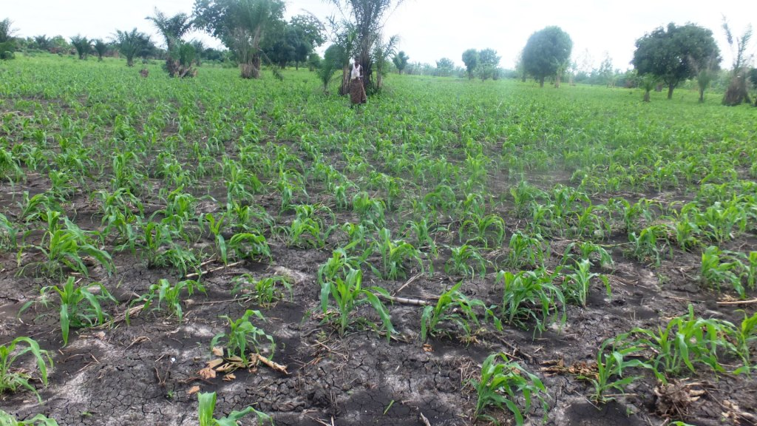
Visit to the Orphanage Farm

WHY a cassava field for the Orphans?

Please allow us to share with you why the orphanage often has a cassava field: just kids can prepare the cassava tubers on the fire and eat especially when we lack money for foods. Or they can cut the tubers into small pieces to dry in order to turn them into powder to prepare the paste which is eaten with sauce. Some tubers are sweet but others are not sweet. But the ones you see below are sweet and it depends on the breed.

The corn field
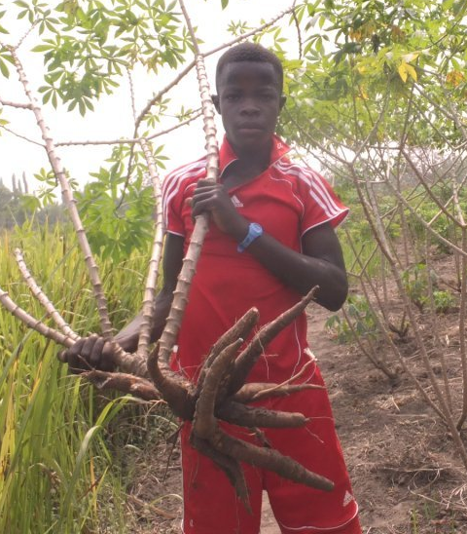
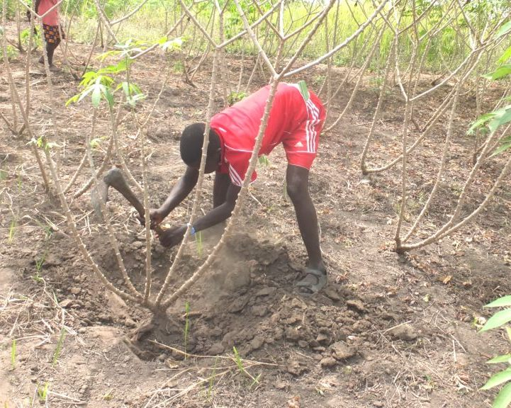
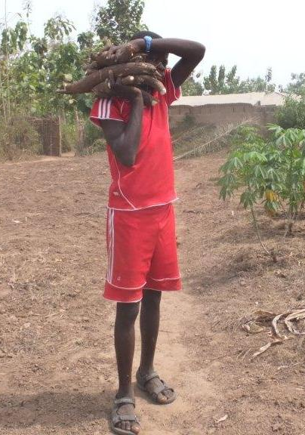

Harvesting cassava

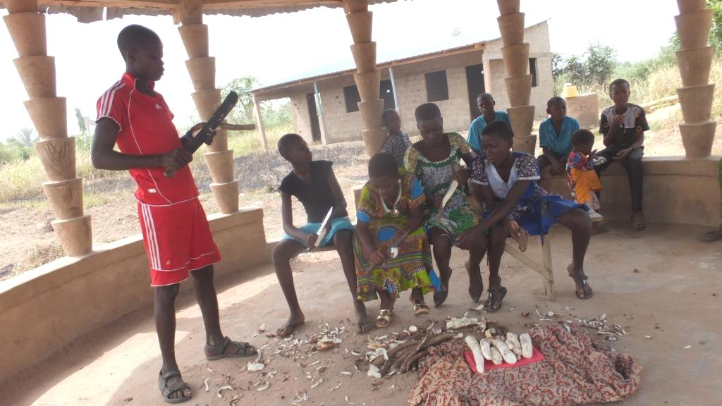
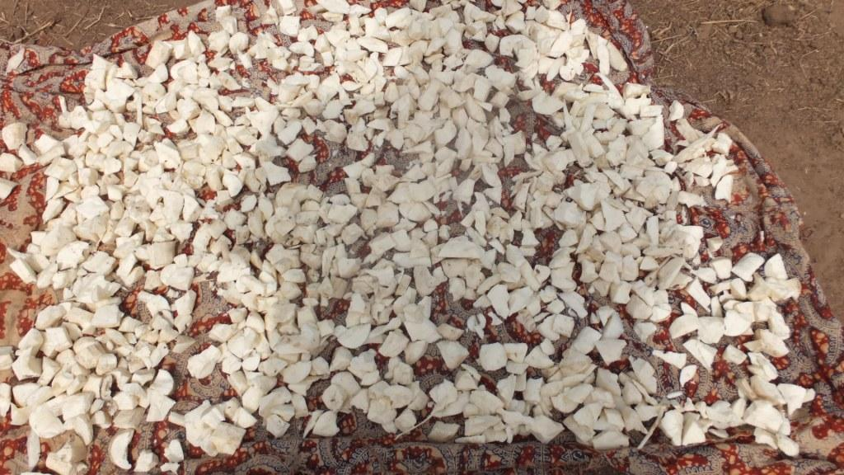
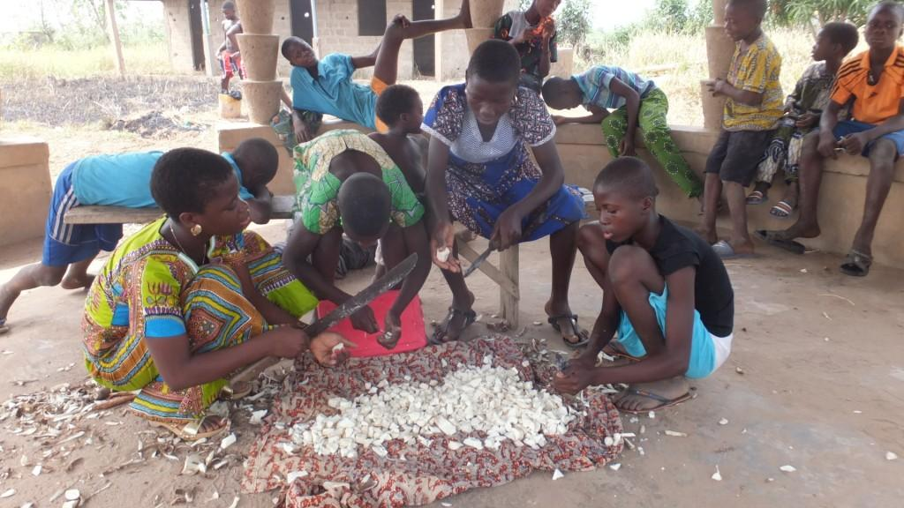
Chopping and preparing the cassava to be dried in the sun before grinding into flour is very time-consuming but all the orphans help. Once turned into flour, it can be kept until mixed with water to form a paste and cooked (much like semolina).

S.O.S: for the Orphanage Church Building
We would like to urgently request from you to pray for the completion of the orphanage church. We erected these corner posts in faith last year as the present bamboo building is far too small and falling down.
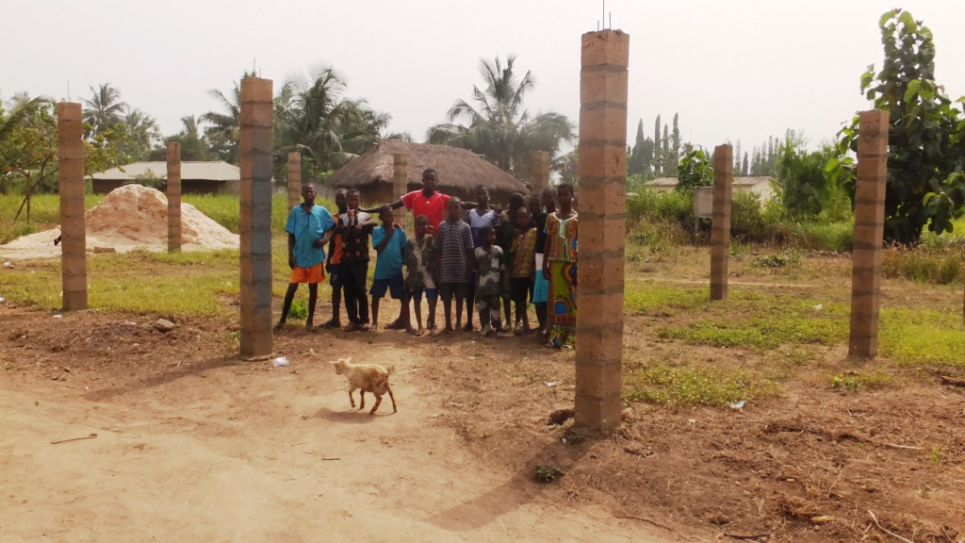

HELP PLEASE !!!

Church Planting
The sad news is that much of the Togolese population is still lost. Latest statistics show the following results: Paganism 50%; Muslim Religion 20% and Christian Religion 30% (includes all Christian denominations). And are all the 30% really saved? The answer is no.
This defines our real motive of seeking to reach one of the villages called Fiokondji and which is located in the South Eastern Region of Togo where idol worshiping and magic practices are at their peak.

Description of the Region
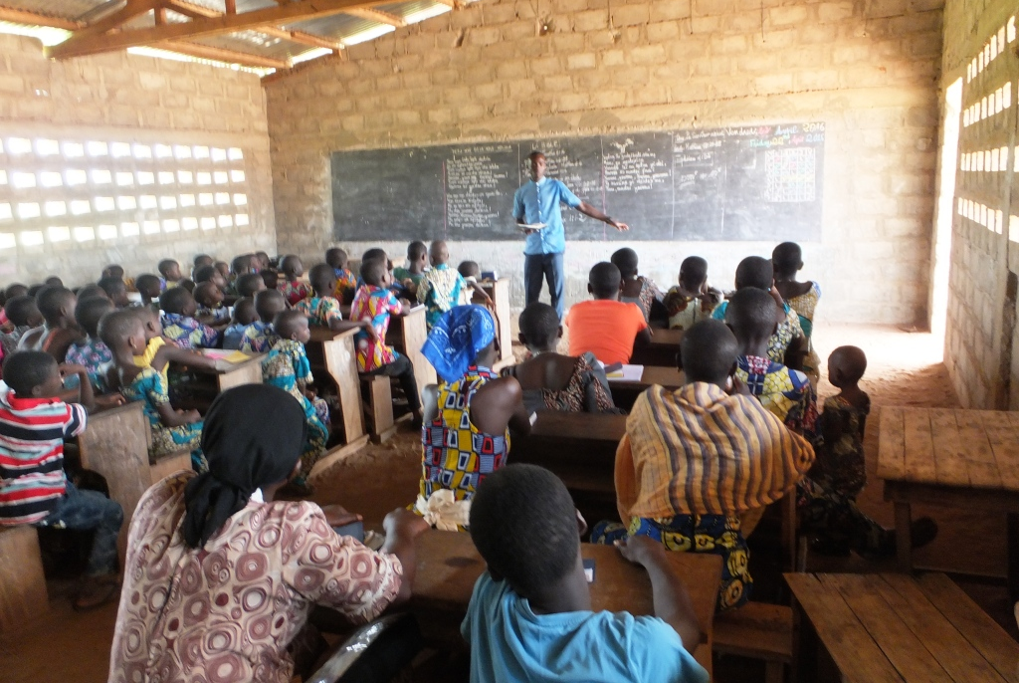
The South Eastern Region of Togo is renowned for its idol worshiping. They worship air, water, sirens, thunder, trees and stones which they consider as their gods. They develop a certain pride for their voodoo worshiping and always prove hostile to the Gospel. This is our motive for planting our church in the village of Fiokondji as it will prove to be the beginning of the spread of the True Gospel which will result in the planting of so many of our churches in that region renowned for its hostility to the Gospel.

S.O.S: Special Requests for this Region
We pray that God provides financial means for the purchase of a land and the church building. Right now we are worshiping in the premises of the village school. But, unfortunately, we are being evicted from the place. We have been given up to the end of this year 2017 as the deadline for vacating the place. This thus defines urgent need of finding a piece of land on which we can set up our church building.

Open Air Evangelism: All our actions aim at the salvation of souls
My church, Bethany Baptist Church has organized an open air evangelism program which is destined to preaching the Gospel to the youth throughout a soccer game.
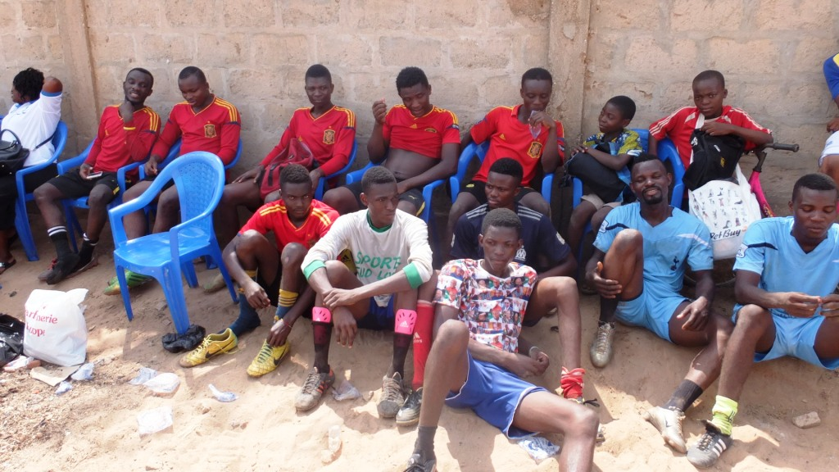
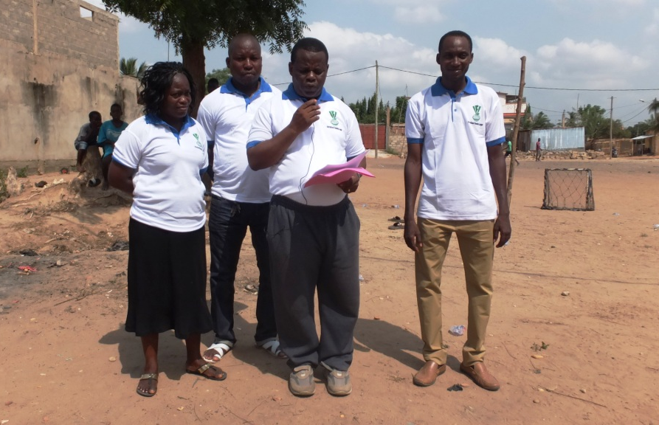

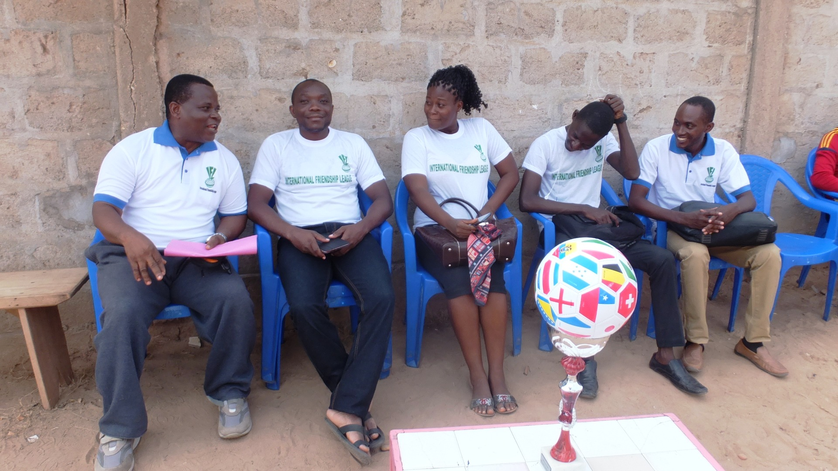
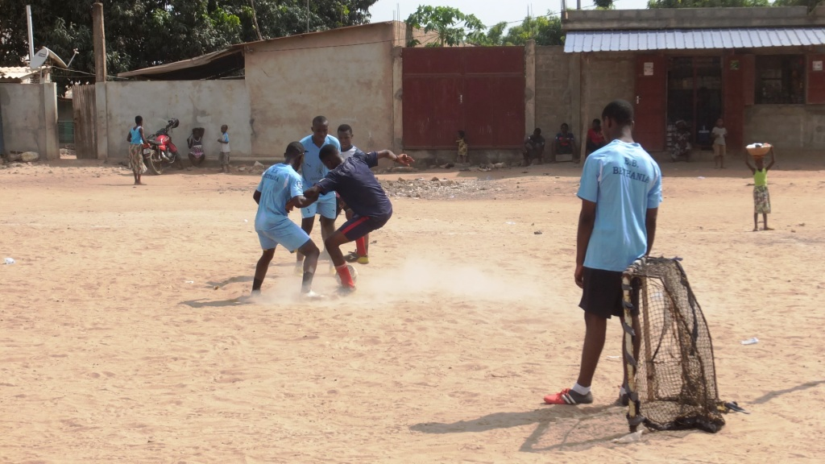

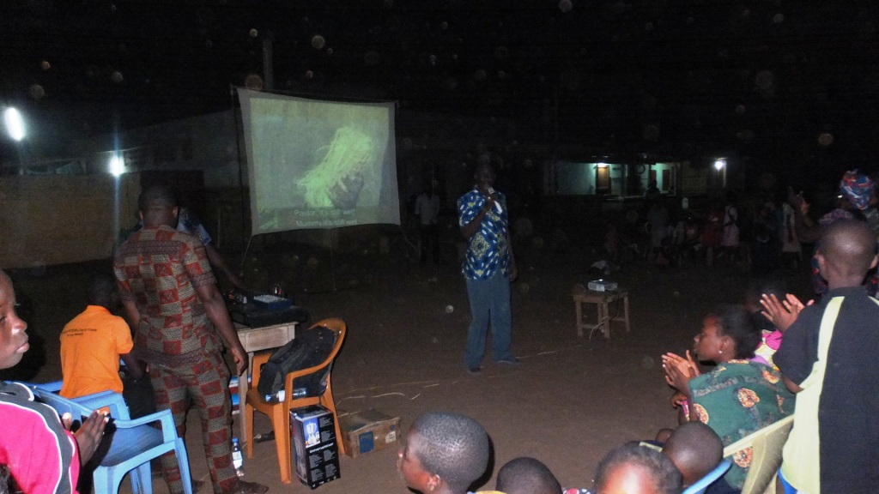

Evangelism campaign in the Village called ABOBO
We are thankful to the Lord for enabling us to carry out evangelism campaigns in villages and that so many souls are coming to Jesus Christ. Your prayers and financial support are really welcome.

Training Ministry
We are grateful to the Lord for enabling us to keep on carrying out trainings for pastors so that, through them, our Bible Courses could reach distant places throughout the country. We would also like to be grateful to the Lord for Randy’s family serving in Ukraine. He provided us with books for pastors’ training. These books prove relevant for pastors to work in hostile areas and are more adapted to our African realities. We therefore request from you to pray for the financial means in order to print these books.
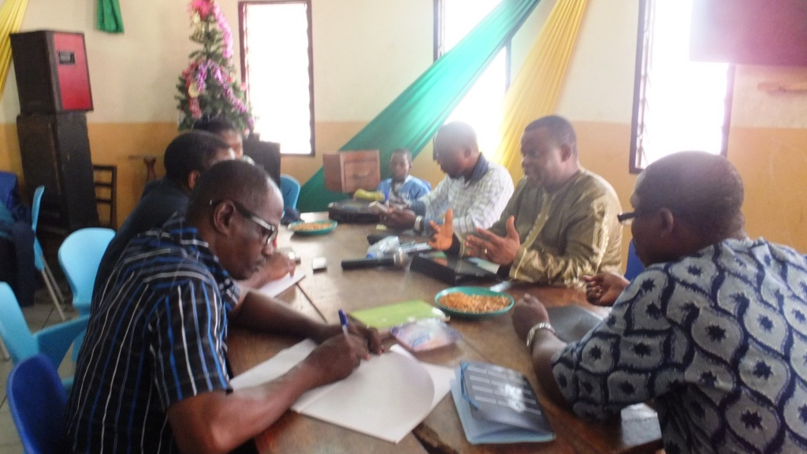
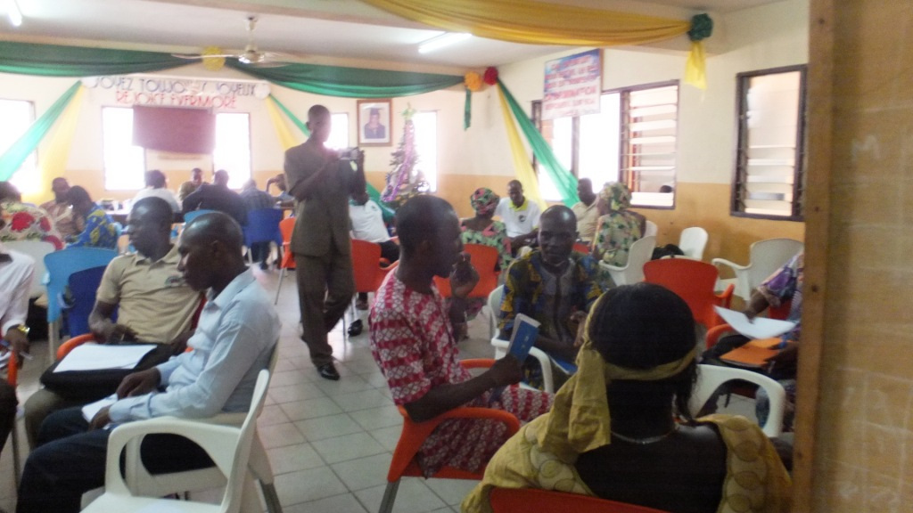

Prison Ministry
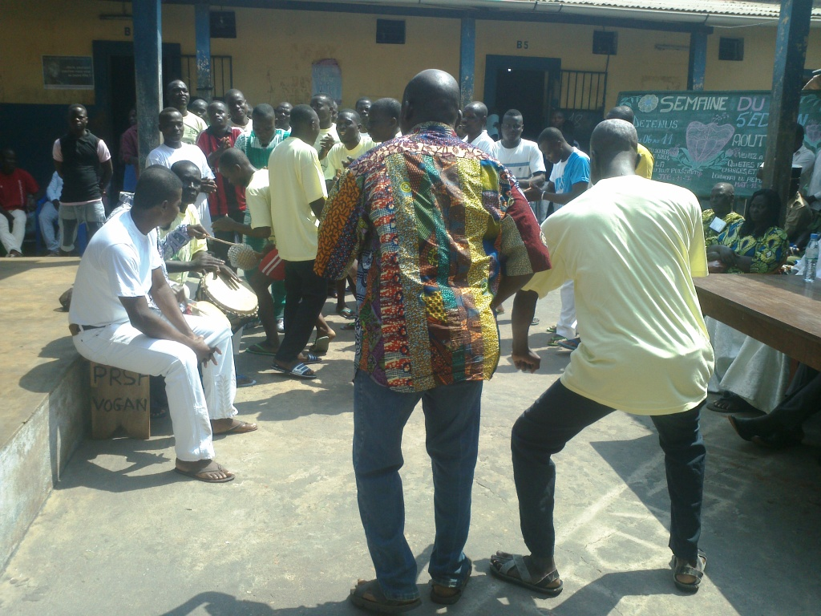
By God’s grace, we have been able to visit some prisons again recently. Prisoners rejoiced during the celebration of Prisoners’ Day and Vogan District authorities also witnessed the event:
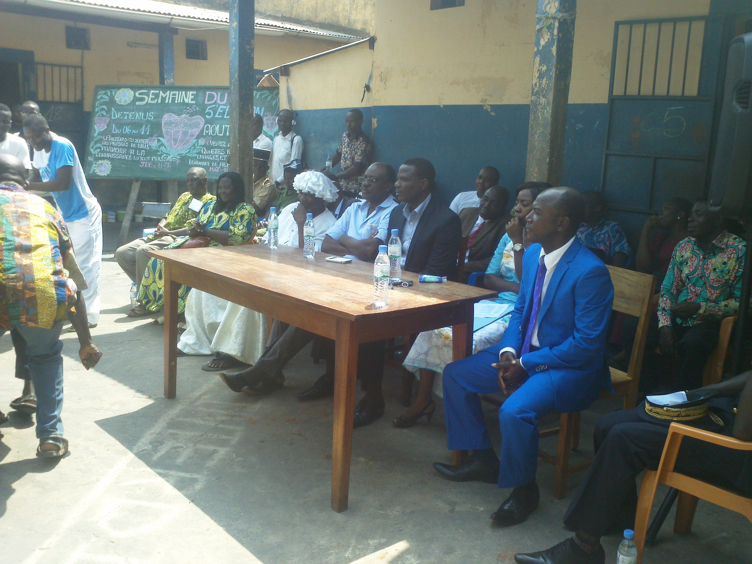

SOS: Local Missionaries Needed
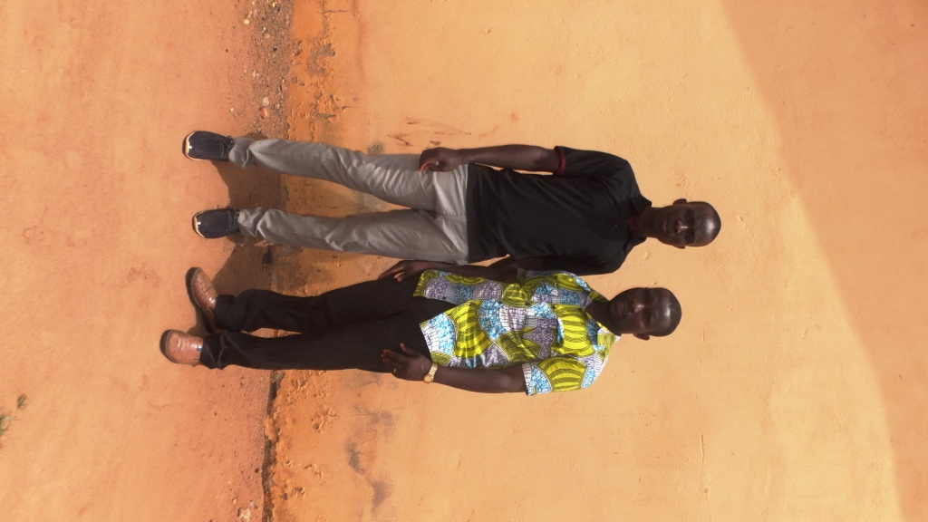
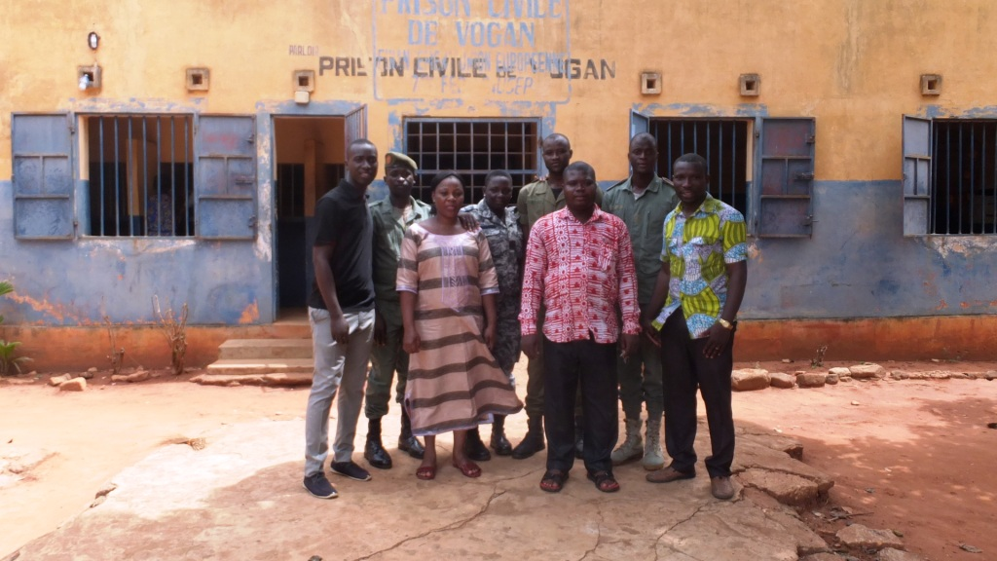

Brother Senyo and Brother Toussaint are seen here with other local missionaries to the prison and the prison authorities. There is no doubt about the two brothers being called for Christ’s ministry. I need your prayers so that God could touch hearts that could financially support them, lessening thus my task. Therefore, I need your prayers so that each one of these brothers could be financially supported with a total of $200 a month for the field work to be effective. They do help me also in other areas of the ministry such as church planting, prison ministry and school ministry. I also need a secretary who could help with office work. She also needs to be supported with an amount of $200.

Our church, my team and all my family constantly keep you in their prayers. May God richly bless you.
Pastor Sika and Lucie.

