**Togo Latest Term Newsletter Update June 2017**

Togo Religious Statistics

N.B: Bitter Remark



**The Evangelicals (all church groups combined) represent only 9% of the population. The Baptists just represent a tiny portion of the populace coming close to 0.07%, the fundamentalists included.**

# All-Out Battle for the Spread of the Gospel in Problem Mission Field

Definitely, I have come to the conviction of my Call to serve the lord in problem mission fields, where Church planters and Evangelists experience outrageous persecution. Contrarily to what most people think that China and India are the only most problematic Gospel fields in the world, the Lord, through the power the Holy Spirit, has led me, in the scope of my ministry, to most spiritually darkened confined areas in Togo, West Africa, which are still shut out from the light of the Gospel and which prove to be totally baffling well-informed preachers. After our attempt to reach the Village of Fiokondji (an area reputed for its hostility to the Gospel and Evangelists,) the Lord led us to the village of **Agbanakin**, a neighboring hamlet which proves more challenging and brain teasing to me as a preacher. The hostility of such a hamlet, according to me, is totally unheard of in the world. However, it may be beyond human’s might, but not beyond God’s might. I faithfully believe the Lord has allowed me to touch this hamlet for the Christian world to clearly see that there are still areas in the world which still remain in unthinkable darkness and which need to be reached by the Gospel according the Great Commission of Matthew 28.

In spite of these two women’s desperate situation (they live in those huts built just at the roadside,) they refuse to give their lives to Jesus for fear of being killed by the devil.

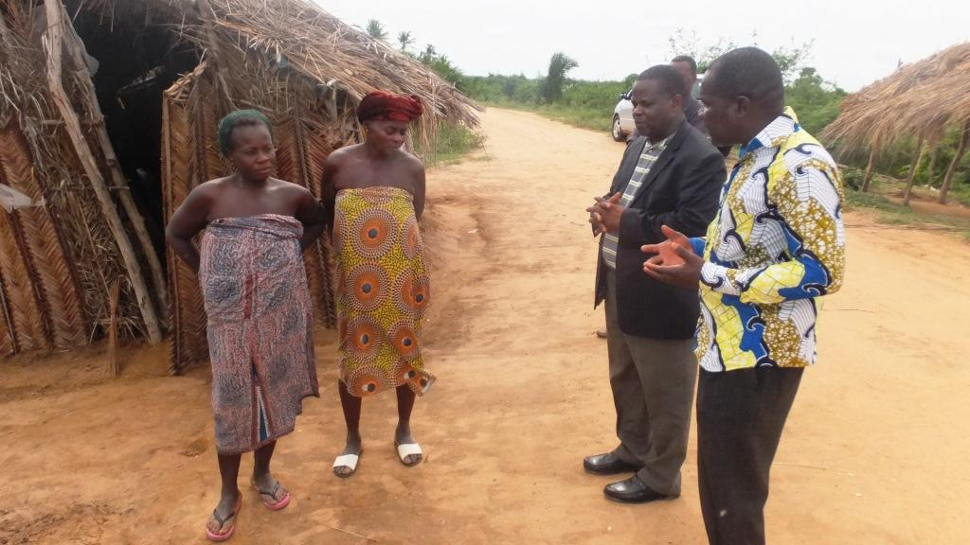

**Historical Background of the Hamlet of Agbanakin**

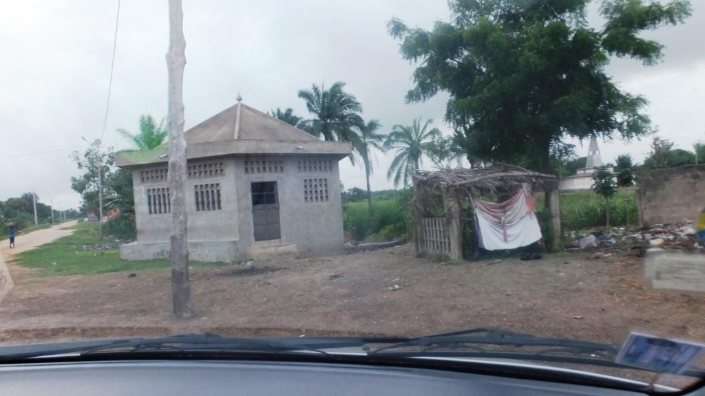

Agbanakin is a hamlet located in the coastal areas in Southern Togo and is one of the many villages which are in the Togolese frontier zone with Benin. It is a hamlet which has as sole religion idols worshiping. According to the testimony of the village chief, the whole village has been grounded on idols (idols have been buried throughout the village and serve as its foundation) and every home has its own idol.

The main entrance of the village is the site of a fetish

which welcomes every new comer to the village.

A religious shrine has been erected in full heart of the village and serves as place of pilgrimage and high sanctuary whereby eminent priests perform 24 hours sacrifices for the village people. The village is renowned for its radical hostility to the Gospel in that no preacher or church is allowed in the midst of the village people. Evangelists who venture to bring the Gospel to this village are violently driven away by the youth. Though most of the young people have a high school education, they all prove fanatics of idol worshiping and are the main actors of the village pagan religion. There are many Togolese learned scholars who originate from this village, but they have all fled for fear of being killed through fetish practices. Those few of these intellectuals who can often visit or live in the village are those who identify with the idols practices. Some of them even become in turn fetish priests.

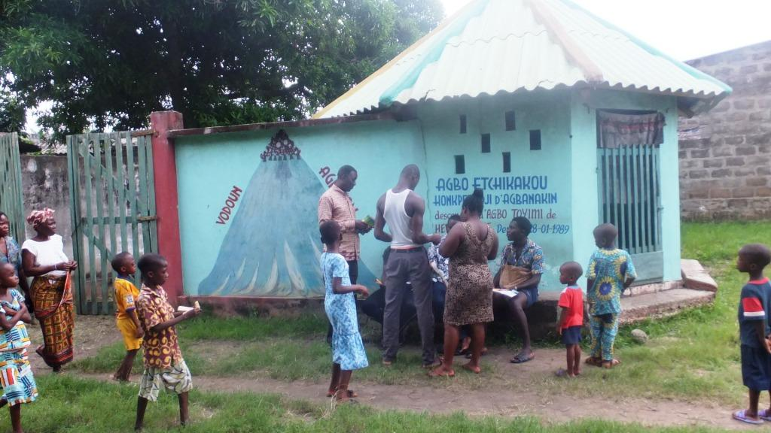

**The Village Chief’s Palace built by the pagan well-off intellectuals**

# 

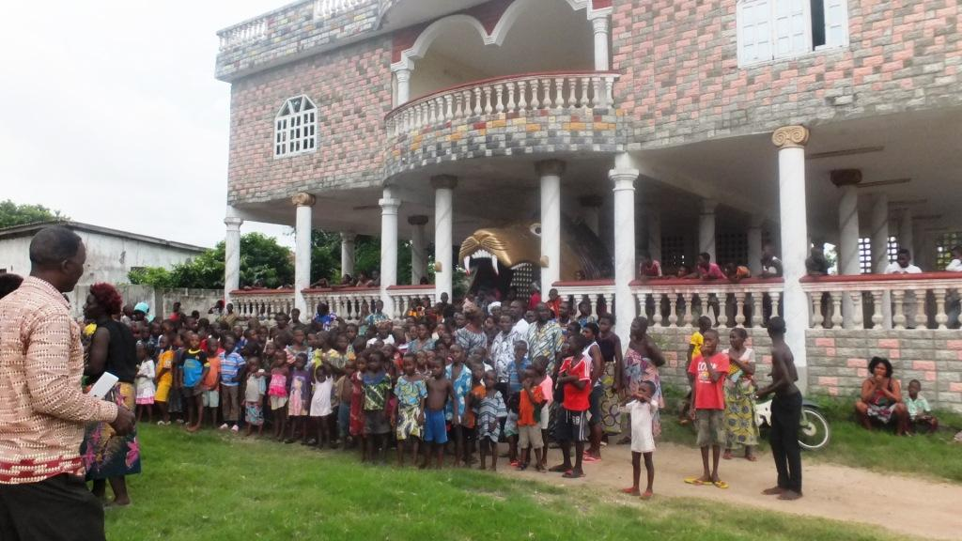

# Our First-Visit to the Hamlet of Agbanakin

As I was forewarned concerning the reception earned by the Gospel in this village and the rebellious attitudes of the village people toward evangelists, I requested the help of three other Pastors with whom I first of all organized a three-day fasting a prayer session on behalf of the ministry to be started. When we first set our feet in the hamlet of Agbanakin, we were welcomed by two of the fetish priests. The two fetish priests led us to the Prince Regent who has taken over from the village chief who had passed away two months before. Even before we could introduce ourselves to the Prince Regent of the village, the two fetish priests revealed our identity of preachers and started instructing a set of warnings. We were warned not to preach Jesus and were told that Church planters were not allowed in their village. We were then to find a strategy to reach those people in darkness without offending them for fear of being expelled from the village.

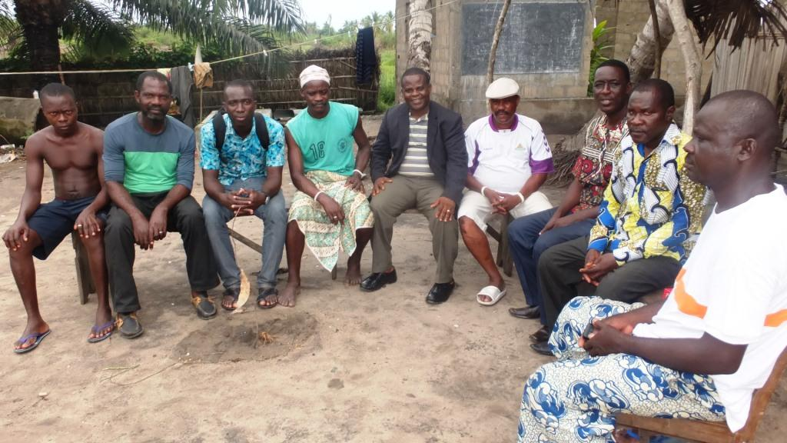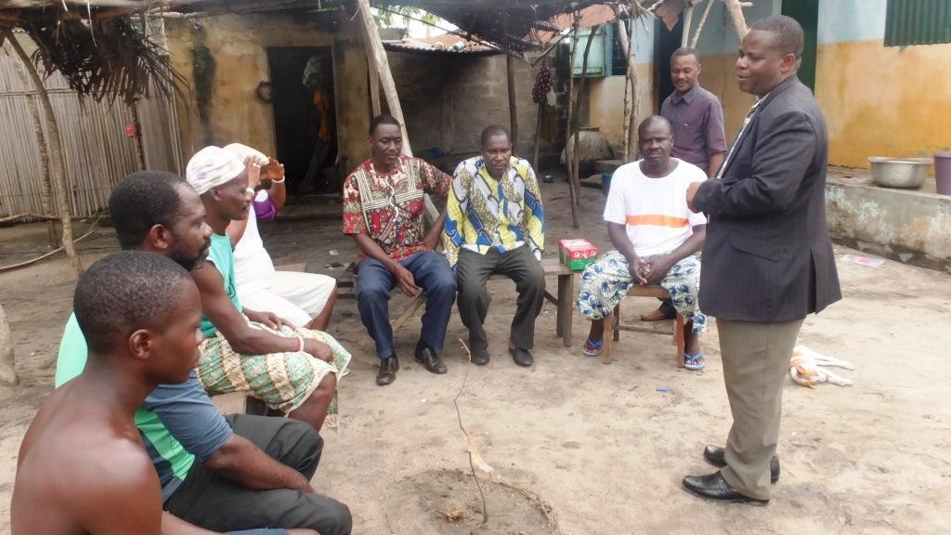

**I am sitting between the two fetish priests**

**Answering questions to the fetish priests**

The Lord flashed our minds back to the shoeboxes which were of great use in our attempt to reach all the village of Fiokondji. We therefore introduced ourselves as missionaries caring for the welfare of desperate people and requested from them to call upon some village kids toward whom we could demonstrate our love. Henceforth, we distributed the shoeboxes to 40 children and the hearts of the Regent and the fetish priests were deeply moved through our actions.

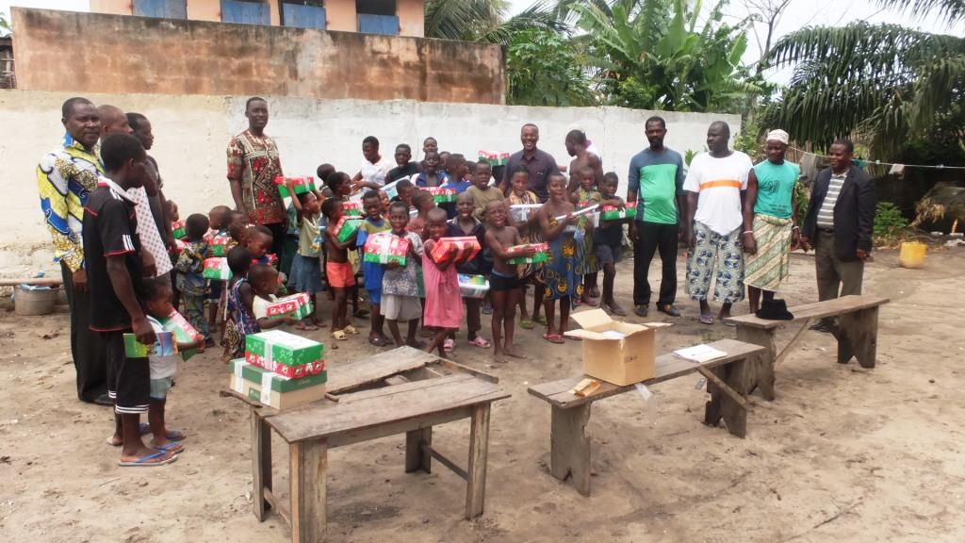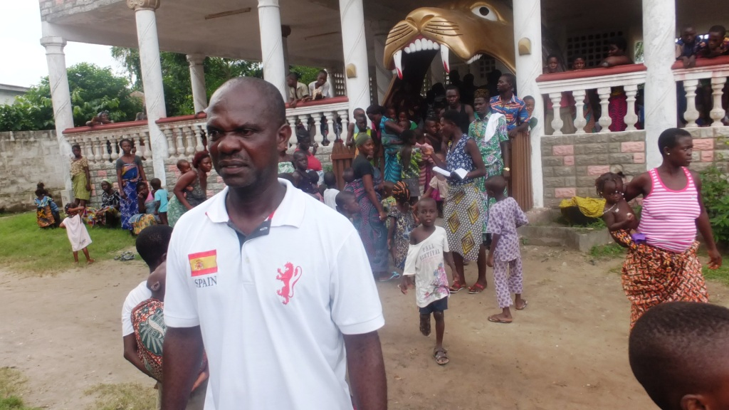

After the shoeboxes distribution, the Regent displayed his joy and informed us that he appreciated our love for the kids. They expect from us to do more since most of the village is crawling under the weight of poverty. However, they kept a watchful eye on us. He let us know that they had previously driven away pastors of other churches such as Assembly of God and Pentecostal. The Regent formulated the desire of being one of us and promised to gather the whole village population during our next visit.

**The Regent who God uses to enable us to reach out to the village**

**Our Second Visit to the Hamlet of Agbanakin**

God enabled us once again to pay a second visit to the village of Agbanakin and meet a crowd consisting mainly of women. The meeting took place in the Chief’s Palace, not far from the fetish shrines. All the eminent fetish priests of the village took part in the meeting. They licensed me to speak, but strongly warned me not to mention the name Jesus in my speech, not to talk about any church, not to mention the word pastor in my speech. We were called by the term “Guests” and not “Pastors.” Since they did not have any knowledge of mission, I always mention the name “mission” instead of “church” and even told them that we were missionaries. Upon getting the floor, I was confused and I asked God what I could say. My mind flashed back through the Bible and I focused on the story of the Richman and Lazarus. I could conclude my message by telling them about hell which will be the destination of all those who disobey God. But still, I did not mention the name of Jesus Christ. The meeting was brought to an end and another date was set for a movie projection. All the village people are looking forward to this date. But what movie should we show, since they do not want to hear about Jesus, Church, or Pastor? We sincerely request your faithful prayers.

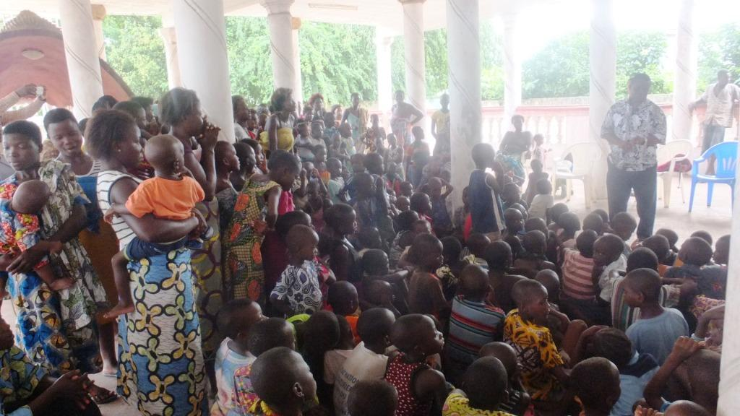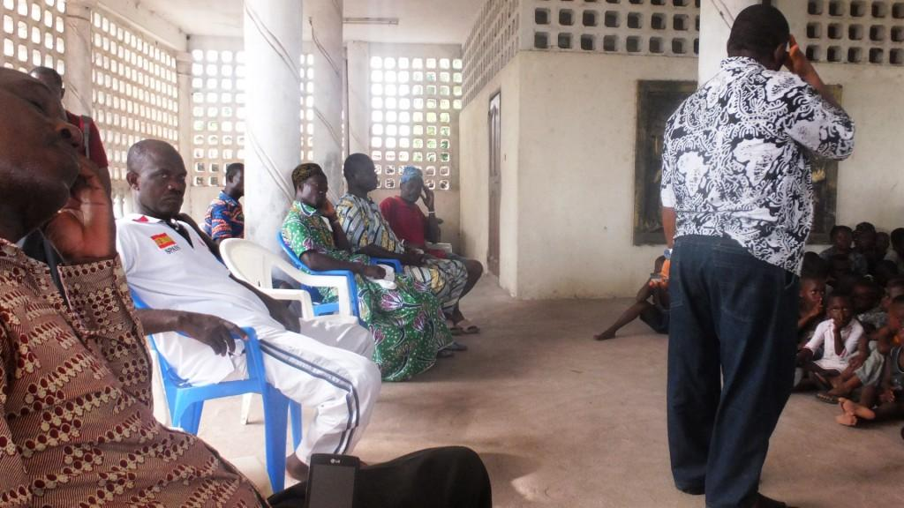

**Speaking to the crowd**

**Allowed to speak before the fetish priests but wondering about what to say due to the restrictions**

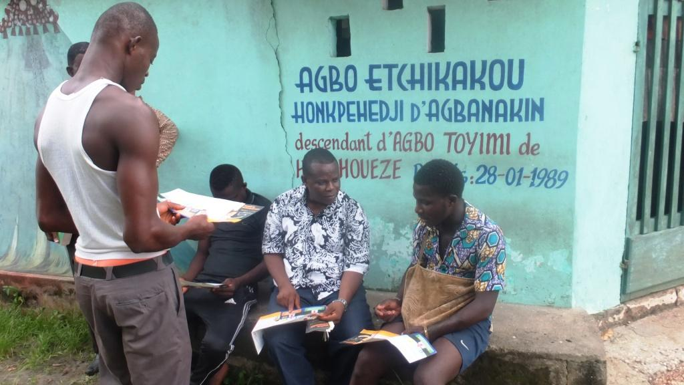

I took my courage in both hands and started ministering to some individuals thanks to a tract I was holding in my hands.

**Outcome of the Two Visits**

By the end of our visits, there are three people who promised to be faithfully engaged by our sides, though not saved. They expressed their innermost feelings about being fed up with many years of Voodoo practices and need to experience our God. These people are: The Regent, a notable leader, and a Voodoo follower. However, they warned us that it would not be an easy battle.

**Our heart cry**

For the planting of a true church which could change the story of this village, we sincerely need you to include the following objectives in your prayers:

1) Our spiritual and physical protection

2) The reinforcement of our financial capacity to enable an enhanced development of the children’s ministry in this area, to offer support to the widows and orphans of this village; what would serve as ground for the Gospel to be spread.

3) Given the renowned hostility of this village to the Gospel, can the promotion of a social development project be excluded from our plans? Can’t we promote projects such as providing the village people with first-aid health center? A hand training center for the young fetish priests which could help instill in the darkened poor souls the light of the Gospel?

4) Moreover, another heart cry is our utmost desire for your visit to our mission fields as a sign of encouragement. This can enable you to better pray on our behalf. This is an important request.

**Some testimonies of the salvation of souls**

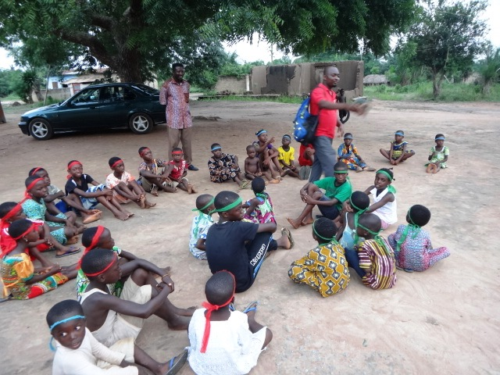

**In the scope of our Children’s ministry**

We are grateful to the Lord who achieves greater accomplishments for the salvation of children in the outskirts of Lomé and the inlands of Togo throughout Brother Donald and his wife. Up to now, our Bible Lessons enable them to reach 250 kids split up in 4 Child Reap Centers. In these centers, those children consisting of orphans, street children, abandoned kids and deprived children are being ministered to on a weekly basis. This special program which aims at the salvation of kids through Bible Studies, and recreational activities, offers psychological, social and spiritual assistance to the kids.

Most kids in the Child Reap Program are deprived with no support. To avoid these kids becoming dangers for the society, and to demonstrate God’s love to them, Brother Donald and his wife need financial support in order to meet the educational needs of the children, and provide food and clothing to them. They are fully involved in the children’s ministry as volunteers and even sometimes invest their own means to take up the challenges of this program. Your help and contributions will enable this program to be more efficient in the Lord. It will also enable the couple to reach children in problem mission fields such as the villages of Agbanakin and Fiokondji as their ministry proves to be a support for church planting in those areas. To reach this objective, **we need a monthly financial support of $300 for Brother Donald and his wife**. Your prayers are requested for this family.

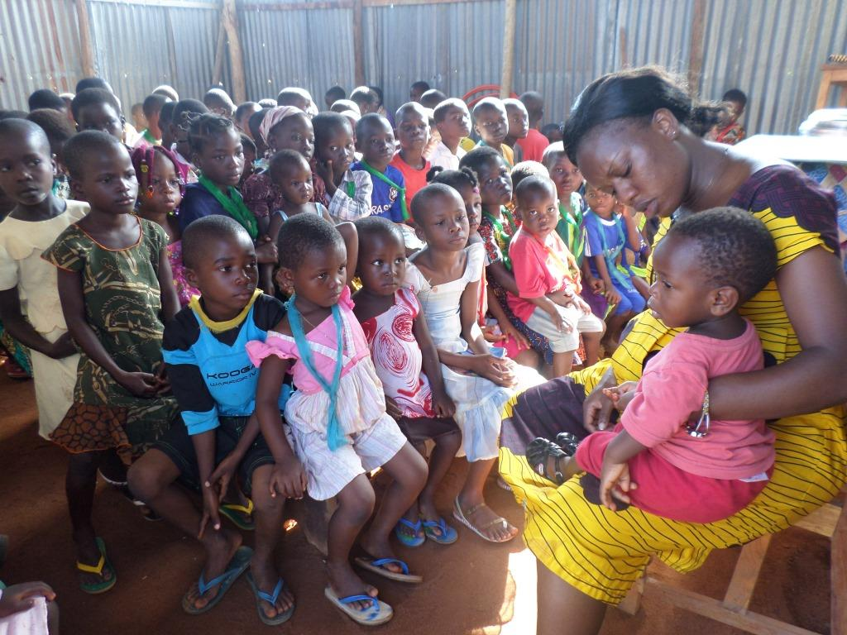

**The Salvation of Two College Girls Who Strongly Need Your Prayers**

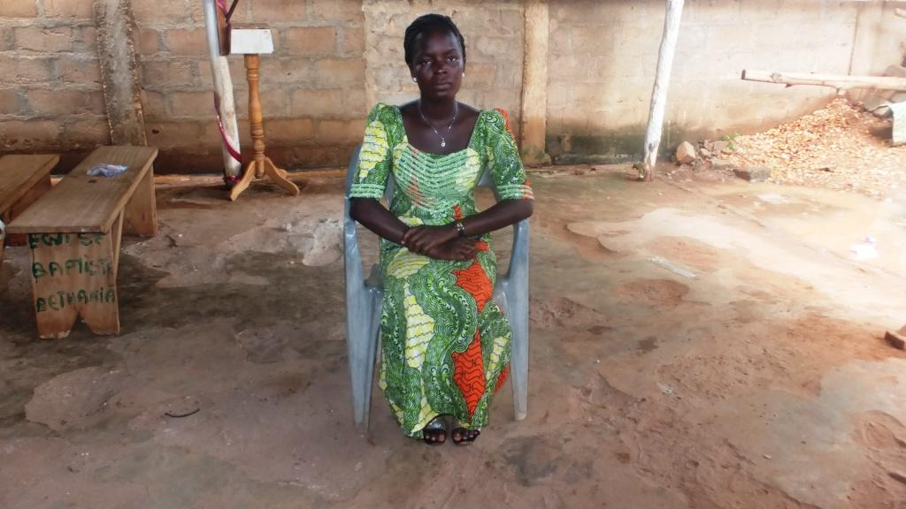

Françoise, a college young girl of 25 years old ventures her first step in faith by surrendering her life to Jesus Christ despite all-out persecutions forwarded by her unsaved mother with whom she spent 18 years in religious wandering. Françoise displayed earnestness in the study of our Bible lessons which led her to a faithful confession of Christ. Being now convinced of the Truth of the Gospel, she feels obliged to spiritually separate from her unsaved mother still blinded by false religious doctrine and fake religious zeal and this obviously earned Françoise serious persecution and rejection from family. We hereby request your prayers in favor of this young girl to be deeply rooted in the truth of the Gospel, so she could be able to victoriously face all tempestuous winds caused by her decision to be born again. Please, also pray for her financial support and her unsaved mother to also benefit by God’s grace.

Another student, Sandra, in her 25 years has eventually come to the knowledge of the Truth after been through years of prostitution. In fact, this young girl, since the age of 18 has been forced by her parents to drop out of high school and get married. As a result of her refusal to comply with such a decision, she lost the support of her family and was obliged to face her destiny alone. In order to survive and meet the financial requirements of high school and college studies, she desperately sought salvation through prostitution. After being acquainted with us and our Bible lessons, she became aware of the dangers she was running into and her need for salvation through Jesus Christ. Now, she has earnestly confessed Jesus Christ and has become a Christian. We hereby request your prayers on her behalf and for her financial support.

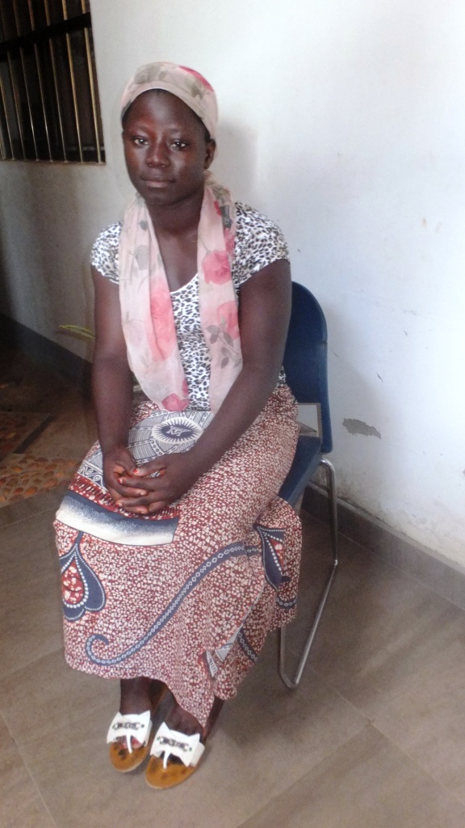

**Urgent Prayer Request for a 19-year old Christian Girl Suffering from Breast Cancer**

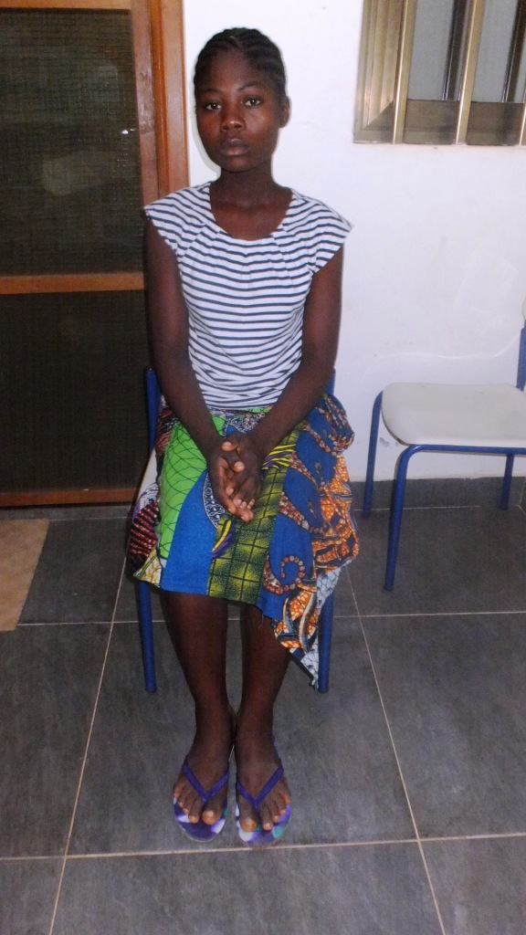

Jolie is 25 years old and has been suffering since last year from Breast cancer. Now her situation is getting worse since she lacks financial means to have access to a hospital. We humbly request your prayers for God to provide financial means for her healing. ($200 can be useful to save the sister.)

**Acknowledgements**

Hereby receive all our sincere gratefulness for your spiritual and financial support. Without your support, it is difficult for the ministry in Togo to be efficient. May God shower you with all sorts of blessings and we always make mention of you in our prayers.

**Prayer Requests**

Your prayers are needed so that the Lord provides us with the strength and courage necessary for the accomplishment of His ministry in problem missionary fields.

Please, do pray for the financial support of my family

Please, do remember to pray for the Lord to provide for the building of the church in Sika Kondji in the premises of the orphanage

May God provide financial means for the purchase of the land and the building of the church in the village of Fiokondji

Please, pray for the purchase of land in the village of Agbanakin and for the building of the church for, we have faith to set up our church in this hostile area.

May God also provide financial means for the purchase of two motorcycles for our local missionaries

We pray for the financial means for the implementation of a seamstresses workshop project.

Thank you, Pastor Sika and Lucie from Togo, West Africa.