Togo news update January 2018
Hi ! Beloved in Christ, Brother Gerald and Sister Shirley,
All my apologies for not being able to write you sooner owing to the political situation in our country. Actually, we witness an extremely hard political situation. The political situation offers all countrymen a terror-stricken environment in which riots and violence are common place. The people are forced to live through hard working conditions due to the fear of being a victim of such a situation and the constant power cuts. All displacement throughout the country is virtually risky for fear of running into a riot and turning into a victim. This situation has considerable incidence on the economy and has originated in considerable rise in the prices of foodstuffs, fuel and other consumable goods. The country has been ruled over sixty years by authoritarian military government which makes use of dread to strengthen their authority and to launder the wealth of the country in foreign banks abroad. The son of the late tyrant president took over the ruling of the country since 2005 and seeks to perpetuate the tradition established by his late father. As a result, only a minority (those who agree with and defend passionately the governing system in place on the basis of self-interest) enjoys the prestigious privileges in the country, leaving behind them a sad poverty-stricken majority who live under the poverty line and who always finds it difficult to make ends meet. In spite of this situation, God has empowered me and given me full access to his grace in order to fulfill some activities. Still, we hereby humbly request your prayers for the effectiveness of peace in my country and for God to help change the socio-economic and political situation established by this tyrannical government which is unwilling to share.
A Call on the Orphanage at Sika-Kondji
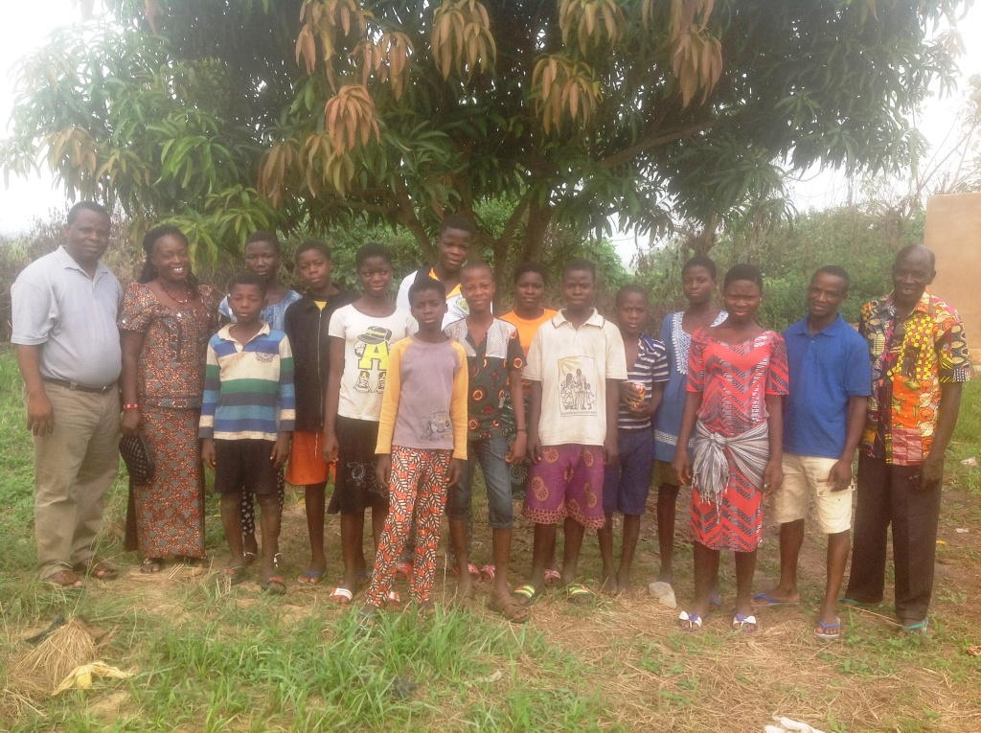The end of the year 2017 witnessed our visit to the J. P. Orphanage of Sika-Kondji during the Christmas period. This was the perfect occasion for me to minister to the orphans and communicate the joy of Jesus Christ with them through a fellowship during which the opportunity was given to them to take part in food sharing together with us. I was therefore able to share their worries, give those kids pieces of advice and give them hope for a bright future in Jesus Christ.
It should be noted that all the orphans and the leading team were strengthened by the message of Sister Shirley. All the orphans had their school fees paid and each orphan received some pocket money as gift to start the New Year. All the kids pay due respect to the offerings of Sister Merrill consisting of medicine and postcards.
We hereby express our grateful thanks to you for your help and ask God to bless you abundantly according to his grace and immense riches. Please keep praying for the orphans and their spiritual growth in Christ.
During this period, we were able to have a get-together with the leading team of the orphanage. This meeting was held inside the new church building and enabled us to assess our previous activities of the year 2017, discuss important issues regarding the organization of the orphanage and future projects in the scope of the New Year 2018.
Please, do pray for three orphans who suffer from HIV/AIDS as they need spiritual, medical and financial support in order to regain psychological balance. My real motive for allowing these three kids in the orphanage is to avoid them being victims of stigmatization within our society. For this reason, pray for their social reinsertion. Please, do pray for the Lord to provide a monthly amount of $1,000 as this amount can cover their medical and food expenses.
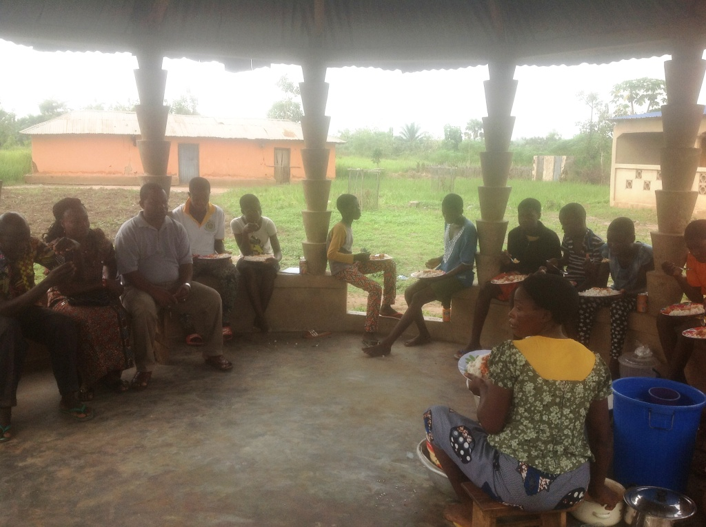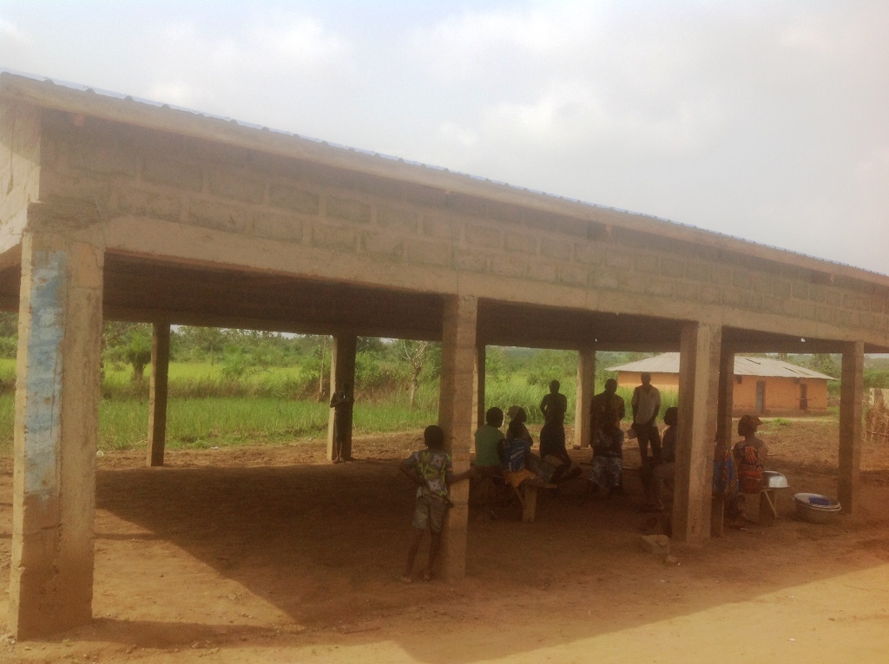

Doing Up and Improving our Home Bethania Baptist Church
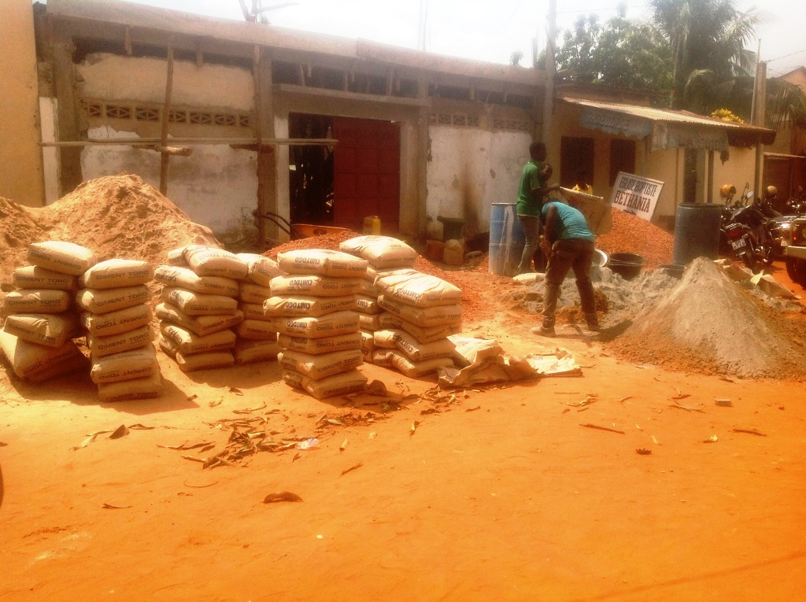One of my important visions for the New Year 2018 is the doing up of our home Bethania Baptist Church which is located in a Muslim area in Lomé. To my mind, the improvement of the church building is vital since we are growing in size and spiritually.
Since God lays upon my heart the burning desire to renovate the Bethania Baptist Church in Lomé which is the headquarters of all Bethania Baptist Churches in Togo, I started saving each penny donated to me for my personal use and other donations for my family use for this purpose. My sister and her fiancée also considerably contributed to this renovation, especially the building of CHILDREN’S SUNDAY SCHOOL CLASS. For the completion of the Sunday School Class building, we still need an overall of $6,000. We are grateful in that God is adding every now and then new converted souls to the church. We are grateful to you for donating for such activities which is being carried on for the glory of the Lord.
Cement and sand provided for the church building renovation

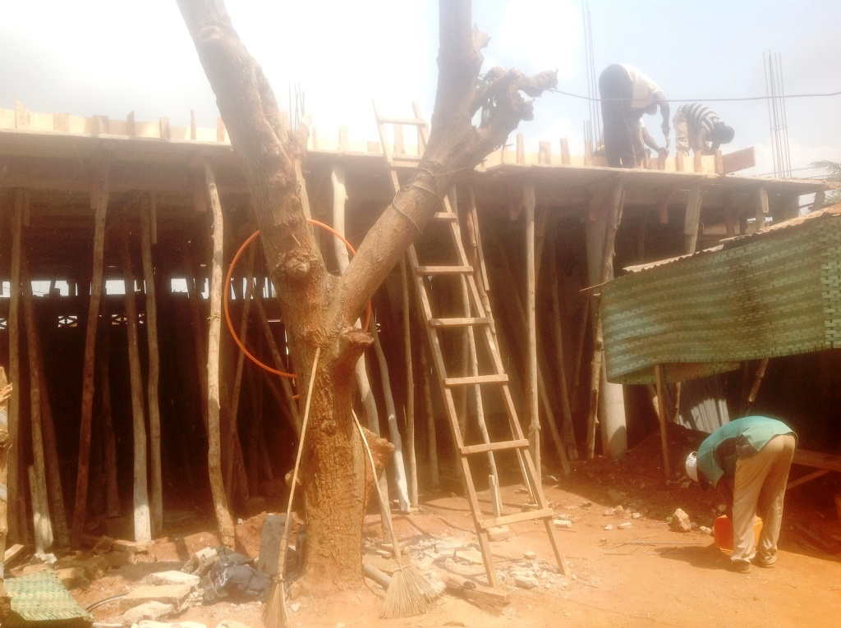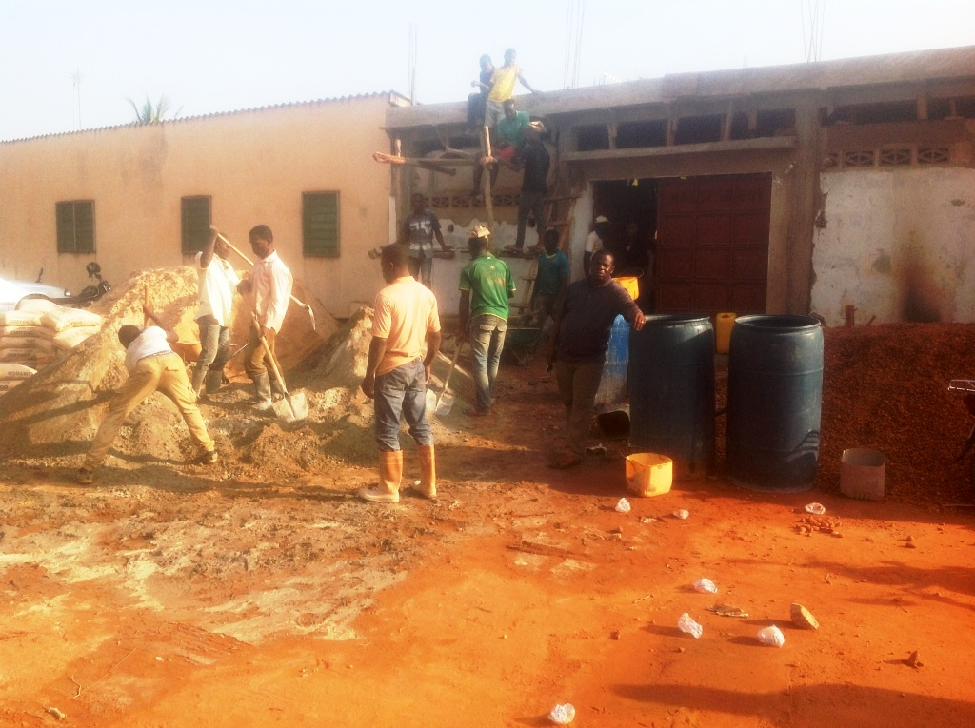

Meeting with the Village People of Sika-Kondji for Appointing a Village Chief
I was invited to take part in an end-of-year meeting organized in my home village Sika-Kondji. This meeting comes as the result the village people’s assessment of the village chief’s performances in the course of the year 2017 for the development of the village. This meeting concluded in the outburst of the growing discontent of the people with the village chief who is accused of bad leadership and the people’s sanction of deposing him. I was therefore appointed by the people to take over him, but I made wise use of this opportunity to turn down their proposal and preach the Gospel to them. In my address, I told them about their necessity to believe in Jesus as Savior in order for them to witness positive changes in their lives.
I humbly request from you to pray for this purpose to be fulfilled in the village and for God to provide them with an efficient and faithful chief who can carry out well his tasks.
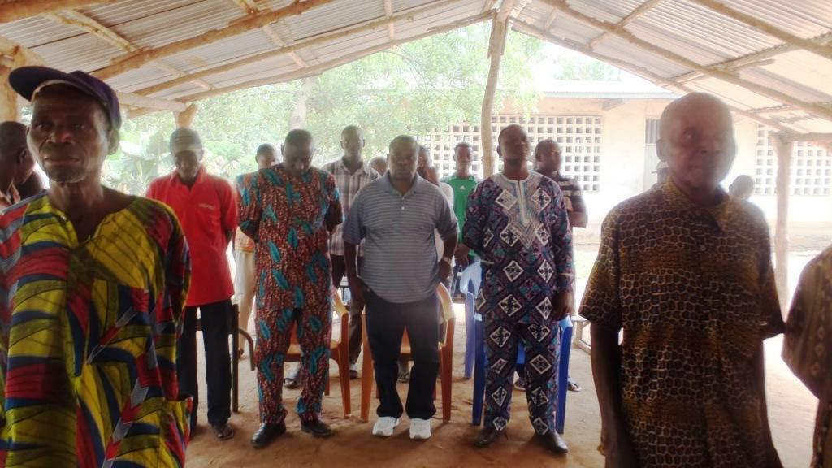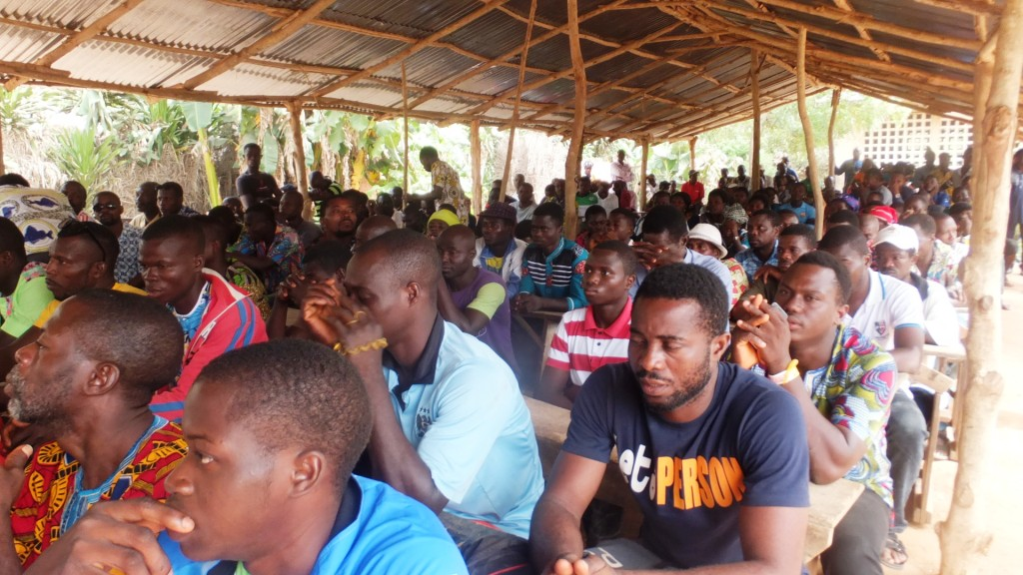
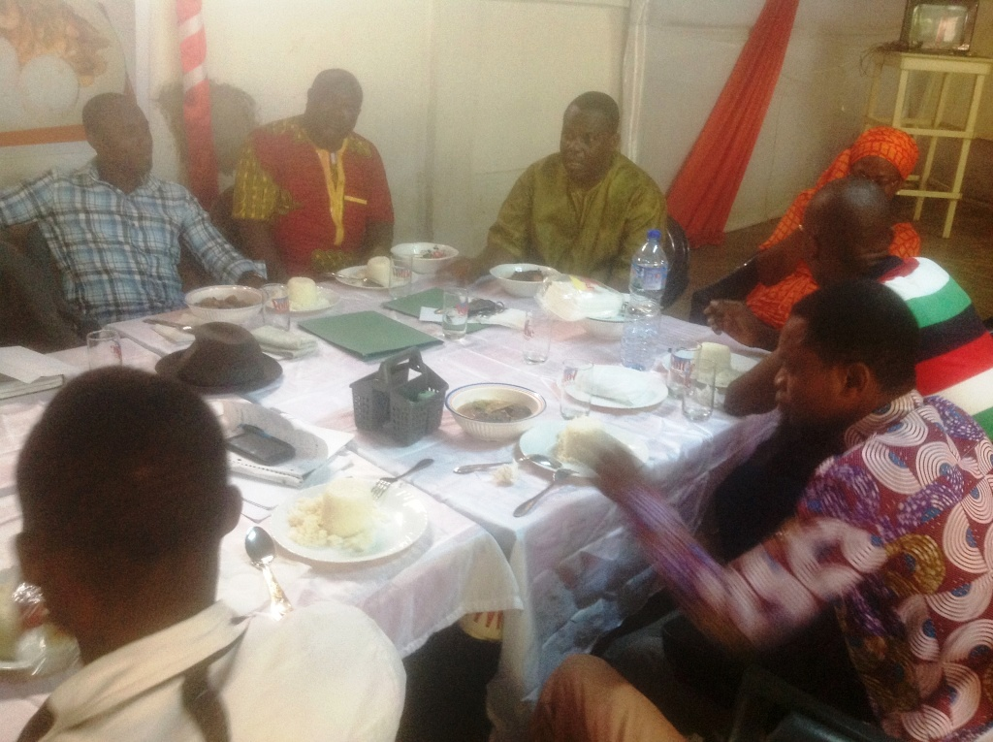End of Year Meeting with Operation Christmas Child’s Team of South Region
I was able to hold an evaluation meeting with the Operation Christmas Child’s Team of South Region. During this meeting, reports of the group’s activities were submitted and we proceeded to the appraisal of the group’s performances. Thereafter, we defined projects and goals and strategies for the New Year to come. The meeting ended with brotherly food sharing in which all participants took part.
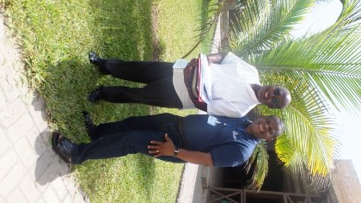

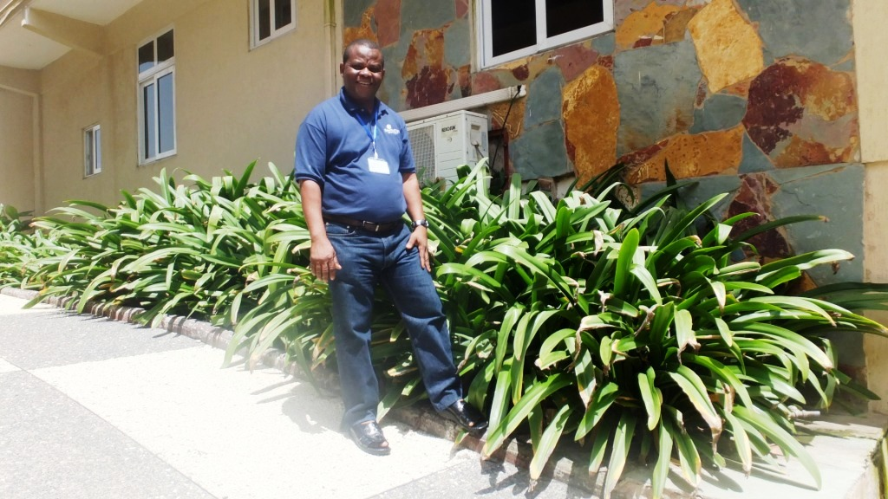Attending Training Seminar in Ghana
The end of this year, the Lord enabled me to take part in Training Seminar in Ghana. During my stay, I could meet several pastors who are great spiritual encouragement to me.

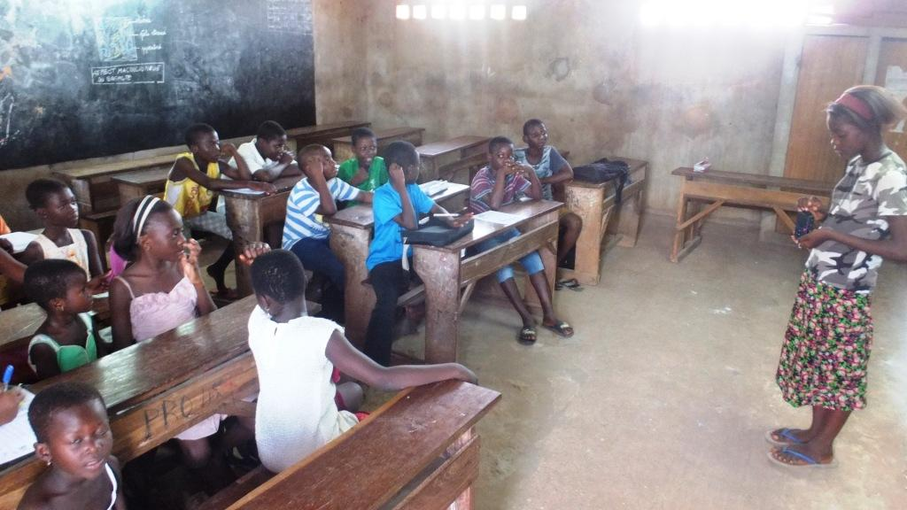Encouraging the Spread of the Gospel in Schools Through Papyrus
One of the missions assigned to me by our Almighty Lord is to share the Gospel among school children. For this reason, I seize every opportunity to encourage the sharing of the Gospel among these kids all over the country. Apart from the Bible course which I distribute to them, I also see the listening of the Gospel through Solar audio player devices as a powerful means to reach school children.
Land Purchase for the Village Churches
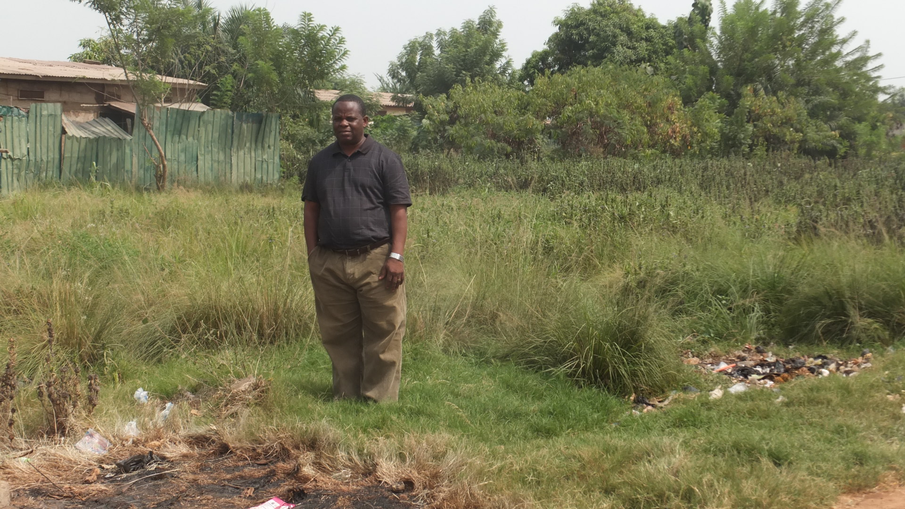With free will donations, the Lord enabled me to purchase a plot of land for each of the two village churches: the church of Fiokondji and Agbanakin. Given that Agbanakin is a hamlet which is extremely hostile to the Gospel, we spent a hard time finding a plot of land to purchase in order to carry out church building activities. Now that the Lord helped us in purchasing the land, we are faced up by oppositions from some of the village people who are hostile to the church building construction activities and who do not want to see any other church established in their village than the Catholic Church. We would therefore like you to pray for the Lord to touch the heart of the hostile village people so that the construction of the church building in Agbanakin could be effective.
Inspecting the land purchased in the village of Agbanakin
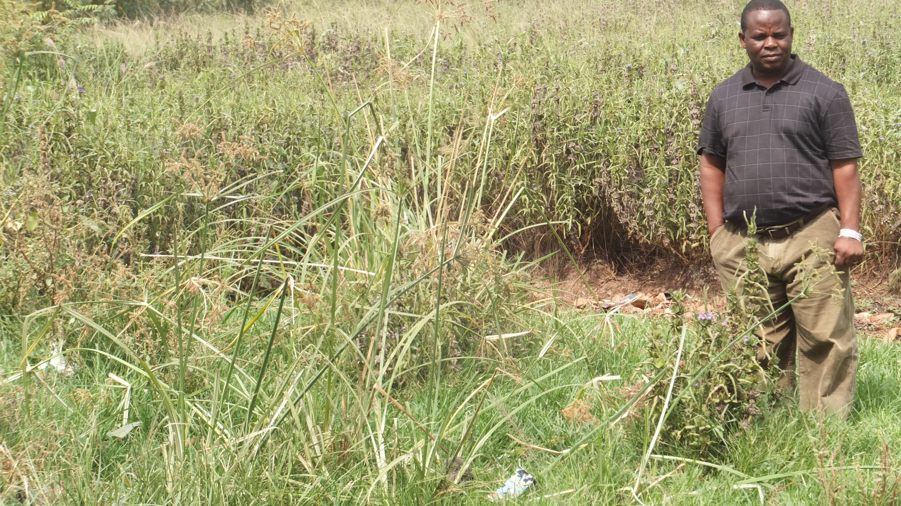
In the village of Fiokondji, we witnessed terrible increase in the price of land due to the decay of the economic situation in the country. Therefore, we could purchase a plot of land for the start of church building construction, but we had to invest much in that. Anyway we are grateful to the Lord for providing this opportunity and humbly ask you to keep on praying for the church building construction in this village to be effective. As one of the pressing needs for the construction activities in the village of Fiokondji, we need an overall of $10,000. We therefore request your faithful prayers for the Lord to provide for the completion of these activities.
Inspecting the area purchased in the Village of Fiokondji
Seasonal Greetings. On behalf of all my family, I would like to extend my seasonal greetings to you. I wish you a Happy New Year and pray that the Lord Almighty strengthens you and bless you abundantly as you serve Him with fear and devotion. Please be praying for my wife, my children and I. Thank you and May God Bless you. Regards, Pastor Sika and Lucie.

