True stories of what God has done for children

A series of short testimonies for children
from some of my personal friends

Psalm 66:16 "All you people who worship God, come and I will tell you what he has done for me." (ERV)

by Shirley Davis

www.imofinc.org

The little girl who taught us a lesson

Recently at our church we've been preparing for a mission trip to Haiti, and so we had a challenge between the kids and the youth to see which group could bring more backpacks and shoes for needy Haitian children. One Sunday, a young girl of about 10 years old was finding a bit too overwhelming the loud singing and jumping up and down of the large group of kids praising God. My daughter, Anna, who looks out for kids with special needs, took her aside to watch from an adjoining room where it was quieter. The girl didn't want to talk and just wandered around aimlessly. Anna sat down and started to draw, and soon the girl sat down beside her and began to draw too. She drew several pictures but didn't appear to pay any attention to what was going on in the main room, where I was showing slides and telling the children about life in Haiti and the many needs there.
Suddenly Anna glanced over and realized that the girl had drawn a lovely picture of a little girl wearing a ragged dress with holes! Around the picture she was writing some words: "Love the homeless like God does....Do something to help..." Anna realized that even though the girl appeared to be paying no attention to the class, she was actually listening ....and responding!! Anna praised the girl's work and then the girl started talking excitedly about how God loves everyone and we should all do something to help the poor children!
What an amazing lesson for us all! It is tempting to view a child who will not sit still and pay attention as being "difficult" or causing distraction - it's easier if they would just go away! Yet if we are truly children's MINISTERS we should seek to find some way to draw closer to such children, learn more about them and find out how best we can share Jesus with them. We have no idea what is in their heart or how God may be reaching out to them, so we should NEVER overlook them or push them aside.
Anna asked the girl if we could use her picture to put on the collection box to remind other kids to bring shoes and backpacks, and she happily agreed. She had made a very special contribution and as soon as I heard what had happened, I realized how important it is to share both her story and the lesson we can all learn from it.

"Even children show what they are like by the things they do.
You can see if their actions are pure and right." Proverbs 20:11 (ERV)

"You are young, but do not let anyone treat you as if you were not important. Be an example to show the believers how they should live.
Show them with your words, with the way you live, with your love,
with your faith, and with your pure life." 1 Timothy 4:12 (ICB)

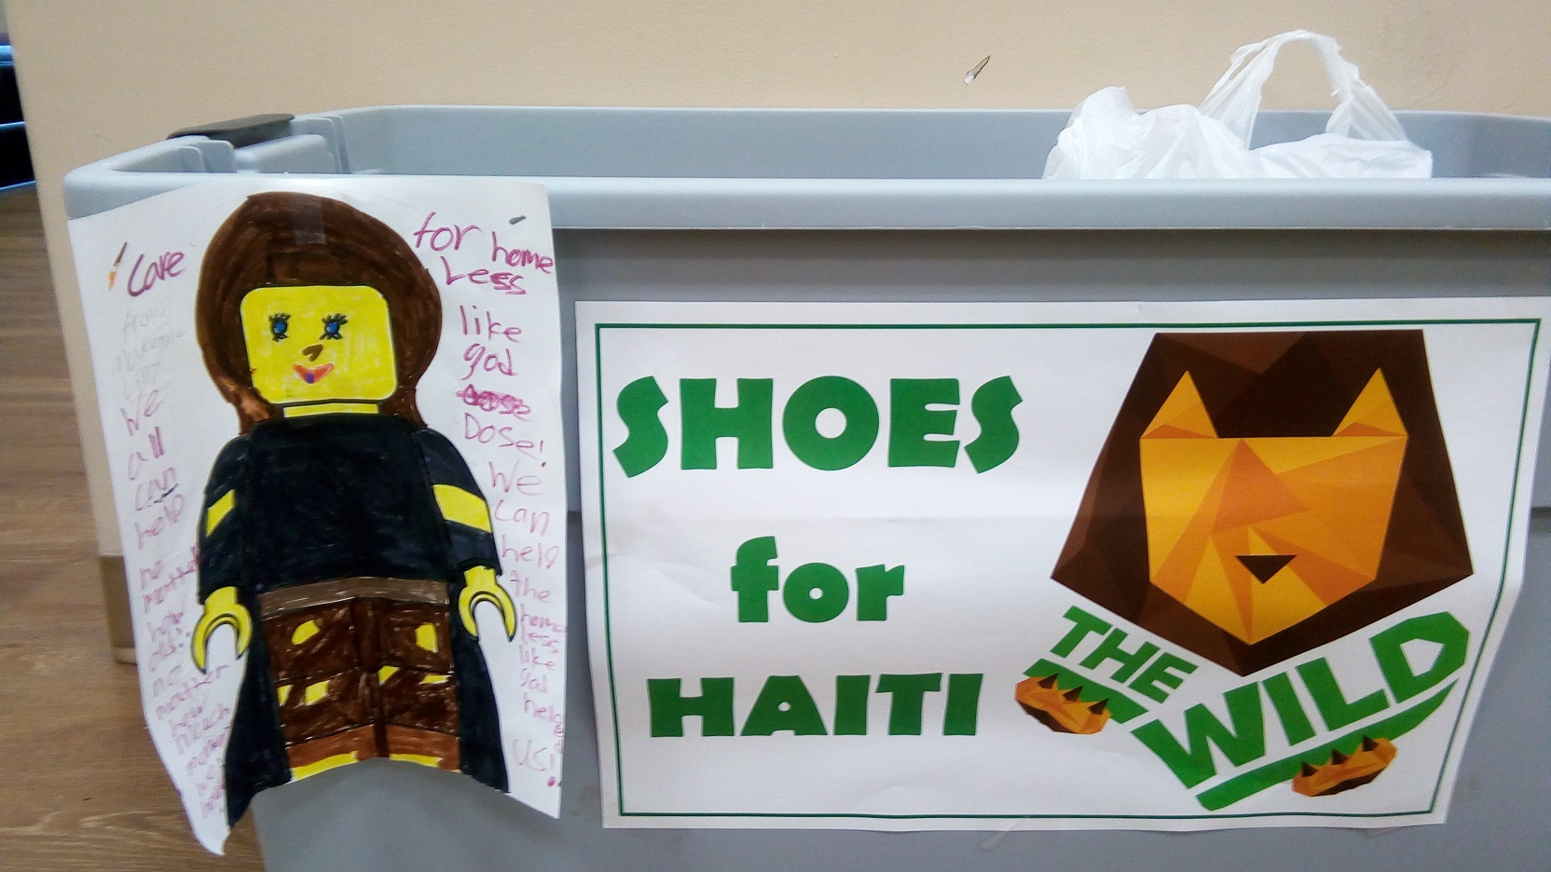

A little boy who couldn't go to school

Through the years I have collected a number of true stories from Christian friends that have inspired my faith, and I would like to share some of them that might be particularly helpful to children. This first one was shared by an elderly friend in Australia, whom I never actually met in person but corresponded with for many years. His name is Lloyd Freeth, who went on to be with Jesus around Christmas last year at the age of 94. He told this story of his grandfather, William Congdon, who left England as a young boy with his family in 1867 (over 150 years ago!). The dangerous journey by ship lasted 9 months until they finally arrived in New Zealand to start a new life. The story continues:
"William was eager to start school and learn how to read and write, but sadly the local school there was fully booked until the following year, and little William (aged 6 or 7) was too young as they had limited teachers. It was decided that while he was waiting, William should earn some money to help the family, so he went to live with a group of men working at the Forestry Headquarters cutting down trees. His job was as a gardener and cleaner, and he did odd jobs with the men he lived with who really liked him.
One day when he was eating with them, a man named Jim asked William to pass the plum jam which was in front of William. William asked Jim how he knew that it was plum and the man said, “Because it says so.” William was puzzled. A jam jar can’t talk! Jim laughed and told William that reading was about sounding out words, each letter at a time. From that simple first word “plum”, William learned to read everything he could put his hands on. He had a good brain and was soon reading more difficult books, and eventually he could read the Bible. He was fascinated with the Parables in the New Testament. I’m told that when William read the Parable of the Lost Sheep being rescued by the Good Shepherd, he exclaimed, “I’m the Lost Sheep. Jesus is the Good Shepherd who gave his life to save me.”
Years later, after William had grown up and left the camp, he went to the South Island. He joined a church in Blenheim, bought a home with large gardens, married a lovely woman and had 8 children (7 girls and 1 boy). Dora, one of his daughters, met Dick Freeth whom she married. Richard and Dora adopted a baby boy whom they brought up on their farm in Picton. Dick and Dora and Lloyd (the baby boy) saw Grandpa weekly and it was from Grandpa’s own lips that I learned of the story of an unschooled boy who learned to read from a jam jar." Written by Lloyd Freeth, 25th Nov 2018

Philippians 4:13 "For I can do everything through Christ,
who gives me strength." (NLT)
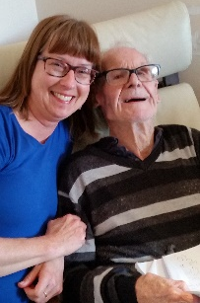

The little boy without a father

I want to share with you another true story from one of my friends. I first got to know Mike 15 years ago when he wrote me a letter asking to learn how to tell children about Jesus. He lives in Kenya in East Africa and had already studied at Bible College and could have been a church pastor, but he believed that God wanted him to reach children with the Gospel. We wrote often and I sent him all our materials for children's ministry, and shared lots of ideas with him. For two years he prayed for me to visit him in Kenya and in 2006 I received an unexpected gift that allowed me to visit him for 10 days. We have become close friends since then, as his family has grown from one child to four, and his ministry has also grown to be recognized in many parts of both Kenya and the surrounding countries. This is his story.
"I was born in 1977 and when I was two weeks old my mother left me to be cared for by my grandmother. I never learned who my father was, and although my grandma was very old, she did her best to look after me. When I reached school age, she handed me over to my uncle who took me to elementary school. When I was 9, missionaries came to our village with puppets and I followed them to the local church where I gave my life to Jesus, then from there my life began a new change. My uncle never accepted my call as a born again young boy and things were not good for me because my uncle’s wife threatened to poison me, and so I had to leave his home.
After I finished my elementary education I went far away to get some employment. Soon after that I went to my pastor to ask for help to attend high school to further my education. But my pastor didn’t help much and discouraged the idea. So I was on my own and had to learn how to make money doing little jobs on the street. I often had nowhere to live and nothing to eat, but somehow I survived as God took care of me. One day, when I was 16, I heard singing in a little church building, and decided to sleep outside after everyone had left. The pastor found me there and heard my story, so decided to help me. I learned more of Jesus and even began to preach! Later a lady saw me preaching with my ragged clothes, and she gave me a small amount of money so that I could start a little business. As I worked hard, I was able to save my money and eventually went to bible college.
I had been rejected by my family and even by the church at times, but God has always been faithful to me. Now I have a wonderful wife and family, and MANY friends, even in far away lands like England and the USA - it's a big family because it is the family of God!"

"I will bless you with a future filled with hope—a future of success,
not of suffering." Jeremiah 29:11 (CEV)

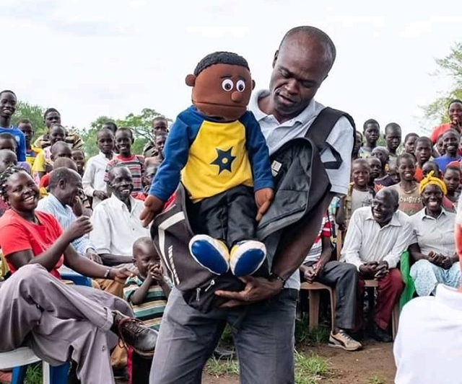

The little girl with no family or friends

This true story is about a dear friend whom I have known for about 15 years, although we've never met in person. Her name is Kathy and she lives near Los Angeles in California. We often have long phone conversations and I have never known her to complain or be worried, although her story tells how hard her life has been. It is a good reminder that no matter where we live around the world, life can sometimes be very hard for children, but Jesus is always close by to help get through it!
Kathy's parents were born in Ireland (near England). Her mother was only 12 years old when she married her husband, who was 35!! They moved to New York where they lived in Manhattan and had lots of children. Kathy was their 10th child! Soon after she was born, her parents decided they didn't want to have to care for their children any more!! The older ones were sent to an orphanage, and Kathy and her youngest sister were sent to a Catholic foster home. Their foster mother was a tyrant and very abusive, making them work hard. Kathy was often beaten, thrown down the stairs, and treated terribly during the 18 years that she lived there. She was a sickly child, often ill with colds and flu, and she even got TB. She went to school but evidently had a kind of learning disability and spent much of her time sitting under her desk! No-one cared enough to help her and she had no friends. At 15 she went to a high school for abandoned kids and learned some trades that helped her in later years work in a variety of jobs, but always just earning minimum wage.
It was a requirement for the foster home to send her to a local Roman Catholic church, where she learned the Catechism and about Jesus. One day when she was still just 12 years old, she was working building a cement path for her foster mother. Suddenly she clearly heard Jesus speaking to her. He told her that she would not have a life like other people, get married or have a family. But he had something better for her if she wanted it, and he would take care of her. She strongly felt the presence of Jesus and from that day forward she started trusting and following him, and he became her best friend.
Now, many years later, she has amazing stories to tell of how Jesus has taken care of her - even one time when her home was destroyed in an explosion! She was terribly burned but Jesus appeared to her and said she would not feel any pain - she didn't, even though she had to have many operations. She has always given money to help the poor and is busy with different projects to help people in need - and she is always happy and eager to tell others about her best friend, Jesus!

John 15:15b "Now you are my friends, since I have told you everything
the Father told me." (NLT)

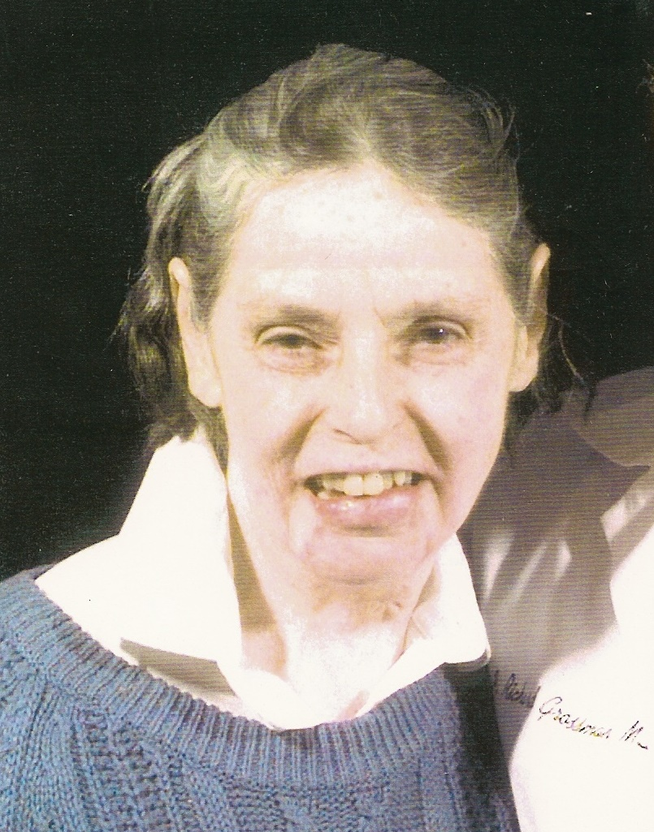

The little boy who received a miracle

This amazing true story of how a young boy’s prayer was miraculously answered seems almost unbelievable, yet we came to know him very well during our time as missionaries in Mexico. We met his family and often visited the very humble little church which he had started as a mere teenager, in spite of much persecution in his village. The miracle led to him giving his life to serve Jesus as a pastor and evangelist, preaching the Gospel in many isolated villages.
10 year old Erasmo lived in the tiny Indian village of Aquixcuatitla in the hills of Mexico. After school, he had to help with the family chores – getting water from the village well, or working on the steep hillside where his family grew corn and beans. He often did these chores with his donkey. It really belonged to the family, but Erasmo was the only one it wouldn't bite, so they had a special bond. One day he went to the hillside to get the donkey, but was shocked to find it lying on the ground dead! It had been strong and healthy, but Erasmo recognized the telltale signs explaining its sudden death: its body was bloated, with blood on its mouth and ears. It had been bitten by a poisonous snake! Overcome with shock and grief, the boy ran back to tell his parents. They were very poor and couldn't afford to get another donkey soon, but promised to bury the donkey just as if it were a family member, but Erasmo could not be comforted.
As he set off with a shovel to bury his pet, he recalled a story he had heard a few months before from a Mexican evangelist who had visited their village. It was of a man named Jesus whose friend had died. When Jesus prayed to God for his friend, his friend was restored to life! The boy kept thinking about this as he walked. If God really did exist, and could do miracles like that, surely He could bring his donkey back to life! So he prayed a simple prayer: “God, if you really do exist and can do miracles as I’ve heard, bring my donkey back to life and I’ll spend the rest of my life serving you.”
When he finally got back to the donkey, he was amazed see its feet beginning to move! Then it opened its eyes, and as he watched in wonder, the swelling went down and about an hour later, the donkey was running about the hillside! Erasmo raced home crying tears of joy instead of sadness, and told his amazed parents. They returned with him to see the donkey, and couldn't explain what had happened, but his father believed God had answered the boy’s prayer.
Erasmo and his father went to church meetings whenever they could and started living for Jesus, but this brought great problems at home. Erasmo’s mother was completely against their new beliefs, so she refused to cook for her husband and son, or wash their clothes! This made life very hard, but they refused to give in, and continued praying for her. Finally after 3 years she accepted Jesus Christ, and gradually more of their family and friends were saved. Erasmo kept his promise to God. When he was 13, he left home and spent 3 years learning more of the Bible so he could start a church in his home village when he was 16. He continues to pastor the church, which his whole family and half the village attend!

Mark 10:27: Jesus looked at them intently and said, “Humanly speaking, it is impossible. But not with God. Everything is possible with God.” (NLT)


